**Eurofarma, first Brazilian company to implement Körber’s PAS-X MES for enhanced data access, traceability, and regulatory compliance**

**Lüneburg, Germany, 10 July 2025. Eurofarma Laboratórios has successfully transitioned all of its manufacturing operations at the main production facility in Itapevi, São Paulo to Körber’s PAS-X Manufacturing Execution System – becoming the first national company in Brazil to do so. The implementation paves the way to operational excellence, enabling real-time data access, full traceability, and enhanced regulatory compliance.**

At the Itapevi site, Eurofarma manufactures a wide range of products, including generics, oncology medicines, OTC drugs, and veterinary products – all of which were previously produced through manual processes. These numerous manual tasks, supported by thousands of paper documents, needed to be replaced with digital workflows.

“To achieve a digital Factory of Excellence, Eurofarma chose PAS-X MES from Körber,” says Daniel Bosso Gonçalves, Vice President Latin America Software, Körber Business Area Pharma. “The company once again takes the lead in the region, by overcoming the challenging transformation of its manufacturing processes, shifting from manual, paper-based operations to a fully digital environment, enhancing quality, efficiency, and visibility, and setting the stage for sustained innovation.”

Today, over 200 workstations are using Electronic Batch Recording (EBR), covering the entire process from warehouse distribution to final packaging. This spans five buildings and multiple production types. The implementation also includes digital equipment setup, cleaning processes, and electronic logbooks.

“We’re celebrating a major milestone in our digital transformation journey with the successful implementation of PAS-X MES at our facility,” says Allan Santiago, Director of Global Quality at Eurofarma. “This achievement marks a new era of operational excellence, enabling real-time data access, full traceability, and enhanced regulatory compliance. By replacing manual processes with digital workflows, we’ve significantly reduced errors and improved efficiency. For the Quality team, this means faster, data-driven decisions and stronger audit readiness.”

Eurofarma partnered effectively with Körber, leveraging their project management expertise and coordination of a multidisciplinary team. Key users from various departments – including Quality, Production, Automation, IT, and Manufacturing Excellence – were strategically involved throughout the project.

The digitalization project was rolled out in different phases. The initial phase focused on deploying PAS-X MES in weighing and dispensing areas including connectivity with digital scales, and the manipulation steps through to final filling and packaging for a small family of products/, all these also integrated with SAP. This phase was completed in just eight months from project kickoff to go-live. Subsequent phases extended coverage to all other processes, products, and recipes, ultimately achieving full digital integration.

As part of the MES project, more than 20,000 Master Batch Records (MBRs) were designed, providing comprehensive control over operations, equipment usage, and material tracking. All operator interactions are now conducted digitally, ensuring full compliance with FDA 21 CFR Part 11.

“We now operate a fully digitalized factory capable of producing thousands of batches per month, across various forms and presentations, in a harmonized and transparent way,” adds Marilene Narciso, Digital Project Manager at Eurofarma. “With PAS-X MES, we have a robust tool that enables Eurofarma to reach new levels of maturity, integrating elements of Industry 4.0 and Artificial Intelligence as we move forward.”

**Picture**

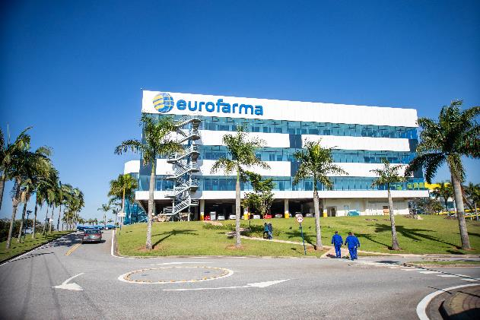

Eurofarma’s main production facility in Itapevi, São Paulo, Brazil

**About Körber**

We are Körber – an international technology group with around 13,000 employees at over 100 locations worldwide and a common goal: We turn entrepreneurial thinking into customer success and shape the technological change. In the Business Areas Digital, Pharma, Supply Chain, and Technologies, we offer products, solutions and services that inspire. We act fast to customer needs, we execute ideas seamlessly, and with our innovations we create added value for our customers. In doing so, we are increasingly building on ecosystems that solve the challenges of today and tomorrow. Körber AG is the holding company of the Körber Group.

At Körber Business Area Pharma, we deliver the difference by empowering our customers with a holistic ecosystem approach. Our unique portfolio of end-to-end solutions ranges from machines – for aseptic processing, inspection, packaging and materials, and transport systems – to consulting, services, software, and digital and AI-driven solutions that serve as integrating layers to boost pharmaceutical manufacturing.

We simplify processes, reduce risks and accelerate time-to-market – ensuring smooth collaboration along the entire pharmaceutical and biotech value chain. With deep industry expertise, we support global customers unlock new potential. Our solutions support a better quality of life for both present and future generations.

[www.koerber-pharma.com](http://www.koerber-pharma.com/)

**Contact**

Dirk Ebbecke

Körber Business Area Pharma

Head of Product Marketing

T: +49 4131 8900-0

E-mail: dirk.ebbecke@koerber.com