Novo Nordisk leads cloud-native manufacturing with NextGen PAS-X MES from Körber

Lüneburg, Germany, 05 December 2022. Driven to deliver medicines to patients faster with more agility, Novo Nordisk is leading the pharma industry’s technology advancement by bringing MES to the cloud through their strategic partnership with Körber. Körber’s Werum PAS-X MES 3.3 Suite will be deployed in Novo Nordisk’s private Azure cloud infrastructure to implement MES faster than ever.

As an early adopter, Novo Nordisk and Körber are working closely on the development and deployment of PAS-X MES 3.3 to ensure the success of this cutting-edge program. So far, this close partnership has enabled PAS-X MES to be on a massive scale already.

With Werum PAS-X MES 3.3 at the center of Novo Nordisk’s Pharma 4.0 digital ecosystem, the company will be able to bring best-of-breed applications with out-of-the-box capabilities tailored to GMP production to manufacturing sites across the world – globally empowering workforces and increasing manufacturing productivity.

Körber has developed PAS-X MES 3.3 as a solution that will continue to evolve with market needs through a continuous evolution stream support model that will allow Novo Nordisk to continuously bring new functionality into production. This approach to application lifecycle management ensures that the company’s systems can adapt as technology continues to improve while still meet productivity demands today. By leveraging the integrated intelligence and analytics products, Novo Nordisk ensures to get the most out of their manufacturing data to further drive efficiencies.

Picture
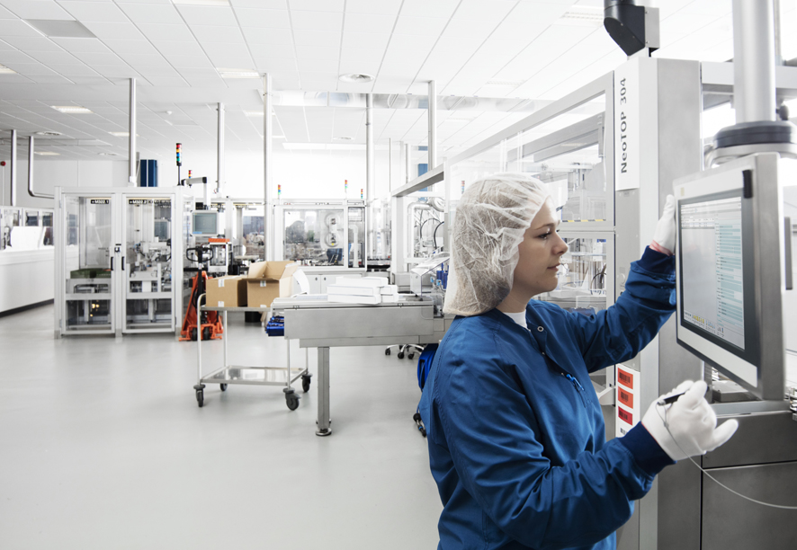

About Körber
Körber is an international technology group with about 12,000 employees, more than 100 locations worldwide and a common goal: We turn entrepreneurial thinking into customer success and shape the technological change. In the Business Areas Digital, Pharma, Supply Chain, Tissue and Technologies, we offer products, solutions and services that inspire.
At the Körber Business Area Pharma we are delivering the difference along the pharma value chain with our unique portfolio of integrated solutions. With our software solutions we help drug manufacturers to digitize their pharmaceutical, biotech and cell & gene therapy production. The Werum PAS-X MES Suite is recognized as the world’s leading Manufacturing Execution System for pharma, biotech and cell & gene. Our Werum PAS-X Intelligence Suite accelerates product commercialization with data analytics and AI solutions and uncovers hidden business value.
www.koerber-pharma.com

Contact
Dirk Ebbecke
Körber Business Area Pharma
Head of Product Marketing
T: +49 4131 8900-0
E-mail: dirk.ebbecke@koerber.com

