Exciting new partnership to boost paperless pharma manufacturing in Pakistan and the Middle East
News Release

Werum IT Solutions and Emad Trade House have commenced a partnership for expanding the market reach into Pakistan and the Middle East
Lüneburg/Germany, Bangkok/Thailand, 10 April 2019 – Werum IT Solutions, the world’s leading supplier of manufacturing execution systems (MES) and manufacturing IT solutions for the pharmaceutical and biopharmaceutical industries, is pleased to announce a new partnership with Emad Trade House. Emad Trade House is a leading trading company with over 40 years of experience in providing cost effective solutions such as raw and packaging materials as well as process equipment to the pharma, cosmetics, food and beverage industry in Pakistan and the Middle East region.

Werum’s PAS-X MES enables pharmaceutical and biotech facilities to run manufacturing processes completely paperless at the highest level and to be compliant with international GMP guidelines and FDA regulations. The requirements of the pharma industry are directly addressed by Werum’s out-of-the-box PAS-X solution without any need for expensive and time-consuming customization. Based on standard functionality and best practice content, pharma and biotech manufacturers will be able to have the number one global pharma MES up and running in a very short time.

“We’re very pleased that Emad Trade House will join us as a sales partner to expand our presence in the Middle East region and to be able to support our first activities in Pakistan to grow the PAS-X user base. We look forward to working closely with their team and to learn from their excellent understanding of the market”, says David Margetts, Managing Director, Werum IT Solutions Ltd, Thailand. “Together with Emad Trade House we will be able to increase the availability and access to cutting-edge manufacturing IT that will dramatically improve the quality and efficiency of producing important medicines in Pakistan and the Middle East.”

Mr. Emad Shabbir, Director, Emad Trade House, adds “We are looking forward to this collaboration with Werum IT Solutions having no doubt that this partnership will yield great success. With Werum's technical expertise and our strong outreach in the market, surely we will achieve new milestones together."

Photo:
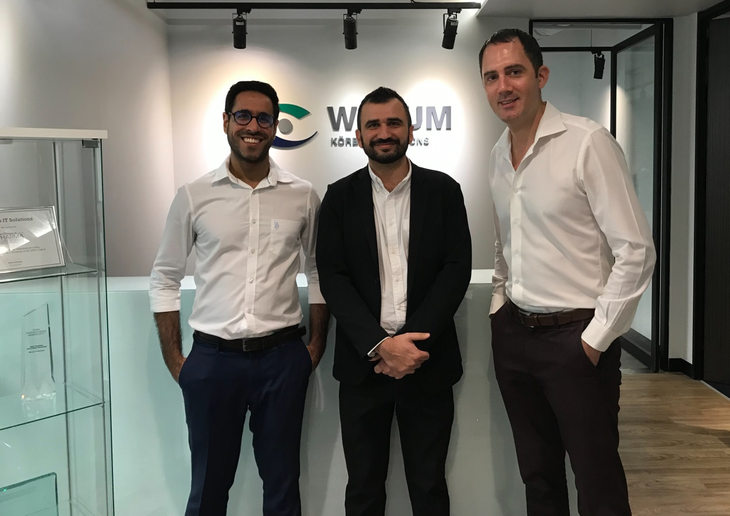
From left: Orchun Thakral, Senior Manager of Sales & Marketing (Werum IT Solutions Ltd.); Emad Shabbir, Director (Emad Trade House); David Margetts, Managing Director (Werum IT Solutions Ltd.)

About Werum IT Solutions
Werum IT Solutions is the world’s leading supplier of manufacturing execution systems (MES) and manufacturing IT solutions for the pharmaceutical and biopharmaceutical industries. Its PAS-X software product is run by the majority of the world’s top 30 pharmaceutical and biotech companies and also by many mid-sized manufacturers. Werum’s manufacturing IT solutions help pharma manufacturers to increase efficiency, improve productivity, and meet regulatory requirements. Founded in 1969, Werum is headquartered in Lüneburg, Germany, and has many locations in Europe, America, and Asia.
www.werum.com

Werum is part of Medipak Systems, the Pharma Systems business area of the international technology group Körber. The Business Area’s companies, Dividella, Fargo Automation, Mediseal, Rondo, Seidenader Maschinenbau, Systec & Services, Traxeed and Werum IT Solutions, are global leading providers of high-quality solutions for the manufacturing and packaging process of pharmaceutical products. As a Medipak Systems company, Werum provides integrated IT solutions for all phases of pharmaceutical and biopharmaceutical production – including process development, commercial production, and packaging as well as track & trace serialization. Körber unites around 12,000 professionals in industry-leading companies worldwide, achieving annual earnings of 2.6 billion Euros.
www.medipak-systems.com, www.koerber.com

Contact:
Dirk Ebbecke
Director Corporate Communications
Werum IT Solutions GmbH
Wulf-Werum-Str. 3
21337 Lüneburg, Germany
Tel. +49 4131 8900-689
Fax +49 4131 8900-200
dirk.ebbecke@werum.com

About Emad Trade House
Emad Trade House is a trading house with over 200 customers in Pakistan, MENA and South-East Asia. With experience of over 40 years, 50+ team members and 5+ master certifications, it is the leading trading service in the fields of raw materials, packaging materials, process equipment and B2B facilitation for several industries such as food and beverages, pharmaceuticals and the cosmetic industry.
www.emad-uae.com

Contact:
Mr. Emad Shabbir
Emad Trade House
Tel. +971 4 443 0114
Fax +971 4 443 0110
Cell +971 50 558 0221
emad@emad-uae.com

