TRAXEED: Common goals, common name – Medipak Systems launches new brand for its Track & Trace business
Under the new Traxeed brand, Medipak Systems will bundle all Track & Trace solutions, products and services of its companies Seidenader Maschinenbau and Systec & Services. With Traxeed, Medipak Systems is a partner for complete pharma serialization solutions from level 1 to level 5.
Hamburg/Winterthur/Markt Schwaben/Karlsruhe, June 11, 2018. – Medipak Systems, the Business Area Pharma Systems of Körber AG and leading provider of system solutions for the pharmaceutical and biotech industry, is introducing a new brand. In future, all products, services and solutions related to Track & Trace and serialization of the Medipak Systems companies Seidenader Maschinenbau and Systec & Services are bundled under the brand name Traxeed. From a single source Medipak Systems offers its customers integrated serialization solutions from level 1 to level 5. For this purpose, the responsible departments at Seidenader and Systec & Services were merged under a common brand name.
With Traxeed, Seidenader and Systec & Services will offer their customers worldwide serialization solutions for the entire production process from a single source. Customers can rely on the many years of experience of both companies, not only regarding the forthcoming commencement of the Directives 2011/62/EU or the Drug Supply Chain Security Act (DSCSA). Seidenader contributes its know-how in serialization and aggregation machines as well as the necessary software for level 1 to level 3. Systec & Services stands for many years of experience in the implementation of levels 1 to 5. Both companies have already successfully cooperated as partners in levels 1 to 3 in the past. However, within Traxeed, projects and processes can be even better coordinated and services can be offered customer-specific from a single source.
In November 2017, Körber AG announced the acquisition of Systec & Services GmbH. With the acquisition of the system partner, specializing in consulting and implementation of production control systems (Manufacturing Execution Systems, MES) and Track & Trace solutions, Körber has further strengthened its Business Area Pharma Systems. The introduction of the Traxeed brand, now, successfully completes the merger of the Track & Trace areas of the two companies. Traxeed will be accessible via the locations in Markt Schwaben and Karlsruhe.
The brands Seidenader and Systec & Services will continue to be independently represented in the market. The Seidenader brand stands for the successful business with inspection machines and inspection applications, while the manufacturing consulting business will be positioned on the market under the Systec & Services brand in the future.
For the first time Medipak Systems will be represented with the brand Traxeed at the Achema 2018 in Frankfurt from June 11 to 15, 2018 at booth J72 in hall 3.1. Under the Traxeed brand current Track & Trace and serialization solutions for the pharmaceutical industry will be presented at the leading trade show for the process industries.
END
Picture material

Traxeed_logo.jpg

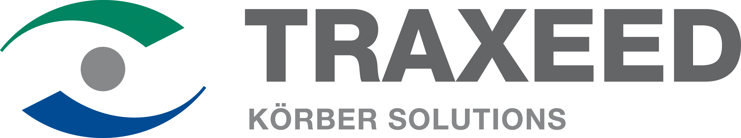

Caption: The new Traxeed brand name is derived from the terms "Track" (Track & Trace), "Proceed" and "Succeed". It stands for the fast, process-oriented monitoring of production processes.

Track-und-trace-Stufen_Lev1-5.jpg
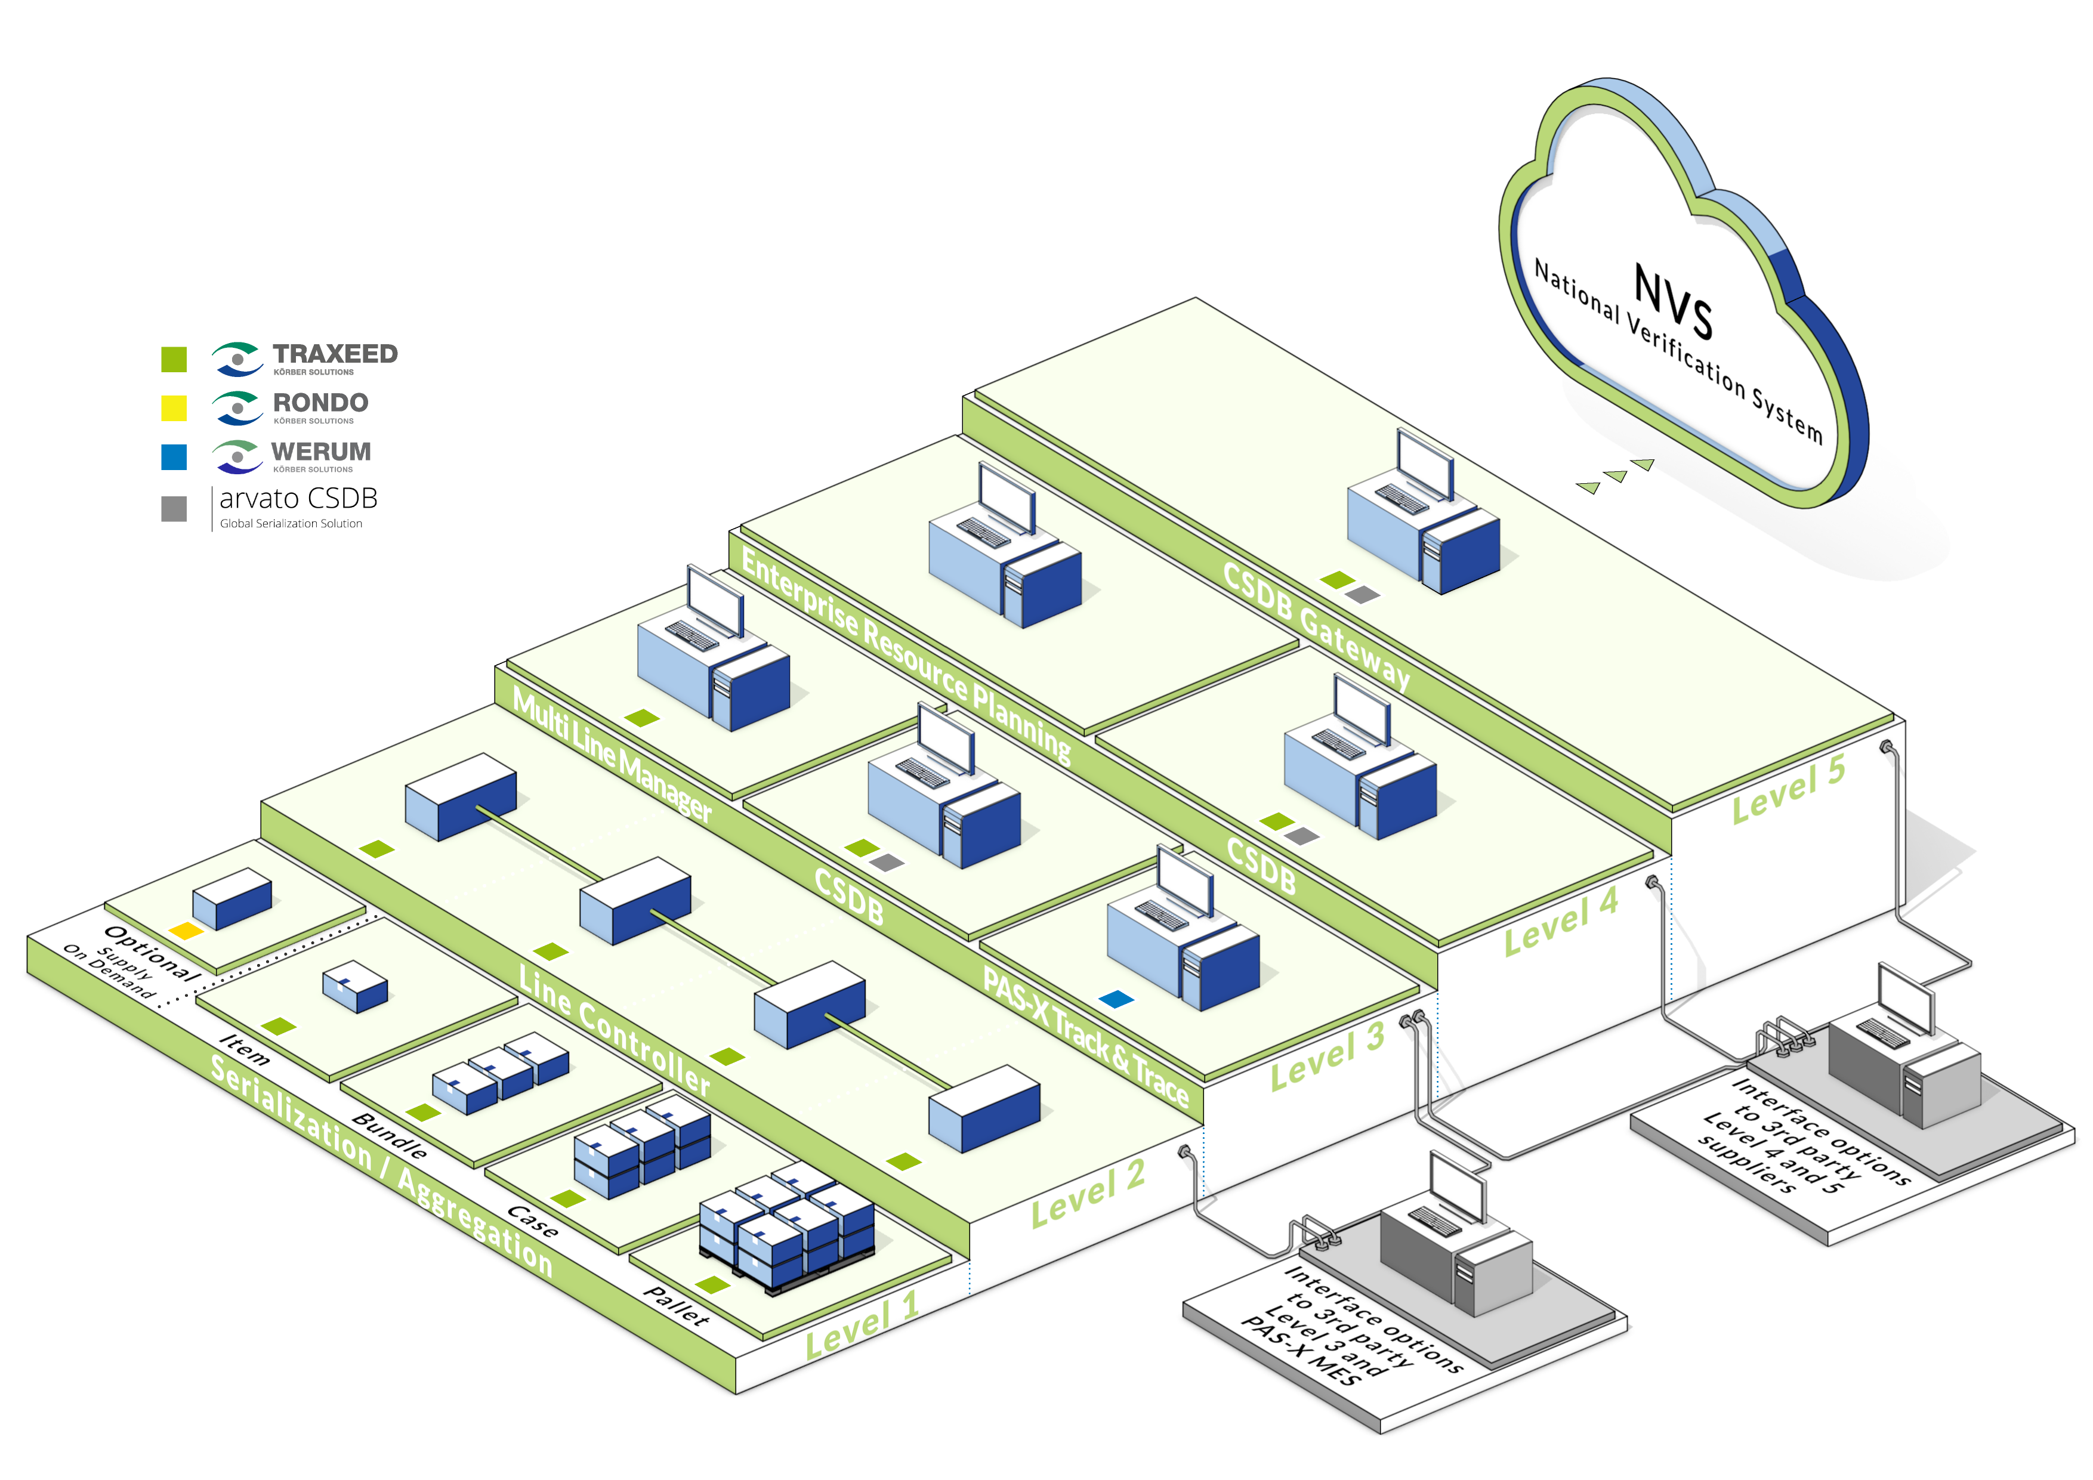
Caption: With Traxeed, Medipak Systems offers its customers serialization solutions for the entire production process (levels 1 to 5) from a single source.

About Traxeed

Under the Traxeed brand, Medipak Systems bundles the Track & Trace activities of its companies Seidenader Maschinenbau and Systec & Services. They are partner for complete pharma serialization solutions from level 1 to level 5 – from serialization and aggregation machines to software and implementation at all levels and from a single source.

Traxeed is part of Medipak Systems, the Business Area Pharma Systems of the international Körber technology group. Körber unites around 11,200 professionals in industry-leading companies worldwide, achieving annual earnings of 2.2 billion Euros.

About Medipak Systems

Medipak Systems is partner to the international Pharma and Biotech Industries and provides solutions for secure and efficient processes for the manufacturing, inspection and packaging of pharmaceutical products. Global leadership in technical know-how, outstanding service and close personal contact form the basis of our long-term partnerships. Medipak Systems unites internationally successful enterprises with locations in Germany, Switzerland, the Czech Republic, the USA, Brazil and China and offers a single source for software, materials, machines and technologies for the production, inspection and packaging of pharmaceutical products: these include Pharma Manufacturing Execution Systems, the development and production of standard and special folding boxes, innovative packaging and inspection machines, and solutions for the traceability of medicines.

Medipak Systems unites the companies and brands Dividella, Fargo Automation, Mediseal, Rondo, Seidenader Maschinenbau, Systec & Services, Traxeed and Werum IT Solutions. Approximately 1,700 employees worldwide work for our company. Medipak Systems is a Business Area of the Körber Group, an international leading technology group with around 11,500 employees and an annual turnover of € 2.3 billion.

Contact to the press

Körber Medipak Systems GmbH
c/o Seidenader Maschinenbau GmbH
Lilienthalstr. 8
85570 Markt Schwaben
Germany

Ms. Claudia Pietsch
Tel.: +49 8121 802 117
claudia.pietsch@medipak-systems.com
www.medipak-systems.com

Traxeed  Systec & Services GmbH  Emmy-Noether-Straße 17  76131 Karlsruhe  Germany  Mr. Florian Kofler  Tel. : +49 721 6634 343  flk@systec-services.com  www.traxeed.com | Traxeed  Systec & Services GmbH  Emmy-Noether-Straße 17  76131 Karlsruhe  Germany  Mr. Titus Krauss  Tel. : +49 721 6634 560  tk@systec-services.com  www.traxeed.com

