**Körber reaches strategic partnership with Taibang Biologic to future-proof blood product manufacturing and increase production efficiency**

**Lüneburg, Germany / Tai’an, China, 4 September 2024. Taibang Biologic Group, a leading Chinese blood product manufacturer, has signed a strategic partnership agreement with the international technology group Körber. Amidst the heightened Chinese regulations for blood products, Körber will support the company in digitalizing its manufacturing and inspection processes, ensuring safety and compliance.**

Within the partnership, Körber will provide comprehensive support to Taibang in various areas, including the implementation of software products, inspection and packaging machines, training, technology, project consulting, and the assistance for development of production information platforms. The collaboration encompasses in-depth cooperation across project planning and execution, production, and maintenance, as well as sharing of relevant solutions and experiences.

Taibang is currently implementing the newest version of Werum PAS-X MES, Körber’s market-leading manufacturing execution system for pharma, biotech and cell & gene therapy production, at its manufacturing base. The MES is expected to facilitate digital transformation and upgrades in areas such as processes, product quality control, and production efficiency, thereby fostering high-quality development in the blood products industry. PAS-X MES will be deployed as a full-scale MES at two Taibang sites – one in Tai’an and the other in Guiyang – covering complex processes from plasma melting to the finished product.

“As a national high-tech enterprise and one of the largest blood product groups in China, Taibang attaches great importance to R&D and production capacity,” says Hao Zhang, IT Director of Taibang, “Since Körber is an expert in technological innovation in the pharmaceutical industry worldwide, we believe that this cooperation will further enhance our overall strengths. Aligning with international cutting-edge digital solutions will enable us to increase production efficiency and quality, providing patients with safer blood products.”

Jerry Zheng, Managing Director of Körber Business Area Pharma China, adds: “We are pleased to establish a long-term strategic partnership with Taibang, which is an important milestone in our China business. Over the years, Körber has been helping customers in the pharma industry to achieve digitalization and information management with its end-to-end integrated technology solutions, enabling them to move quickly to the 'Factory of Excellence'. We look forward to writing a new chapter in the blood products industry together with Taibang.”

The Chinese National Medical Products Administration (NMPA) recently unveiled a set of regulations for blood products, including the “Three-Year (2024-2026) Action Plan for Smart Supervision of Blood Products Production”. These regulations aim to expedite the digitalization process, establish standards for the visualization of blood product manufacturing and inspection, and stimulate the transformation of blood product manufacturing. Ultimately, these measures are designed to ensure the safety, efficacy, and quality control of blood products.

Körber's software solutions, such as Werum PAS-X MES, are of great importance here. The strategic partnership will accelerate Taibang’s pace of product research and development with a commitment to enhancing product quality and production efficiency.

**Pictures**

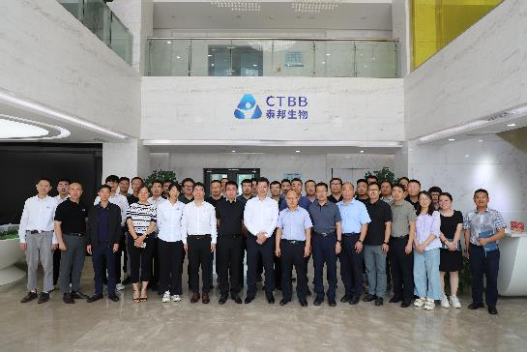

Cooperation kick-off at Taibang

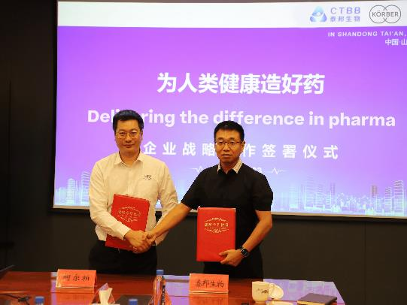

Signing ceremony: Jerry Zheng, Managing Director, Körber BA Pharma and Hao Zhang, IT Director, Taibang (from left)

**About Körber**

We are Körber – an international technology group with more than 12,000 employees at over 100 locations worldwide and a common goal: We turn entrepreneurial thinking into customer success and shape the technological change. In the Business Areas Digital, Pharma, Supply Chain, and Technologies, we offer products, solutions and services that inspire. We act fast to customer needs, we execute ideas seamlessly, and with our innovations we create added value for our customers. In doing so, we are increasingly building on ecosystems that solve the challenges of today and tomorrow. Körber AG is the holding company of the Körber Group.

At the Körber Business Area Pharma we are delivering the difference along the pharma value chain with our unique portfolio of integrated solutions. With our software solutions we help drug manufacturers to digitalize their pharmaceutical, biotech and cell & gene therapy production. The Werum PAS-X MES Suite is recognized as the world’s leading Manufacturing Execution System for pharma, biotech and cell & gene. Our Werum PAS-X Savvy Suite accelerates product commercialization with data analytics and AI solutions and uncovers hidden business value.

[www.koerber-pharma.com](http://www.koerber-pharma.com/)

**About Taibang Biologic Group**

Founded in 2002, Taibang Biologic Group (“Taibang”) is a leading Chinese biopharmaceutical company that provides a comprehensive range of plasma-derived and blood products. The company's core business includes the development, manufacture and sale of blood products and other biopharmaceutical products.

As a leader in China's blood products industry, Taibang possesses leading international technology, one of the largest manufacturing capacities for plasma-derived products in Asia, and world-class R&D capabilities. The company's industry-leading product portfolio currently includes 10 plasma-derived products covering more than 20 specifications in three main categories: human albumin, human immunoglobulin, and human coagulation factors.

Taibang's non-plasma-derived products business segment covers a wide range of products including artificial dura, artificial spinal dura, artificial nerve conduits and anti-adhesion membranes for tendons. With its mission to produce quality medicines that benefit humanity and its commitment to excellence and innovation, Taibang is focused on leveraging the latest R&D to manufacture top-notch products that set the standard for quality, safety and effectiveness.

**Contact**

Dirk Ebbecke

Körber Business Area Pharma

Head of Product Marketing

T: +49 4131 8900-0

E-mail: dirk.ebbecke@koerber.com