Driving pharma & biotech manufacturers on their digital journey: New PAS-X MES software consulting & advisory services from Körber

Lüneburg, Germany, 12 October 2020. The PAS-X MES software experts of Körber’s Business Area Pharma have established a new Principal Consulting & Client Advisory team. Pharmaceutical and biotech manufacturers benefit from new, value-adding PAS-X MES services by Werum Solutions on their digital transformation journey.

Many pharma and biotech companies today have either not digitized their production processes or only to a certain extent. If production data is available electronically at all, it is hardly contextualized, so that it can only be used insufficiently to increase production performance, quality or compliance. In most cases, it is challenging to setup upfront clear, reliable and executable digital production IT strategies, where all necessary aspects in terms of people, processes, data and technology are carefully considered, planned and put into a context to drive production IT compliance and excellence.

The new Principal Consulting & Client Advisory services help drug manufacturers to develop and implement holistic digital manufacturing IT strategies utilizing the broad PAS-X MES portfolio of Werum Solutions, that is tailor-made to the customer’s circumstances and business targets. Customers will be advised and supported throughout the entire digitization lifecycle, from the very beginning of the digital strategic analysis and definition process to project/program execution up to optimization potentials in operations. The new unit is headed by Zinaid Dzinovic, who worked for several years at a major pharma and biotech manufacturer in Switzerland in various positions.

“Turning pains into gains: with our new PAS-X MES Consulting & Advisory services we address our customers’ key pain points in business, quality, compliance and operational excellence,” says Zinaid Dzinovic, Director of Principal Consulting & Client Advisory Software, Körber Business Area Pharma. “The new services are complementing our existing portfolio and help our customers in the strategic process towards fully digitizing their pharma operations.”

Torsten Isenberg, Vice President Global Business Consulting Software, Körber Business Area Pharma, adds: “In discussions with our customers, we often find that the organizations are only insufficiently prepared for the digital transformation. We want to ensure an understanding for the disruptive potential of digitization. Together with our customers we develop and implement the right strategy for the successful journey to their digital pharma 4.0 factory of the future.”

Picture
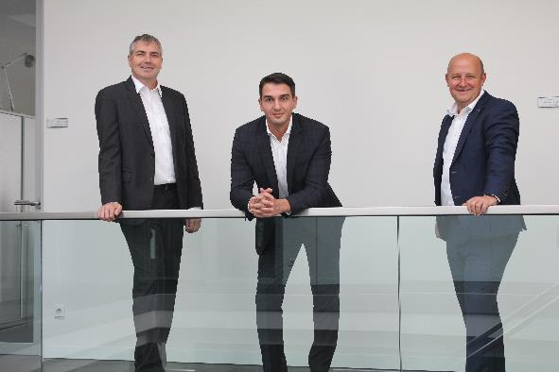
Zinaid Dzinovic, Director of Principal Consulting & Client Advisory Software (center), supported by Torsten Isenberg, Vice President Global Business Consulting Software (left), and Jens Woehlbier, CEO Software (right), Körber Business Area Pharma

About Körber
Körber is an international technology group with about 10,000 employees, more than 100 locations worldwide and a common goal: We turn entrepreneurial thinking into customer success and shape the technological change. In the Business Areas Digital, Pharma, Supply Chain, Tissue and Tobacco, we offer products, solutions and services that inspire.
At the Körber Business Area Pharma we are delivering the difference along the pharma value chain with our unique portfolio of integrated solutions. With our software solutions we help drug manufacturers to digitize their pharma, biotech and cell & gene factories. The software product Werum PAS-X MES is recognized as the world’s leading Manufacturing Execution System for the pharma & biotech industry. Our data analytics and AI solutions accelerate product commercialization and uncover hidden business value.
www.koerber-pharma.com

Contact
Dirk Ebbecke
Körber Business Area Pharma
Head of Global Marketing & Communications Software
Werum IT Solutions GmbH
T: +49 4131 8900-689
E-mail: dirk.ebbecke@werum.com

