Press release

Körber and AGU announce their partnership to further improve the digital transformation of laboratory workflows and MES in the pharmaceutical industry

Lüneburg / Leverkusen, Germany, 11 April 2023. Körber, the global leader in Manufacturing Execution Systems (MES) and integrated solutions, welcomes AGU Planungsgesellschaft für Automatisierungs-, Gebäude- und Umwelttechnik mbH (AGU), a leading provider of middleware integrating a wide range of devices in laboratories, to its Körber Ecosystem Partner program as a “PAS-X MSI Plug & Produce” partner.

AGU received the “Ready” level partner certificate for their data integration solution “Sm@rtLine Data Cockpit” (SDC) which is used by the 25 biggest pharmaceutical companies worldwide to standardize operations and measurements in validated and non-validated environments. Using robust drivers, their software extracts data ranging from simple instruments such as pH meters to more complicated instruments such as cell counters and metabolite analyzers, delivering time and cost savings to customers.

The Werum PAS-X MES Suite from Körber controls, monitors, and documents manufacturing processes digitally and in real time. With just a few mouse clicks, customers can seamlessly integrate Körber’s best-of-breed ecosystem solutions with PAS-X MSI Plug & Produce. This no-code integration uses standardized message-based communication between MES and shop floor equipment as for instance outlined in the ISPE Plug & Produce Working Group's Concept Paper.

SDC from AGU has specialized on the integration of laboratory equipment with PAS-X MES, enabling the complete digitalization of laboratory workflows down to the individual devices. By integrating PAS-X MES and SDC through PAS-X MSI Plug & Produce, pharmaceutical companies can now fully automate the transfer of production data to laboratory analysis and analytical data back to MES through standardized interfaces in real-time.

“AGU's expertise and capabilities in integrating laboratory equipment with enterprise systems such as PAS-X MES are an essential part of enabling our customers to continue on their journey of digital transformation,” says Lars Hornung, Sr. Principal Alliance & Technology Partners Software, Körber Business Area Pharma. “We are pleased to welcome AGU to our Körber Ecosystem Partner Program”. The partnership between Körber and AGU provides customers with a seamless software solution that meets GMP requirements, significantly reduces lab and operator workload, eliminates errors, and ensures data integrity.

“Over the last 14 years, we have developed SDC into a widely adopted solution that allows plug-and-play connectivity of standalone devices,” says Klaus Bruch, CTO and Co-Founder, of AGU. “With PAS-X MES from Körber, we can help customers to improve their workflow by using the fully automated way of transferring data. The certified interface between SDC and PAS-X MES guarantees sustainable connectivity of the two systems and mature communication with a high degree of technical maturity.”

Picture

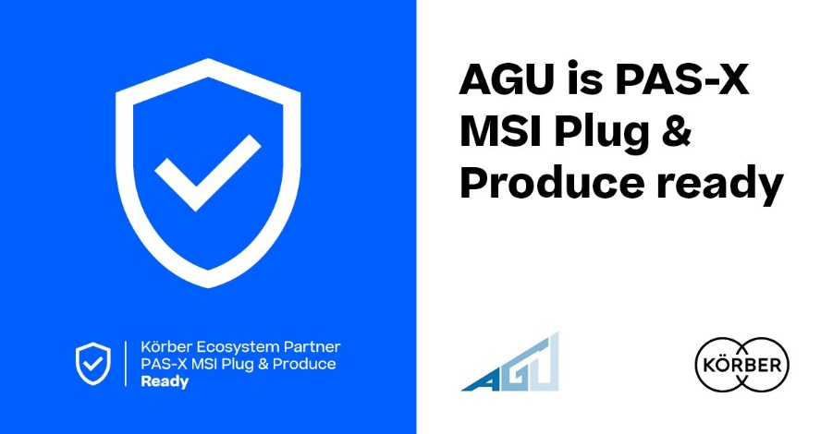

AGU receives the “PAS-X MSI Plug & Produce Ready" certification from Körber

Lars Hornung, Senior Principal Alliances & Technology Partners Software, Körber Business Area Pharma

Klaus Bruch is CTO and Co-Founder of AGU GmbH. As head of the IT department, he has been responsible for product development as well as the strategic orientation of the Sm@rtLine Data Cockpit for many years.

About AGU
AGU was founded in 1992 and is based in Leverkusen (Germany). Our software solutions are marketed worldwide, and we develop our products exclusively "Made in Germany". Today, AGU employs more than 90 people in the areas of industrial IT and process automation. Both areas especially complement each other which led to the development of SDC the Sm@rtLine Data Cockpit®️, which is used today by the 25 largest pharmaceutical companies in the world.
www.agu.de/de/SDC

Contact
Klaus Bruch
CTO and Co-Founder
Mobil: +49 (0) 151 151487 13
E-mail: klaus.bruch@agu.de

About Körber
Körber is an international technology group with about 12,000 employees, more than 100 locations worldwide and a common goal: We turn entrepreneurial thinking into customer success and shape the technological change. In the Business Areas Digital, Pharma, Supply Chain, Tissue and Technologies, we offer products, solutions and services that inspire.
At the Körber Business Area Pharma we are delivering the difference along the pharma value chain with our unique portfolio of integrated solutions. With our software solutions we help drug manufacturers to digitize their pharmaceutical, biotech and cell & gene therapy production. The Werum PAS-X MES Suite is recognized as the world’s leading Manufacturing Execution System for pharma, biotech and cell & gene. Our Werum PAS-X Intelligence Suite accelerates product commercialization with data analytics and AI solutions and uncovers hidden business value.
www.koerber-pharma.com

Contact
Dirk Ebbecke
Körber Business Area Pharma
Head of Product Marketing
T: +49 4131 8900-0
E-mail: dirk.ebbecke@koerber.com

