Körber enables seamless integration of Werum PAS-X MES with filling and packaging systems from Bausch+Ströbel for pharmaceutical and biopharmaceutical production
柯尔柏无缝集成维隆PAS-X MES与Bausch+Ströbel的灌装和包装系统，用于制药和生物制药生产

Lüneburg, Germany / Ilshofen, Germany, 29 September 2023. International technology group Körber awards the "PAS-X MSI Plug & Produce Certified" partnership certificate to machine manufacturer Bausch+Ströbel.
德国吕讷堡/德国伊尔绍芬，2023年9月29日。国际技术集团柯尔柏授予机器制造商Bausch+Ströbel“PAS-X MSI即插即用认证”级别的合作伙伴证书。

The partnership between these two renowned companies enables customers to seamlessly integrate Bausch+Ströbel's filling and packaging systems with PAS-X MES, Körber's leading Manufacturing Execution System (MES). This significantly reduces manual configuration efforts for customers in the pharmaceutical, biotech, or cell and gene therapy industries, as the machines can be easily connected to PAS-X MES with just a few clicks.
这两家知名公司的合作，使客户能够无缝集成Bausch+Ströbel的灌装和包装系统与柯尔柏的生产执行系统PAS-X MES。这大大减少了制药、生物技术或细胞和基因治疗行业客户的手动配置的工作量，因为只需点击几下，机器就可以轻松连接到PAS-X MES系统。

Körber's innovative "PAS-X MSI Plug & Produce" interface facilitates a smooth and efficient integration of both systems. The no-code integration is based on standardized message-based communication, as described in the concept paper of the ISPE Plug & Produce Working Group.
柯尔柏创新的“PAS-X MSI即插即用”接口有助于两个系统的平稳高效集成。如ISPE即插即用工作组的概念文件所述，无代码集成是在标准化的基于消息通信（message-based）的基础上实现的。

Lars Hornung, Senior Principal Alliances & Technology Partners Software in Körber's Business Area Pharma, expresses delight about the new addition to Körber's Ecosystem Partner Program: "The successful collaboration with Bausch+Ströbel in recent years confirms the acceptance and added value of the PAS-X MSI Plug & Produce interface in pharmaceutical and biopharmaceutical production. We are pleased to welcome Bausch+Ströbel as an MSI partner in our new partner program."
柯尔柏医药的软件主要联盟与技术合作伙伴高级负责人Lars Hornung对柯尔柏生态系统合作伙伴计划吸纳新成员表示高兴，他说：“近年来与Bausch+Ströbel的成功合作，证明了PAS-X MSI即插即用接口在制药和生物制药生产中的高接受度和高附加值。我们热烈欢迎Bausch+Ströbel作为MSI合作伙伴，加入我们全新的合作伙伴计划。”

Andreas Bühler, Head of Automation Project Design at Bausch+Ströbel, adds: "The 'PAS-X MSI Plug & Produce Certified' partnership certificate is the result of our longstanding and open collaboration in many projects. I look forward to our partnership, which provides our mutual customers with the assurance of an efficient and secure integration. With the standardized and verified PAS-X MSI Plug & Produce interface, the cumbersome coordination of handshake signals is eliminated, and allows to immediately focus on the essential order and reconciliation data.”
Bausch+Ströbel自动化项目设计负责人Andreas Bühler补充道：“‘PAS-X MSI 即插即用认证’合作伙伴证书是我们在许多项目中长期开放的合作成果。我期待着我们的合作伙伴关系能为我们的共同客户提供了高效和安全集成的保证。有了标准化和经过验证的PAS-X MSI即插即用接口，无需再进行繁琐的握手信号协调工作，可立即专注于重要的订单和数据的核对。”

Pictures
图片

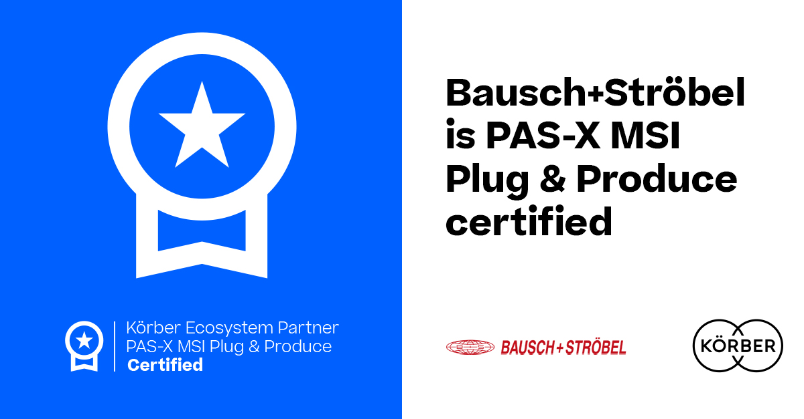
Bausch+Ströbel receives the "PAS-X MSI Plug & Produce Certified" certification from Körber
Bausch+Ströbel获得柯尔柏“PAS-X MSI 即插即用认证”级别证书

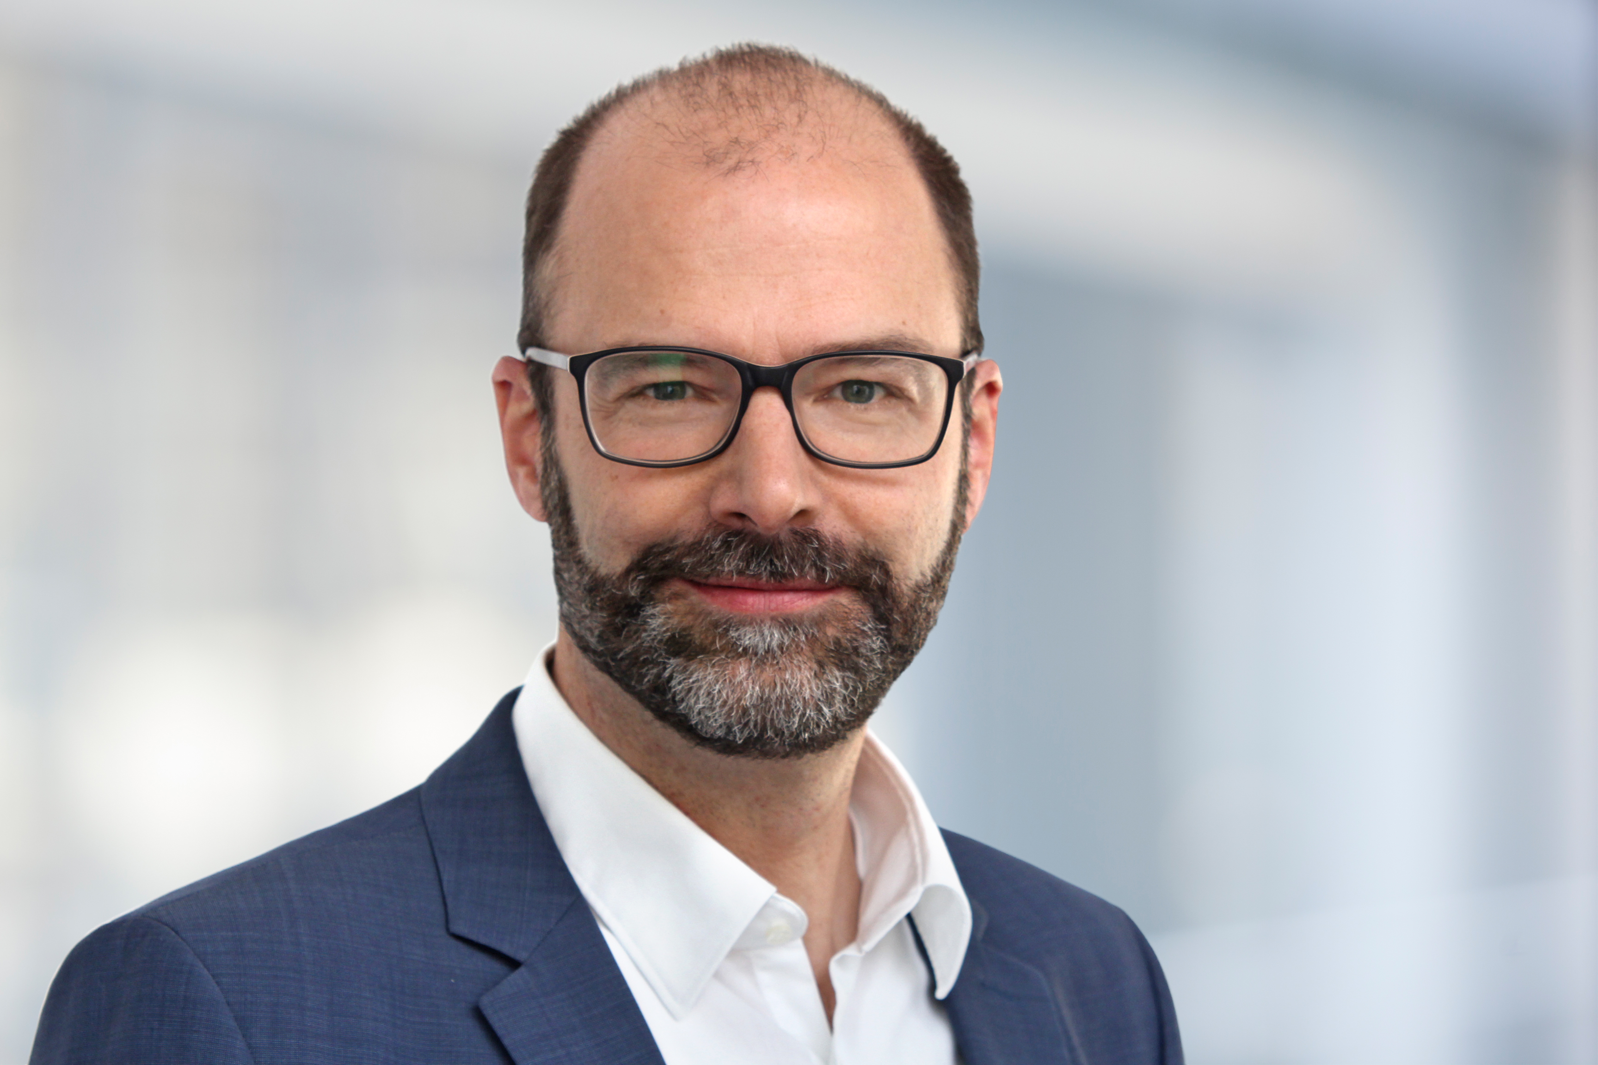
Lars Hornung, Senior Principal Alliances & Technology Partners Software, Körber Business Area Pharma
柯尔柏医药的软件主要联盟与技术合作伙伴高级负责人Lars Hornung
Andreas Bühler, Head of Automation Project Design, Bausch+Ströbel SE + Co. KG
Bausch+Ströbel自动化项目设计负责人Andreas Bühler
About Bausch+Ströbel
关于Bausch+Ströbel

Bausch+Ströbel's filling and packaging systems worldwide handle high-quality liquid and powder pharmaceuticals in syringes, vials, cartridges, or ampoules. This includes tasks from cleaning and sterilizing objects to labeling and syringe assembly. In addition to designing and building customized systems to meet customer needs, Bausch+Ströbel offers a wide range of services.

Bausch+Ströbel的灌装和包装系统在全球范围内高质量地处理注射器、西林瓶、卡式瓶或安瓿瓶中的液体和粉末药物。应用范围包括从清洁和灭菌到贴标和注射器组装等。除了设计和构建满足客户需求的定制系统外，Bausch+Ströbel还提供广泛的服务。

Bausch+Ströbel's technologies and services play a crucial role in ensuring the safe, reliable, and affordable availability of essential and life-saving medicines and vaccines worldwide. As a family-owned company with over 2,300 employees worldwide, Bausch+Ströbel has represented continuity, stability, and safety since 1967.
Bausch+Ströbel的技术和服务在确保安全、可靠和经济实惠地向全球提供基本救生药物和疫苗方面发挥着至关重要的作用。作为一家在全球拥有2300多名员工的家族企业，Bausch+Ströbel自1967年以来一直代表着连续性、稳定性和安全性。

www.bausch-stroebel.com/

Contact
Tanja Bullinger
Bausch+Ströbel
Head of Corporate Communications
T: 49 7904 701-3447
E-mail: tanja.bullinger@bausch-stroebel.de

联系我们
Tanja Bullinger
Bausch+Ströbel
企业传播负责人
T: 49 7904 701-3447
E-mail: tanja.bullinger@bausch-stroebel.de

About Körber
关于柯尔柏

We are Körber – an international technology group with about 13,000 employees at more than 100 locations worldwide and a common goal: We turn entrepreneurial thinking into customer success and shape the technological change. In the Business Areas Digital, Pharma, Supply Chain, Technologies and Tissue, we offer products, solutions and services that inspire. We act fast to customer needs, we execute ideas seamlessly, and with our innovations we create added value for our customers. In doing so, we are increasingly building on ecosystems that solve the challenges of today and tomorrow. Körber AG is the holding company of the Körber Group.
柯尔柏是一家国际技术集团，拥有约13,000名员工，在世界各地有100多个分支机构。所有人都有一个共同的目标：我们将企业家精神转化为客户成功，并塑造技术变革。在数字化、医药科技、供应链、纸业科技和工程技术等业务领域，我们提供激发灵感的产品、解决方案和服务。

At the Körber Business Area Pharma we are delivering the difference along the pharma value chain with our unique portfolio of integrated solutions. With our software solutions we help drug manufacturers to digitize their pharmaceutical, biotech and cell & gene therapy production. The Werum PAS-X MES Suite is recognized as the world’s leading Manufacturing Execution System for pharma, biotech and cell & gene. Our Werum PAS-X Savvy Suite accelerates product commercialization with data analytics and AI solutions and uncovers hidden business value.
在柯尔柏医药科技业务领域，我们通过提供先进的综合制药解决方案，在整个制药价值链中实现差异化。我们的软件解决方案支持医药企业实现制药、生物技术、细胞和基因治疗生产流程的数字化。维隆PAS-X MES套件是公认的一款适用于制药、生物技术和细胞与基因领域的生产执行系统。我们的维隆PAS-X智能套件通过数据分析和人工智能解决方案加速产品商业化，并发现隐藏的商业价值。

www.koerber-pharma.com

Contact
Dirk Ebbecke
Körber Business Area Pharma
Head of Product Marketing
T: +49 4131 8900-0
E-mail: dirk.ebbecke@koerber.com

联系我们
Dirk Ebbecke
柯尔柏医药科技
产品市场总监
T: +49 4131 8900-0
E-mail: dirk.ebbecke@koerber.com

