Körber enables seamless integration of Werum PAS-X MES with filling and packaging systems from Bausch+Ströbel for pharmaceutical and biopharmaceutical production

Lüneburg, Germany / Ilshofen, Germany, 29 September 2023. International technology group Körber awards the "PAS-X MSI Plug & Produce Certified" partnership certificate to machine manufacturer Bausch+Ströbel.

The partnership between these two renowned companies enables customers to seamlessly integrate Bausch+Ströbel's filling and packaging systems with PAS-X MES, Körber's leading Manufacturing Execution System (MES). This significantly reduces manual configuration efforts for customers in the pharmaceutical, biotech, or cell and gene therapy industries, as the machines can be easily connected to PAS-X MES with just a few clicks.

Körber's innovative "PAS-X MSI Plug & Produce" interface facilitates a smooth and efficient integration of both systems. The no-code integration is based on standardized message-based communication, as described in the concept paper of the ISPE Plug & Produce Working Group.

Lars Hornung, Senior Principal Alliances & Technology Partners Software in Körber's Business Area Pharma, expresses delight about the new addition to Körber's Ecosystem Partner Program: "The successful collaboration with Bausch+Ströbel in recent years confirms the acceptance and added value of the PAS-X MSI Plug & Produce interface in pharmaceutical and biopharmaceutical production. We are pleased to welcome Bausch+Ströbel as an MSI partner in our new partner program."

Andreas Bühler, Head of Automation Project Design at Bausch+Ströbel, adds: "The 'PAS-X MSI Plug & Produce Certified' partnership certificate is the result of our longstanding and open collaboration in many projects. I look forward to our partnership, which provides our mutual customers with the assurance of an efficient and secure integration. With the standardized and verified PAS-X MSI Plug & Produce interface, the cumbersome coordination of handshake signals is eliminated, and allows to immediately focus on the essential order and reconciliation data.”

Pictures

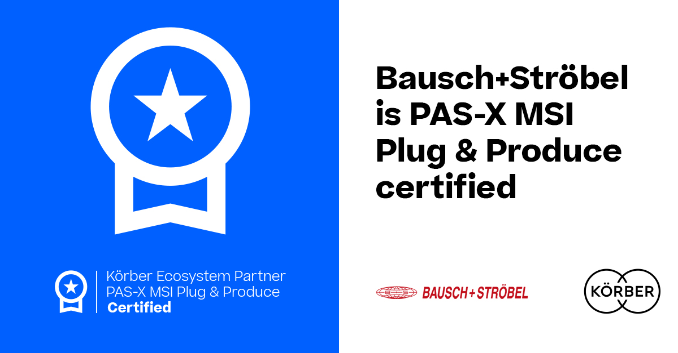
Bausch+Ströbel receives the "PAS-X MSI Plug & Produce Certified" certification from Körber

Lars Hornung, Senior Principal Alliances & Technology Partners Software, Körber Business Area Pharma

Andreas Bühler, Head of Automation Project Design, Bausch+Ströbel SE + Co. KG
About Bausch+Ströbel

Bausch+Ströbel's filling and packaging systems worldwide handle high-quality liquid and powder pharmaceuticals in syringes, vials, cartridges, or ampoules. This includes tasks from cleaning and sterilizing objects to labeling and syringe assembly. In addition to designing and building customized systems to meet customer needs, Bausch+Ströbel offers a wide range of services.

Bausch+Ströbel's technologies and services play a crucial role in ensuring the safe, reliable, and affordable availability of essential and life-saving medicines and vaccines worldwide. As a family-owned company with over 2,300 employees worldwide, Bausch+Ströbel has represented continuity, stability, and safety since 1967.

www.bausch-stroebel.com/

Contact
Tanja Bullinger
Bausch+Ströbel
Head of Corporate Communications
T: 49 7904 701-3447
E-mail: tanja.bullinger@bausch-stroebel.de

About Körber

We are Körber – an international technology group with about 13,000 employees at more than 100 locations worldwide and a common goal: We turn entrepreneurial thinking into customer success and shape the technological change. In the Business Areas Digital, Pharma, Supply Chain, Technologies and Tissue, we offer products, solutions and services that inspire. We act fast to customer needs, we execute ideas seamlessly, and with our innovations we create added value for our customers. In doing so, we are increasingly building on ecosystems that solve the challenges of today and tomorrow. Körber AG is the holding company of the Körber Group.

At the Körber Business Area Pharma we are delivering the difference along the pharma value chain with our unique portfolio of integrated solutions. With our software solutions we help drug manufacturers to digitize their pharmaceutical, biotech and cell & gene therapy production. The Werum PAS-X MES Suite is recognized as the world’s leading Manufacturing Execution System for pharma, biotech and cell & gene. Our Werum PAS-X Savvy Suite accelerates product commercialization with data analytics and AI solutions and uncovers hidden business value.

www.koerber-pharma.com

Contact
Dirk Ebbecke
Körber Business Area Pharma
Head of Product Marketing
T: +49 4131 8900-0
E-mail: dirk.ebbecke@koerber.com

