Körber and COPA-DATA partner to enhance MES integration for filling lines in the pharmaceutical industry

Lüneburg, Germany / Salzburg, Austria, 30 May 2023. COPA-DATA joins the Körber Ecosystem Partner program and receives the "PAS-X MSI Plug & Produce Ready" certification for its zenon software platform.

zenon is a software platform that helps pharmaceutical manufacturers automate their manufacturing facilities and manage data more effectively. COPA-DATA has developed strong functionality as well as comprehensive connectivity that makes it easy to integrate shop floor machines into higher systems, such as a Manufacturing Execution System (MES) - for greater efficiency, better control and comprehensive documentation of manufacturing processes.

The Werum PAS-X MES Suite from Körber controls, monitors and documents manufacturing processes digitally and in real time. With just a few mouse clicks, customers can seamlessly integrate Körber's best-of-breed ecosystem solutions from partner companies with PAS-X MSI Plug & Produce. This no-code integration uses standardized message-based communication between MES and shop floor equipment as outlined in the ISPE Plug & Produce Working Group's Concept Paper. The partnership between Körber and COPA-DATA makes it possible to implement out-of-the-box projects with zenon as a configurable interface to PAS-X MES.

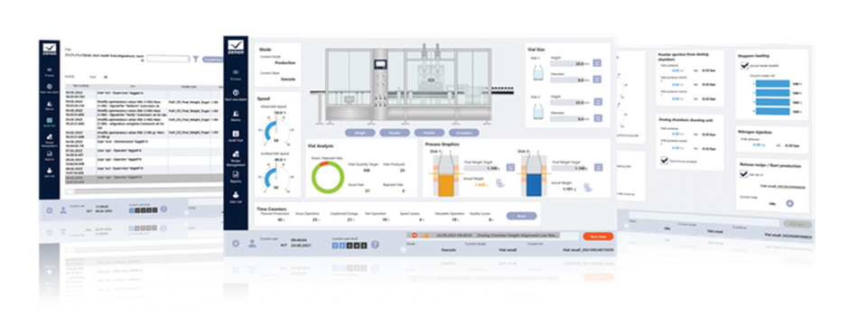

zenon as a Line Execution System with integrated PAS-X MSI interface

"COPA-DATA's zenon software platform is a strong solution for the pharmaceutical industry particularly regarding the integration of filling lines into MES. In addition, the COPA-DATA team has already built up the required skill set for both, technology and business processes. We are pleased to have them join the PAS-X MSI Plug & Produce partner program," says Lars Hornung, Senior Principal Alliances & Technology Partners Software, Körber Business Area Pharma.

"With Körber we are cooperating for several years as a member of the ISPE Pharma 4.0 working group, addressing digitalization challenges in life sciences manufacturing. We are very pleased to be part of the Körber Ecosystem Partner program and happy to provide a comprehensive solution for pharmaceutical companies with our PAS-X MSI interface in zenon," says Giuseppe Menin, Life Sciences & Process Industry Manager at COPA-DATA.

More about the zenon Werum PAS-X MSI Interface can be found here.

Pictures

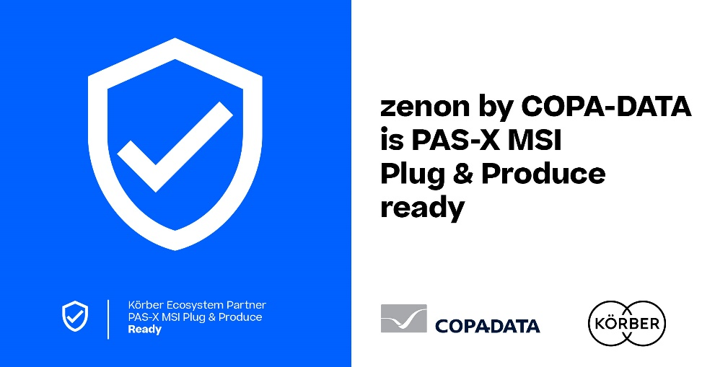

COPA-DATA joins the Körber Ecosystem Partner program as a "PAS-X MSI Plug & Produce" partner

Lars Hornung, Senior Principal Alliances & Technology Partners Software, Körber Business Area Pharma

Giuseppe Menin, Life Sciences & Process Industry Manager, COPA-DATA

About COPA-DATA
COPA-DATA is an independent software manufacturer that specializes in digitalization for the manufacturing industry and energy sector. Its zenon® software platform enables users worldwide to automate, manage, monitor, integrate and optimize machines, equipment, buildings and power grids. COPA-DATA combines decades of experience in automation with the potential of digital transformation. In this way, the company supports its customers to achieve their objectives more easily, faster and more efficiently. The family-owned business was founded by Thomas Punzenberger in 1987 in Salzburg, Austria. In 2022, with more than 350 employees worldwide, it generated revenue of EUR 69 million. A sales network of international distributors and 14 subsidiaries ensures that the software is marketed worldwide. More than 400 certified partner companies further support end users with the efficient implementation of the software, particularly in the key industries of food & beverage, energy & infrastructure, automotive and pharmaceutical.
https://www.copadata.com/en/

Contact
Sebastian Bäsken
COPA-DATA Headquarters
Marketing Communications Manager
T: +43 662 431002-345
E-mail: sebastian.baesken@copadata.com

About Körber
Körber is an international technology group with about 13,000 employees, more than 100 locations worldwide and a common goal: We turn entrepreneurial thinking into customer success and shape the technological change. In the Business Areas Digital, Pharma, Supply Chain, Tissue and Technologies, we offer products, solutions and services that inspire.
At the Körber Business Area Pharma we are delivering the difference along the pharma value chain with our unique portfolio of integrated solutions. With our software solutions we help drug manufacturers to digitize their pharmaceutical, biotech and cell & gene therapy production. The Werum PAS-X MES Suite is recognized as the world’s leading Manufacturing Execution System for pharma, biotech and cell & gene. Our Werum PAS-X Savvy Suite accelerates product commercialization with data analytics and AI solutions and uncovers hidden business value.
www.koerber-pharma.com

Contact
Dirk Ebbecke
Körber Business Area Pharma
Head of Product Marketing
T: +49 4131 8900-0
E-mail: dirk.ebbecke@koerber.com

