Körber and Endeavor announce partnership to enable seamless integration of Werum PAS-X MES and SAP's ERP Platform
柯尔柏和Endeavor宣布建立合作伙伴关系，实现维隆 PAS-X MES和SAP ERP平台的无缝集成

Lüneburg, Germany/ Wayne, Pennsylvania, United States, 15 September 2023. Endeavor Consulting Group receives the “PAS-X ERP Integration Ready” partnership certificate for its iMES solution and becomes an important partner in the Körber Ecosystem Partner program.
德国吕讷堡/美国宾夕法尼亚州韦恩，2023年9月15日。Endeavor咨询集团凭借其iMES解决方案获得“PAS-X ERP集成”就绪级别的合作伙伴证书，并成为柯尔柏制药生态系统合作伙伴计划的重要合作伙伴。

Pharma and biopharma companies can greatly benefit from integrating their Enterprise Resource Planning (ERP) system with a Manufacturing Execution System (MES) solution like Körber’s Werum PAS-X MES. While ERP systems primarily focus on managing various aspects of an organization's operations, such as finance, human resources, or supply chain, MES solutions step in to address the specific needs of the production. Integrating ERP and MES systems has a highly positive impact on life science manufacturing companies who can establish a seamless connection between the shop floor and the rest of the organization. With this integration companies can optimize forecasting and inventory management, effectively avoid production delays, and increase productivity in production.
制药和生物制药企业将从企业资源规划（ERP）系统与生产执行系统（MES）解决方案（如柯尔柏维隆PAS-X MES）的集成中获益匪浅。ERP系统主要专注于管理组织运营的各个方面，如财务、人力资源或供应链，但MES解决方案旨在解决生产的具体需求。集成ERP和MES系统对生命科学行业的生产商有非常积极的影响，这些企业可以无缝连接车间和组织内的其他部门。通过这种集成，企业可以优化预测和库存管理，有效避免生产延迟，提高生产率。

In the past, Endeavor Consulting Group and Körber have collaborated multiple times to provide an out-of-the-box solution for clients with specific needs for integrating PAS-X MES with their existing SAP ERP software system. The PAS-X MES Suite digitally controls, monitors, and documents the manufacturing process in real-time. Endeavor’s solution “iMES” is a set of pre-packaged, SAP-configurable integration applications combined with an event monitoring system, designed to simplify changes to the SAP system should they be required. iMES follows the same design principles as SAP's standard software, offering configurability, flexibility, and ease of maintenance. It has been thoroughly tested for compatibility with recent SAP version upgrades, including SAP S/4 HANA.
过去，Endeavor咨询集团和柯尔柏多次合作，为有特殊需求的客户提供开箱即用的解决方案，将PAS-X MES与其现有SAP ERP软件系统集成。PAS-X MES套件实时进行数字化的控制、监控和记录生产过程。Endeavor的解决方案“iMES”是一套预打包的SAP可配置集成应用程序，结合事件监控系统，旨在简化对SAP系统的更改（如需）。iMES遵循与SAP标准软件相同的设计原则，具有可配置性、灵活性，且易于维护。经全面测试，可与SAP S/4 HANA等SAP的最新版本升级兼容。

"We are pleased to recognize Endeavor for achieving the 'Ready' level certificate with their integration tool, iMES. This accomplishment highlights their expertise and commitment to delivering high-quality solutions. As a partner, we are excited to collaborate and offer clients enhanced capabilities, seamless integration, and optimized operational efficiency between PAS-X MES and SAP's S/4HANA ERP software system," says Lars Hornung, Senior Principal Alliances & Technology Partners Software, Körber Business Area Pharma.
柯尔柏医药科技业务领域的软件主要联盟和技术合作伙伴高级负责人Lars Hornung表示：“我们很高兴认可Endeavor的集成工具iMES获得‘就绪’级别证书。这一成就凸显了Endeavor的专业性和始终提供高质量解决方案的承诺。作为合作伙伴，我们很高兴与他们合作，为客户提供PAS-X MES和SAP的S/4HANA ERP软件系统之间的增加性能、无缝集成和优化的运营效率。”

“iMES is a result of extensive experience and global design requirements, incorporating best practices. It can accelerate implementations, reduce risk and total cost of ownership. As a proud member of Körber's Ecosystem partner program, we are excited to bring our expertise and innovative capabilities to empower businesses i their digital transformation journey,” says Chris Chambers, Managing Partner, Endeavour Consulting Group.
Endeavour咨询集团管理合伙人Chris Chambers表示：“ iMES是积累了丰富经验和全球设计要求的成果，融合了‘最佳实践（Best practices）’。iMES可以加快实施，降低风险和总体拥有成本。Endeavour为自己成为柯尔柏制药生态系统合作伙伴计划的一员而感到自豪，我们很高兴将我们的专业知识和创新能力带入制药企业的数字化转型之旅中。”

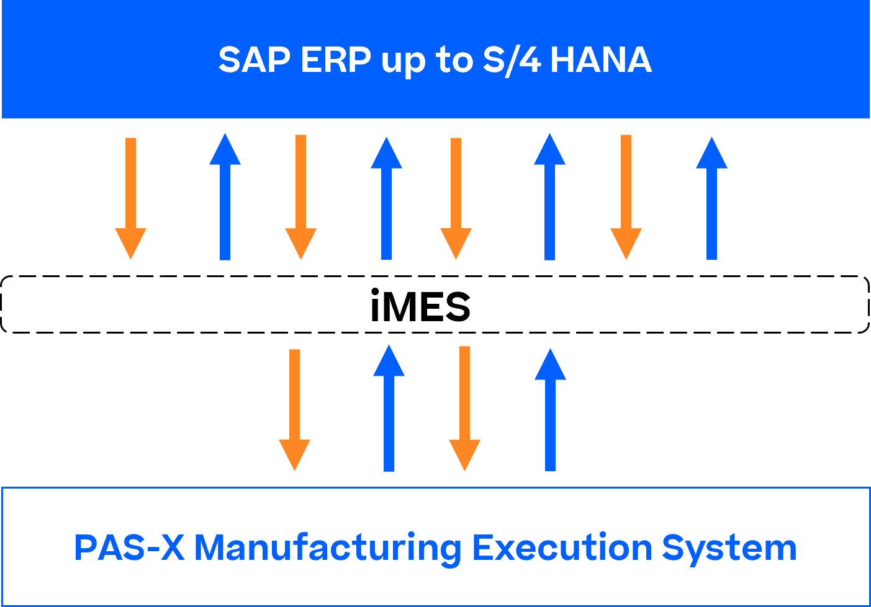

Picture

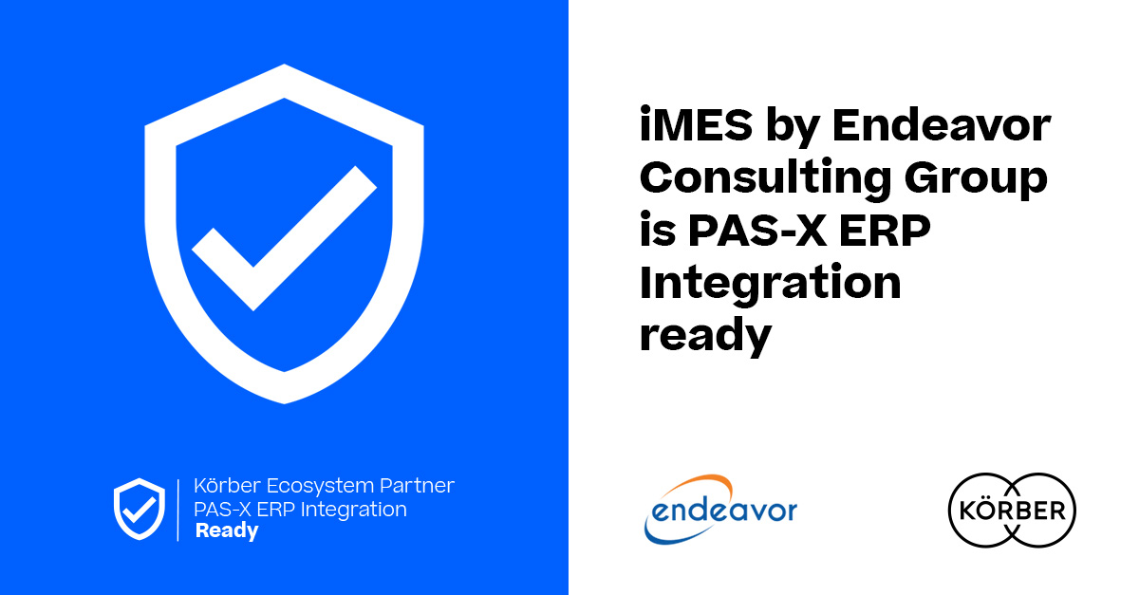

Lars Hornung, Senior Principal Alliances & Technology Partners Software, Körber Business Area Pharma
Lars Hornung，柯尔柏医药科技业务领域的软件主要联盟和技术合作伙伴高级负责人

Chris Chambers, Managing Partner, President, Endeavor Consulting Group
Chris Chambers，Endeavor咨询集团管理合伙人兼总裁

About Endeavor
Endeavor Consulting Group is a leader in life science supply chain and SAP consulting services. Endeavor has a combined 110 years of experience in all areas of life sciences operations including ERP, GxP processes, manufacturing and quality management, shop floor integration, digital industry 4.0 solutions, supply chain, product launch, commercialization, quality assurance, e-commerce, packaging, tech transfer, regulatory, PMO, strategy, rapid response, external manufacturing, and more.
www.endeavorcg.com

关于Endeavor
Endeavor咨询集团提供生命科学供应链和SAP咨询服务。Endeavor在生命科学运营的众多板块拥有110年的经验，包括ERP、GxP流程、生产和质量管理、车间集成、数字工业4.0解决方案、供应链、产品上市、产品商业化、质量保证、电子商务、包装、技术转移、监管、PMO、战略、快速响应、外部生产等。
www.endeavorcg.com

About Körber
Körber is an international technology group with about 13,000 employees, more than 100 locations worldwide and a common goal: We turn entrepreneurial thinking into customer success and shape the technological change. In the Business Areas Digital, Pharma, Supply Chain, Technologies, and Tissue we offer products, solutions and services that inspire.
At the Körber Business Area Pharma we are delivering the difference along the pharma value chain with our unique portfolio of integrated solutions. With our software solutions we help drug manufacturers to digitize their pharmaceutical, biotech and cell & gene therapy production. The Werum PAS-X MES Suite is recognized as the world’s leading Manufacturing Execution System for pharma, biotech and cell & gene. Our Werum PAS-X Savvy Suite accelerates product commercialization with data analytics and AI solutions and uncovers hidden business value.
http://www.koerber-pharma.com

关于柯尔柏
柯尔柏是一家国际技术集团，拥有约13,000名员工，在世界各地有100多个分支机构。所有人都有一个共同的目标：我们将企业家精神转化为客户成功，并塑造技术变革。在数字化、医药科技、供应链、纸业科技和工程技术等业务领域，我们提供激发灵感的产品、解决方案和服务。
在柯尔柏医药科技业务领域，我们通过提供先进的综合制药解决方案，在整个制药价值链中实现差异化。我们的软件解决方案支持医药企业实现制药、生物技术、细胞和基因治疗生产流程的数字化。维隆PAS-X MES套件是公认的一款适用于制药、生物技术和细胞与基因领域的生产执行系统。我们的维隆PAS-X智能套件通过数据分析和人工智能解决方案加速产品商业化，并发现隐藏的商业价值。
http://www.koerber-pharma.com

Contact
Dirk Ebbecke
Körber Business Area Pharma
Head of Product Marketing
T: +49 4131 8900-0
E-mail: dirk.ebbecke@koerber.com

联系我们
Dirk Ebbecke
柯尔柏医药科技
产品市场总监
+49 4131 89000
dirk.ebbecke@koerber.com

