Körber and Endeavor announce partnership to enable seamless integration of Werum PAS-X MES and SAP's ERP Platform

Lüneburg, Germany/ Wayne, Pennsylvania, United States, 15 September 2023. Endeavor Consulting Group receives the “PAS-X ERP Integration Ready” partnership certificate for its iMES solution and becomes an important partner in the Körber Ecosystem Partner program.

Pharma and biopharma companies can greatly benefit from integrating their Enterprise Resource Planning (ERP) system with a Manufacturing Execution System (MES) solution like Körber’s Werum PAS-X MES. While ERP systems primarily focus on managing various aspects of an organization's operations, such as finance, human resources, or supply chain, MES solutions step in to address the specific needs of the production. Integrating ERP and MES systems has a highly positive impact on life science manufacturing companies who can establish a seamless connection between the shop floor and the rest of the organization. With this integration companies can optimize forecasting and inventory management, effectively avoid production delays, and increase productivity in production.

In the past, Endeavor Consulting Group and Körber have collaborated multiple times to provide an out-of-the-box solution for clients with specific needs for integrating PAS-X MES with their existing SAP ERP software system. The PAS-X MES Suite digitally controls, monitors, and documents the manufacturing process in real-time. Endeavor’s solution “iMES” is a set of pre-packaged, SAP-configurable integration applications combined with an event monitoring system, designed to simplify changes to the SAP system should they be required. iMES follows the same design principles as SAP's standard software, offering configurability, flexibility, and ease of maintenance. It has been thoroughly tested for compatibility with recent SAP version upgrades, including SAP S/4 HANA.

"We are pleased to recognize Endeavor for achieving the 'Ready' level certificate with their integration tool, iMES. This accomplishment highlights their expertise and commitment to delivering high-quality solutions. As a partner, we are excited to collaborate and offer clients enhanced capabilities, seamless integration, and optimized operational efficiency between PAS-X MES and SAP's S/4HANA ERP software system," says Lars Hornung, Senior Principal Alliances & Technology Partners Software, Körber Business Area Pharma.

“iMES is a result of extensive experience and global design requirements, incorporating best practices. It can accelerate implementations, reduce risk and total cost of ownership. As a proud member of Körber's Ecosystem partner program, we are excited to bring our expertise and innovative capabilities to empower businesses in their digital transformation journey,” says Chris Chambers, Managing Partner, Endeavour Consulting Group.

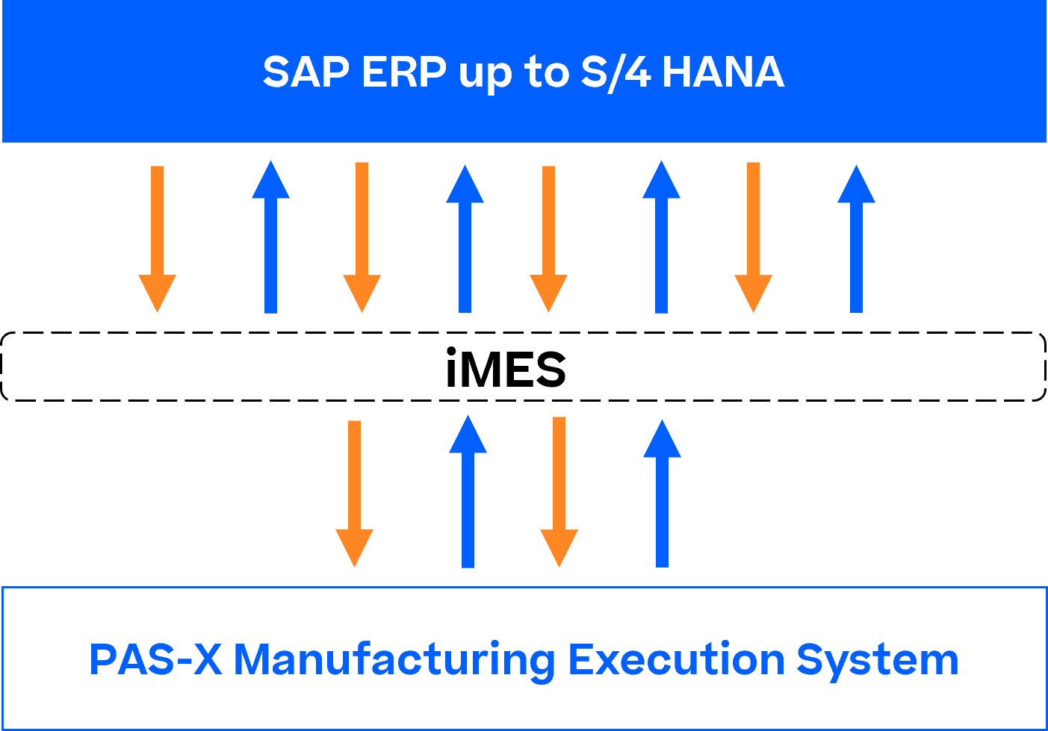

Picture

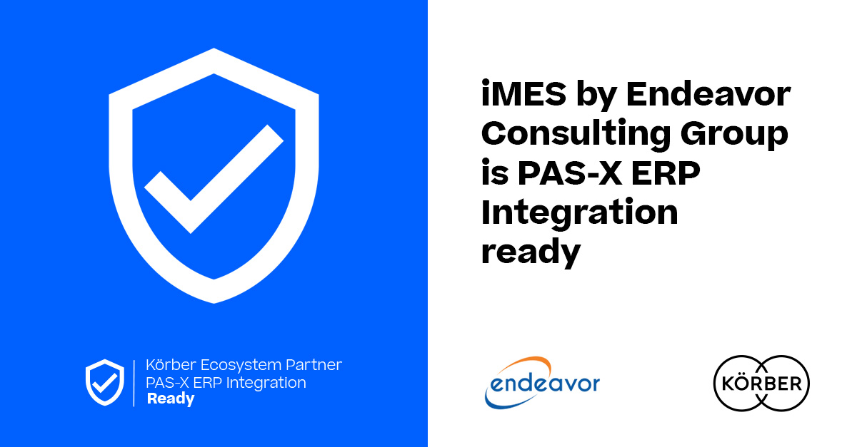

Lars Hornung, Senior Principal Alliances & Technology Partners Software, Körber Business Area Pharma

Chris Chambers, Managing Partner, President, Endeavor Consulting Group

About Endeavor
Endeavor Consulting Group is a leader in life science supply chain and SAP consulting services. Endeavor has a combined 110 years of experience in all areas of life sciences operations including ERP, GxP processes, manufacturing and quality management, shop floor integration, digital industry 4.0 solutions, supply chain, product launch, commercialization, quality assurance, e-commerce, packaging, tech transfer, regulatory, PMO, strategy, rapid response, external manufacturing, and more.
www.endeavorcg.com

About Körber
Körber is an international technology group with about 13,000 employees, more than 100 locations worldwide and a common goal: We turn entrepreneurial thinking into customer success and shape the technological change. In the Business Areas Digital, Pharma, Supply Chain, Technologies, and Tissue we offer products, solutions and services that inspire.
At the Körber Business Area Pharma we are delivering the difference along the pharma value chain with our unique portfolio of integrated solutions. With our software solutions we help drug manufacturers to digitize their pharmaceutical, biotech and cell & gene therapy production. The Werum PAS-X MES Suite is recognized as the world’s leading Manufacturing Execution System for pharma, biotech and cell & gene. Our Werum PAS-X Savvy Suite accelerates product commercialization with data analytics and AI solutions and uncovers hidden business value.
http://www.koerber-pharma.com

Contact
Dirk Ebbecke
Körber Business Area Pharma
Head of Product Marketing
T: +49 4131 8900-0
E-mail: dirk.ebbecke@koerber.com

