Körber launches new biometric authentication partner program to accelerate identification times in pharmaceutical manufacturing
柯尔柏启动了新的“生物识别认证”合作伙伴计划，缩短制药生产中的身份识别时间

Lüneburg, Germany, 30 June 2023. The newly launched PAS-X K.ME-IN partner program provides Werum PAS-X MES customers with an out-of-the-box interface for the use of biometric authentication technology. Together with partners this enables 50 percent faster identification times while ensuring only authorized personnel can access the Manufacturing Execution System (MES). With Integral Biometrics and obion (formerly i.p.a.s.-systeme), two strong partners have already joined the program.
德国吕讷堡，2023年6月30日。柯尔柏新推出的PAS-X K.ME-IN合作项目为维隆PAS-X MES的客户提供了生物识别认证技术的开箱即用接口，这一合作将使识别速度提高50%，同时确保只有经过授权的人员才能访问生产执行系统(MES)。两个强有力的合作伙伴——Integral Biometrics和obion(前身为i.p.a.s.-systeme)已经加入了这一合作项目。

Körber’s Werum PAS-X MES Suite digitally controls, monitors, and documents the manufacturing process in real-time. The PAS-X K.ME-IN solution supports unique biometric authentication such as iris scan, face recognition, fingerprint or a combination of those before granting access to users. This eliminates the cumbersome process of entering usernames, passwords or PIN codes. As a result, the time needed to log in to PAS-X MES is significantly reduced, and providing electronic signatures becomes a lot easier.
柯尔柏维隆PAS-X MES套件以数字化的方式实现实时控制、监测和记录生产过程。PAS-X K.ME-IN解决方案通过识别客户独特的生物特征，如虹膜、面部、指纹或这些特征的组合，然后再授予用户访问权。这消除了输入用户名、密码或PIN码的繁琐过程。因此，登录PAS-X MES所需的时间大大减少，提供电子签名也变得容易得多。

“Werum PAS-X K.ME-IN offers a convenient, user-friendly, and tamper-proof solution for an efficient system interaction in the life sciences production environment,” says Lars Hornung, Senior Principal Alliances & Technology Partners Software, Körber Business Area Pharma.
“维隆 PAS-X K.ME-IN为生命科学生产环境中的高效的系统互动，提供了一个方便的、用户友好的和防篡改的解决方案。”柯尔柏医药科技业务领域的软件主要联盟和技术合作伙伴高级负责人Lars Hornung说。

“Integral Biometrics and obion are two strong partners that recently received the ‘Ready’ level of our PAS-X K.ME-IN partner certification program. Our collaborative efforts are focused on providing our customers with innovative authentication solutions for the future of pharmaceutical production. These cutting-edge technologies not only enhance compliance and data security but also ensure a user-friendly experience,” adds Hornung.
“Integral Biometrics和obion是柯尔柏两个强大的合作伙伴，他们最近获得了‘就绪’级别的PAS-X K.ME-IN合作伙伴认证。我们的合作重点是为我们的客户提供创新的身份认证解决方案，以适应未来的制药生产过程。这些尖端技术不仅提高了合规性和数据安全性，而且还确保了用户友好的体验。”Hornung补充说。

Integral Biometrics provides two options that customers can use to log into Werum PAS-X MES: the At-a-Glance™ and At-a-Touch™ login methods can authenticate users at any workstation via cost-effective iris sensors within two seconds or via fingerprint recognition systems, respectively. With that solution customers work password free, touch free, fast and friction free.
Integral Biometrics提供了两种登录维隆 PAS-X MES的方法：通过At-a-Glance™和At-a-Touch™可以分别在两秒内通过经济的虹膜传感器或通过指纹识别系统对任何工作站的用户进行身份认证。基于这一解决方案，客户在工作中就可以免去输入密码的过程，无需触摸，快速且不产生摩擦。

“In life, our eyes can be our keys to trust. With Integral’s iris biometrics and authentication automation platform, we offer a natural interaction with manufacturing systems eliminating passwords and simplifying work. This is no longer the stuff of science fiction; our goggled, gowned, and gloved customers are now benefitting from using this accessible technology through PAS-X K.ME-IN,” says Marc Diament, CEO, Integral Biometrics.
“在生活中，我们的眼睛可以成为我们信任的钥匙。通过Integral的虹膜生物识别技术和认证自动化平台，建立起与生产执行系统间的互动，无需密码，简化了工作。这不再是科幻小说中的情节；我们的戴眼镜、穿工作服和戴手套的客户，现在正通过PAS-X K.ME-IN受益于这种无障碍技术。”Integral Biometrics的首席执行官Marc Diament说。

LogOnPlus from obion is a solution for logical access to various business applications. It has been productive in the pharma and biopharma industries since 2014. It can use existing identification infrastructure such as RFID readers or employee badges currently in place. With its newest release 5.2, LogOnPlus also supports biometric methods such as the Freevolt™ S-Key fingerprint secured RFID card or iris scan.
来自obion的LogOnPlus针对不同商业应用提供了逻辑访问的解决方案。自2014年以来，它在化药和生物制药行业已经取得了很多成果，它可以使用现有的识别基础设备，包括RFID读取器和目前的员工徽章。在其最新的5.2版本中，LogOnPlus还支持生物识别方法，如Freevolt™ S-Key指纹安全RFID卡或虹膜扫描方法。

“With the integration of biometrics for secure user identification and authentication, LogOnPlus has taken a big step forward: Now also completely password-less and biometrically verified logins are possible, increasing the time saved by using LogOnPlus even further. Our technology partnership with Körber ensures maximum interoperability and so maintains the simplicity of installation, configuration and operation of LogOnPlus,” says Ralf Kühnel, Business Development Manager, obion.
“随着生物识别技术的整合，LogOnPlus在安全的用户识别和认证领域已经向前迈进了一大步： 现在还可以实现完全无密码和生物识别验证的登录，使用LogOnPlus节约了更多的时间。我们与柯尔柏公司的技术合作将确保良好的互操作性，保持了LogOnPlus的安装、配置和操作的简单性。”obion公司的业务发展经理Ralf Kühnel说。

Pictures
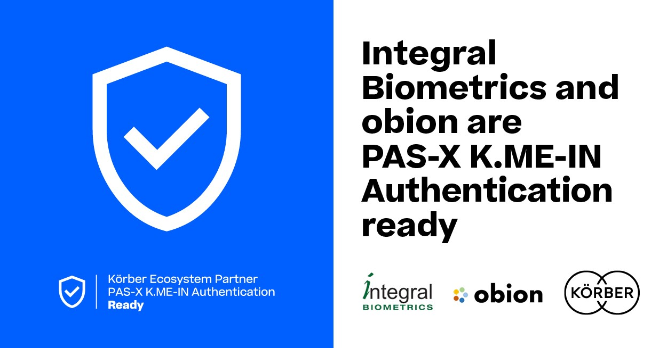

Integral Biometrics and obion join the Körber Ecosystem Partner program as “PAS-X K.ME-IN” partners
Integral Biometrics与 obion 加入柯尔柏“生物识别认证”合作伙伴计划

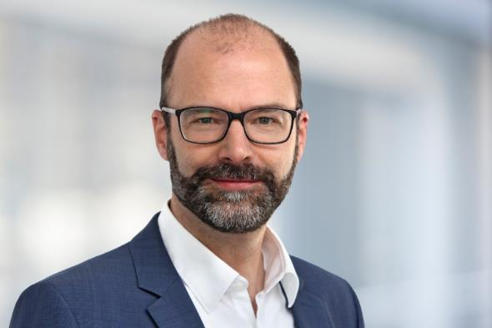

Lars Hornung, Senior Principal Alliances & Technology Partners Software, Körber Business Area Pharma
Lars Hornung，软件主要联盟和技术合作伙伴高级负责人，柯尔柏医药科技业务领域

Marc Diament, CEO, Integral Biometrics
Marc Diament，首席执行官，Integral Biometrics

Ralf Kühnel, Business Development Manager at obion
Ralf Kühnel，业务发展经理，obion

About Integral Biometrics
关于Integral Biometrics

Headquartered in Freehold, New Jersey, USA, Integral Biometrics is a provider of innovative integrated iris and fingerprint biometric solutions for global, world-class life science manufacturers. Integral’s GxP-compliant products enable real-time authentication supporting logins, eSignatures, password management, and other innovative automations. Our robust and flexible integration architecture which has been in continuous use for over 18 years provides increased productivity, ease and speed of use, and cost savings while protecting user privacy and system security.
Integral Biometrics公司总部位于美国新泽西州的菲力荷自治市，是一家为全球生命科学制造商提供创新的集成虹膜和指纹生物识别解决方案的供应商。Integral的产品符合GxP标准，实现了身份认证以支持实时登录、电子签名、密码管理和其他创新性的自动化。我们强大而灵活的集成架构已经连续使用了18年，在保护用户隐私和系统安全的同时，提供了更高的生产力、易用性和速度，节约了成本。
https://integralbiometrics.com

Contact:
Marc Diament
Integral Biometrics
CEO
T: +1-732-414-6000
E-mail: getbiometrics@its.integralbiometrics.com

联系我们
Marc Diament
Integral Biometrics
首席执行官
电话: +1-732-414-6000
邮件: getbiometrics@its.integralbiometrics.com

About obion
obion GmbH is an engineering company based in the Frankfurt area in Germany. obion is the successor of i.p.a.s.-systeme and has taken over its business in April 2023. The obion engineers have decades of experience in the field of custom software development for clients in the pharmaceutical and chemical industries. obion has specialized in MES-to-DCS interface suites but also is proud home of LogOnPlus.
关于obion
obion GmbH是一家位于德国法兰克福地区的工程公司。Obion于2023年4月接管了i.p.a.s.-system的业务。obion的工程师在制药和化工行业的定制软件开发领域拥有数十年的经验。obion专注于MES-to-DCS接口套件，同时 LogOnPlus也是obion引以为豪的产品。

Contact:
Ralf Kühnel
obion GmbH
Business Development Manager
T: +49 6171 2768-123
E-mail: ralf.kuehnel@obion.de

联系我们
Ralf Kühnel
obion GmbH
业务开发经理
电话: +49 6171 2768-123
邮件: ralf.kuehnel@obion.de

About Körber
关于柯尔柏

We are Körber – an international technology group with about 13,000 employees at more than 100 locations worldwide and a common goal: We turn entrepreneurial thinking into customer success and shape the technological change. In the Business Areas Digital, Pharma, Supply Chain, Technologies and Tissue, we offer products, solutions and services that inspire. We act fast to customer needs, we execute ideas seamlessly, and with our innovations we create added value for our customers. In doing so, we are increasingly building on ecosystems that solve the challenges of today and tomorrow. Körber AG is the holding company of the Körber Group.
柯尔柏是一家国际技术集团，拥有约13,000名员工，在世界各地有100多个分支机构。所有人都有一个共同的目标：我们将企业家精神转化为客户成功，并塑造技术变革。在数字化、医药科技、供应链、纸业科技和工程技术等业务领域，我们提供激发灵感的产品、解决方案和服务。我们快速响应客户需求，无缝实时想法，通过创新为客户创造附加价值。我们越来越多地建立能够解决当今和未来挑战的制药生态系统。柯尔柏股份公司是柯尔柏集团的控股公司。

At the Körber Business Area Pharma we are delivering the difference along the pharma value chain with our unique portfolio of integrated solutions. With our software solutions we help drug manufacturers to digitize their pharmaceutical, biotech and cell & gene therapy production. The Werum PAS-X MES Suite is recognized as the world’s leading Manufacturing Execution System for pharma, biotech and cell & gene. Our Werum PAS-X Savvy Suite accelerates product commercialization with data analytics and AI solutions and uncovers hidden business value.
在柯尔柏医药科技业务领域，我们通过提供先进的综合制药解决方案，在整个制药价值链中实现差异化。我们的软件解决方案支持医药企业实现制药、生物技术、细胞和基因治疗生产流程的数字化。维隆PAS-X MES套件是公认的一款适用于制药、生物技术和细胞与基因领域的生产执行系统。我们的维隆PAS-X智能套件通过数据分析和人工智能解决方案加速产品商业化，并发现隐藏的商业价值。

www.koerber-pharma.com

Contact
Dirk Ebbecke
Körber Business Area Pharma
Head of Product Marketing
T: +49 4131 8900-0
E-mail: dirk.ebbecke@koerber.com

联系我们
Dirk Ebbecke
柯尔柏医药科技
产品市场总监
+49 4131 89000
dirk.ebbecke@koerber.com

