Körber launches new biometric authentication partner program to accelerate identification times in pharmaceutical manufacturing

Lüneburg, Germany, 30 June 2023. The newly launched PAS-X K.ME-IN partner program provides Werum PAS-X MES customers with an out-of-the-box interface for the use of biometric authentication technology. Together with partners this enables 50 percent faster identification times while ensuring only authorized personnel can access the Manufacturing Execution System (MES). With Integral Biometrics and obion (formerly i.p.a.s.-systeme), two strong partners have already joined the program.

Körber’s Werum PAS-X MES Suite digitally controls, monitors, and documents the manufacturing process in real-time. The PAS-X K.ME-IN solution supports unique biometric authentication such as iris scan, face recognition, fingerprint or a combination of those before granting access to users. This eliminates the cumbersome process of entering usernames, passwords or PIN codes. As a result, the time needed to log in to PAS-X MES is significantly reduced, and providing electronic signatures becomes a lot easier.

“Werum PAS-X K.ME-IN offers a convenient, user-friendly, and tamper-proof solution for an efficient system interaction in the life sciences production environment,” says Lars Hornung, Senior Principal Alliances & Technology Partners Software, Körber Business Area Pharma.

“Integral Biometrics and obion are two strong partners that recently received the ‘Ready’ level of our PAS-X K.ME-IN partner certification program. Our collaborative efforts are focused on providing our customers with innovative authentication solutions for the future of pharmaceutical production. These cutting-edge technologies not only enhance compliance and data security but also ensure a user-friendly experience,” adds Hornung.

Integral Biometrics provides two options that customers can use to log into Werum PAS-X MES: the At-a-Glance™ and At-a-Touch™ login methods can authenticate users at any workstation via cost-effective iris sensors within two seconds or via fingerprint recognition systems, respectively. With that solution customers work password free, touch free, fast and friction free.

“In life, our eyes can be our keys to trust. With Integral’s iris biometrics and authentication automation platform, we offer a natural interaction with manufacturing systems eliminating passwords and simplifying work. This is no longer the stuff of science fiction; our goggled, gowned, and gloved customers are now benefitting from using this accessible technology through PAS-X K.ME-IN,” says Marc Diament, CEO, Integral Biometrics.

LogOnPlus from obion is a solution for logical access to various business applications. It has been productive in the pharma and biopharma industries since 2014. It can use existing identification infrastructure such as RFID readers or employee badges currently in place. With its newest release 5.2, LogOnPlus also supports biometric methods such as the Freevolt™ S-Key fingerprint secured RFID card or iris scan.

“With the integration of biometrics for secure user identification and authentication, LogOnPlus has taken a big step forward: Now also completely password-less and biometrically verified logins are possible, increasing the time saved by using LogOnPlus even further. Our technology partnership with Körber ensures maximum interoperability and so maintains the simplicity of installation, configuration and operation of LogOnPlus,” says Ralf Kühnel, Business Development Manager, obion.

Pictures
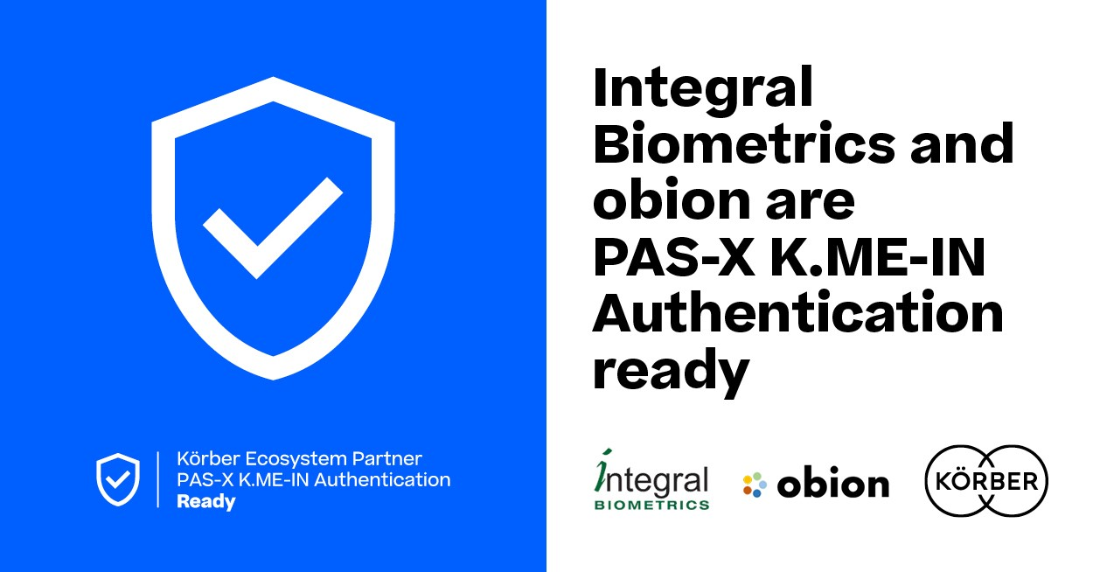

Integral Biometrics and obion join the Körber Ecosystem Partner program as “PAS-X K.ME-IN” partners

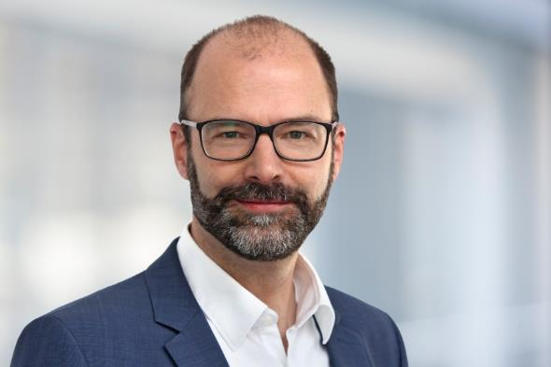

Lars Hornung, Senior Principal Alliances & Technology Partners Software, Körber Business Area Pharma

Marc Diament, CEO, Integral Biometrics

Ralf Kühnel, Business Development Manager at obion

About Integral Biometrics
Headquartered in Freehold, New Jersey, USA, Integral Biometrics is a provider of innovative integrated iris and fingerprint biometric solutions for global, world-class life science manufacturers. Integral’s GxP-compliant products enable real-time authentication supporting logins, eSignatures, password management, and other innovative automations. Our robust and flexible integration architecture which has been in continuous use for over 18 years provides increased productivity, ease and speed of use, and cost savings while protecting user privacy and system security.
https://integralbiometrics.com

Contact:
Marc Diament
Integral Biometrics
CEO
T: +1-732-414-6000
E-mail: getbiometrics@its.integralbiometrics.com

About obion
obion GmbH is an engineering company based in the Frankfurt area in Germany. obion is the successor of i.p.a.s.-systeme and has taken over its business in April 2023. The obion engineers have decades of experience in the field of custom software development for clients in the pharmaceutical and chemical industries. obion has specialized in MES-to-DCS interface suites but also is proud home of LogOnPlus.

Contact:
Ralf Kühnel
obion GmbH
Business Development Manager
T: +49 6171 2768-123
E-mail: ralf.kuehnel@obion.de

About Körber
We are Körber – an international technology group with about 13,000 employees at more than 100 locations worldwide and a common goal: We turn entrepreneurial thinking into customer success and shape the technological change. In the Business Areas Digital, Pharma, Supply Chain, Technologies and Tissue, we offer products, solutions and services that inspire. We act fast to customer needs, we execute ideas seamlessly, and with our innovations we create added value for our customers. In doing so, we are increasingly building on ecosystems that solve the challenges of today and tomorrow. Körber AG is the holding company of the Körber Group.

At the Körber Business Area Pharma we are delivering the difference along the pharma value chain with our unique portfolio of integrated solutions. With our software solutions we help drug manufacturers to digitize their pharmaceutical, biotech and cell & gene therapy production. The Werum PAS-X MES Suite is recognized as the world’s leading Manufacturing Execution System for pharma, biotech and cell & gene. Our Werum PAS-X Savvy Suite accelerates product commercialization with data analytics and AI solutions and uncovers hidden business value.

www.koerber-pharma.com

Contact
Dirk Ebbecke
Körber Business Area Pharma
Head of Product Marketing
T: +49 4131 8900-0
E-mail: dirk.ebbecke@koerber.com

