Körber and iocto announce partnership for the out-of-the-box integration of pharmaceutical equipment with Werum PAS-X MES

Lüneburg / Hofheim am Taunus, Germany, 21 August 2023. Körber, the global leader in Manufacturing Execution Systems (MES) and integrated solutions, welcomes iocto to its Körber Ecosystem Partner program as a “PAS-X MSI Plug & Produce” partner on certified level. iocto (formerly GFS) supplies pharma companies worldwide with measurement technology, automation, and sensor technology.

Körber and iocto have already been collaborating for over five years, which is why iocto received the "Certified" level for their “iocto MSI Core Framework” right from the beginning. The solution connects pharmaceutical control and monitoring systems with the Werum PAS-X MES Manufacturing Execution System via Körber’s Werum PAS-X MSI Plug & Produce interface. It enables the collection, integration, and transfer of data between equipment and MES and also provides the possibility to control the process sequences of the equipment from the MES side. With OEM support, the iocto MSI Core Framework can be seamlessly integrated into the equipment, resulting in a rapid “one box” solution.

The Werum PAS-X MES Suite from Körber controls, monitors, and documents manufacturing processes digitally and in real time. With just a few mouse clicks, customers can seamlessly integrate Körber’s best-of-breed ecosystem solutions through PAS-X MSI Plug & Produce. This no-code integration uses standardized message-based communication between MES and shop floor equipment as for instance outlined in the ISPE Plug & Produce Working Group's Concept Paper.

“We are pleased to welcome iocto as a certified Ecosystem partner for the integration of measurement, automation and sensor technology into our Werum PAS-X MES,” says Lars Hornung, Senior Principal Alliances & Technology Partners Software, Körber Business Area Pharma. “Thanks to the MSI interfaces on the MES and equipment side, the effort involved in integrating equipment can be reduced by up to 75 percent.”

“To be able to exploit the flexibility of their system to create a way of turning traditional equipment into something that can plug directly into MES with minimal development effort has been very satisfying,” says Will Clark, Managing Director Research and Product Innovation, iocto GmbH. “The possibility to take a concept idea and turn it into a solution that meets the customer needs in a matter of weeks is a testament also to the power of the PAS-X MSI Plug & Produce interface. I’m looking forward to an even closer collaboration in the future.”

Pictures

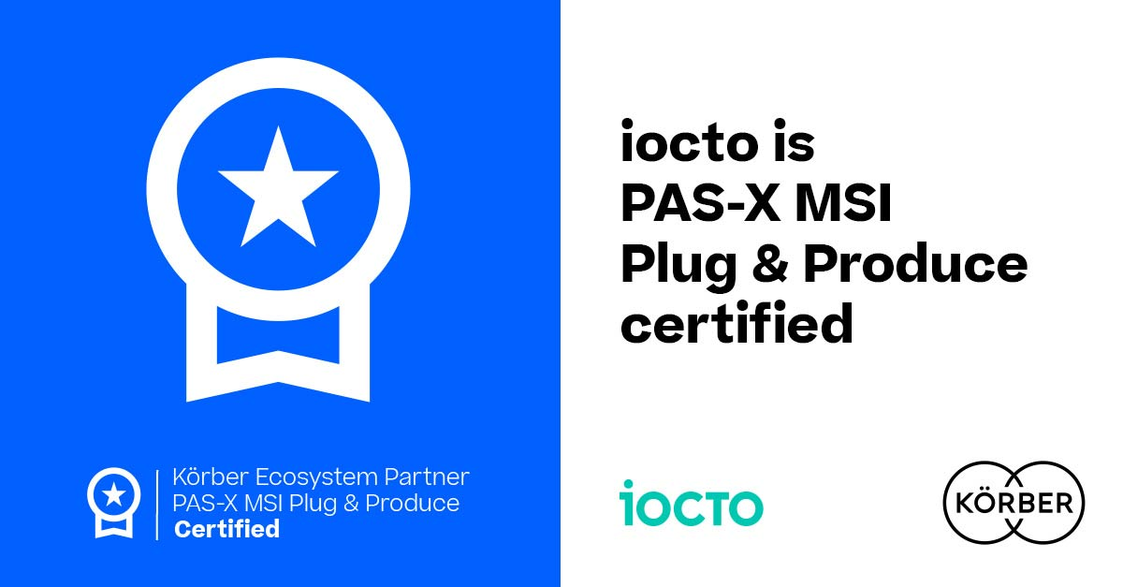

iocto receives the “PAS-X MSI Plug & Produce Certified" certification from Körber

Will Clark, Managing Director Research and Product Innovation, iocto GmbH

Lars Hornung, Senior Principal Alliances & Technology Partners Software, Körber Business Area Pharma

About iocto
Made to Measure – iocto specializes in measurement, automation and sensor technology for the pharmaceutical and other industries. iocto’s 140 experts create and deliver tailored products and services to the market, meeting the highest standards of quality and safety in the pharmaceutical industry. From the evaluation of measurement principles to production-ready measurement devices and automated systems, the company from Hofheim am Taunus has been offering its customers holistic, innovative solutions since 1984.
www.iocto.com

Contact
Will Clark
iocto GmbH
Managing Director, Research and Product Innovation
T: +49 6192 9910-0
E-mail: info@iocto.com

About Körber
Körber is an international technology group with about 13,000 employees, more than 100 locations worldwide and a common goal: We turn entrepreneurial thinking into customer success and shape the technological change. In the Business Areas Digital, Pharma, Supply Chain, Technologies and Tissue, we offer products, solutions and services that inspire.
At the Körber Business Area Pharma we are delivering the difference along the pharma value chain with our unique portfolio of integrated solutions. With our software solutions we help drug manufacturers to digitize their pharmaceutical, biotech and cell & gene therapy production. The Werum PAS-X MES Suite is recognized as the world’s leading Manufacturing Execution System for pharma, biotech and cell & gene. Our Werum PAS-X Savvy Suite accelerates product commercialization with data analytics and AI solutions and uncovers hidden business value.
www.koerber-pharma.com

Contact
Dirk Ebbecke
Körber Business Area Pharma
Head of Product Marketing
T: +49 4131 8900-0
E-mail: dirk.ebbecke@koerber.com

