Körber launches new PAS-X MSI Plug & Produce partnership program for equipment and machine vendors

Lüneburg, Germany, 09 November 2022. The leading MES software provider Körber announces a new partnership program for equipment, machine, and system suppliers. With two different PAS-X MSI Plug & Produce partnership levels, vendors can now prove that they are able to use the MSI (message-based shopfloor integration) technology.

Communication between shop floor equipment and an MES (Manufacturing Execution System) can be challenging if the IT systems do not have a common interface. That is why Werum PAS-X MSI Plug & Produce – an add-on to the market-leading Werum PAS-X MES suite – enables standardized message-based communication between the MES and the equipment or machines on the shop floor. Based on industry best practices, the technology allows a fast and easy integration of machines and automation systems into the pharmaceutical production environment. This leads to a significant reduction in manual configuration effort, with workload being reduced by up to 75%. PAS-X MSI Plug & Produce from Körber is increasingly seen as a standard in the industry and leverages the Concept Paper of the ISPE Plug & Produce Working Group.

With the new PAS-X MSI Plug & Produce partnership certificate, equipment, machine, or system suppliers globally can now become Körber Ecosystem Partners. “We believe that together with our partners we can deliver the difference for our mutual customers in the pharma, biotech or cell & gene industry,” says Lars Hornung, Senior Principal Alliances & Technology Partners Software, Körber Business Area Pharma. "For this reason, we have created a certification model that shows the added value of a standard integration we can bring to our joint customers.”

The “Ready” certification is a free, entry-level certification that shows that the partner company has a basic understanding of the technology and has implemented a system interface based on the MSI interface specification provided by Körber. “Certified” is the advanced certification level that proves that the partner company has implemented an interface and in addition has participated in a formal interface acceptance test. "As a PAS-X MES customer, we need to be sure that machine manufacturers can offer standard integrations of their products. This certification gives us the necessary assurance," says Daniel Degn-Hansen, IT & Automation Area Specialist, Novo Nordisk.

"As a certified partner, we offer a verified, reliable and configurable PAS-X MES connection as part of PAS-X MSI Plug & Produce, which provides our customers with seamless vertical machine integration within the shortest possible time," concludes Jürg Messmer, Head of New Business Packaging Machines, Körber Business Area Pharma.

Interested to learn more? Please contact our Technology Partner Management.

Picture

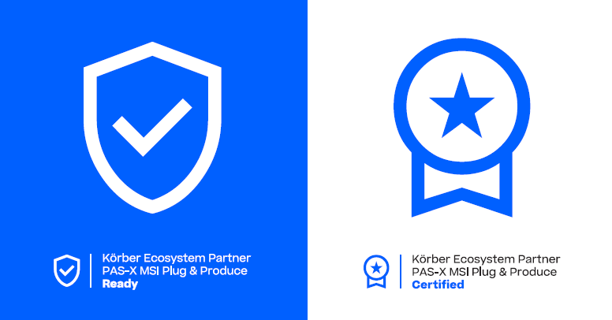

About Körber
Körber is an international technology group with about 12,000 employees, more than 100 locations worldwide and a common goal: We turn entrepreneurial thinking into customer success and shape the technological change. In the Business Areas Digital, Pharma, Supply Chain, Tissue and Tobacco, we offer products, solutions and services that inspire.
At the Körber Business Area Pharma we are delivering the difference along the pharma value chain with our unique portfolio of integrated solutions. With our software solutions we help drug manufacturers to digitize their pharmaceutical, biotech and cell & gene therapy production. The Werum PAS-X MES Suite is recognized as the world’s leading Manufacturing Execution System for pharma, biotech and cell & gene. Our Werum PAS-X Intelligence Suite accelerates product commercialization with data analytics and AI solutions and uncovers hidden business value.
www.koerber-pharma.com

Contact
Dirk Ebbecke
Körber Business Area Pharma
Head of Product Marketing Communications
T: +49 4131 8900-0
E-mail: dirk.ebbecke@koerber.com

Lars Hornung
Körber Business Area Pharma
Senior Principal Alliances & Technology Partners Software
T: +49 4131 8900-344
E-mail: lars.hornung@koerber.com

