Körber Partner Program "PAS-X MSI Plug & Produce": The onoff AG receives the "Ready" certification

Lüneburg, Germany / Wunstorf, Germany, 16 December 2022. The onoff AG, part of the SpiraTec Group, is one of the first companies to receive the "PAS-X MSI Plug & Produce Ready" partnership certificate from Körber Pharma Software GmbH, thus further expanding its long-standing cooperation with one of the leading MES providers in the pharmaceutical and biotech sector.

onoff received the partnership certificate for the innovative communication interface InfoCarrier® BOXI, which has proven to be an effective PAS-X interface solution. Based on the MSI interface specification, the Siemens SIMATIC Batch can be connected effectively to Körber’s PAS-X MES via InfoCarrier® BOXI.

The new partnership program was only recently introduced by Körber. This program aims at providing suppliers of machines and equipment an opportunity to demonstrate their ability of implementing the MSI technology (Message-based Shop Floor Integration).

The innovative InfoCarrier® BOXI developed by onoff enables data exchange and function calls between different systems via defined interfaces. It has the significant advantage of connecting process control systems and MES by using universal connectors. With predefined workflows, common best practice use cases, such as creating a batch or reading and writing parameters, can be implemented consistently with minimal effort. This saves manual input and ensures a significant reduction in errors.

onoff has been a PAS-X Endorsed Service Partner since 2017 and has a high level of expertise and system knowledge of PAS-X MES as well as in the integration of subordinate systems to PAS-X MES. The SpiraTec Group – which onoff has belonged to since 2022 – can also look back on a long collaboration with Körber Pharma Software GmbH and has been in the partnership program since February 2020.

"We are delighted about the new technology partnership with Körber, which underpins our expertise in the pharmaceutical sector. We are particularly proud to be among the first providers to be certified. "This is a great acknowledgement of the work we do," emphasized Dr. Daniel Olivotti, Sales & Business Development Manager, onoff it-solutions gmbh and adds: "This allows us to significantly simplify integration for our customers and shorten implementation times."

This certification model was introduced to demonstrate the additional benefits of standard integration: "Communication between the equipment on the shop floor and a MES can be a challenge if the IT systems do not have a common interface. Together with our partners, we can make a decisive difference for our customers in the pharmaceutical, biotech or cell & gene therapy industries. We are delighted to have such an experienced partner on board like onoff," stated Lars Hornung, Senior Principal Alliances & Technology Partners Software, Körber Business Area Pharma.

Pictures

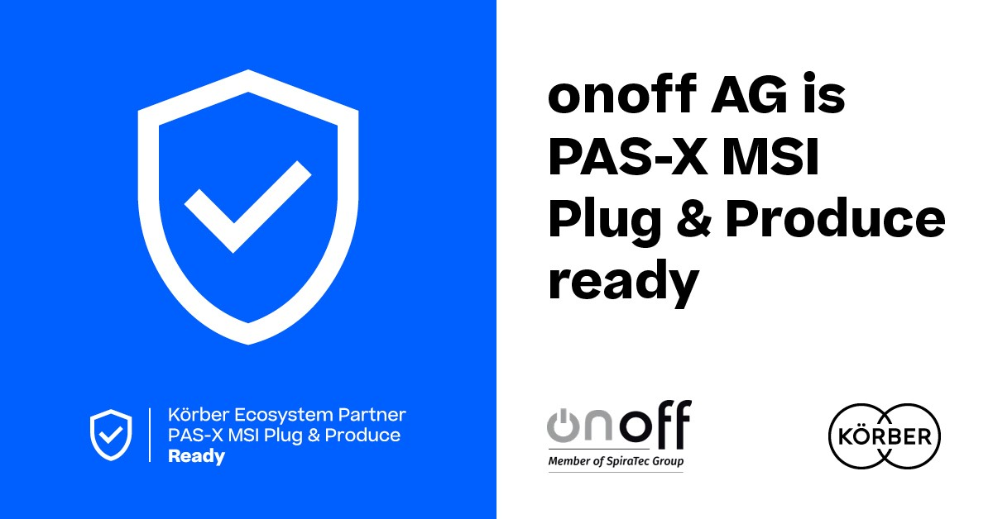
The onoff AG receives the “PAS-X MSI Plug & Produce Ready" certification from Körber

Lars Hornung, Senior Principal Alliances & Technology Partners Software, Körber Business Area Pharma

Dr. Daniel Olivotti, Sales & Business Development Manager, onoff it-solutions gmbh

About the onoff AG

As a system-independent partner for automation and IT, onoff AG develops precisely customized, future-oriented solutions for process automation, digitalization and artificial intelligence. The sector focus is on pharmaceuticals, foods, chemicals, water/wastewater, natural gas and retail.

As part of the SpiraTec Group since April 2022, onoff operates together with more than 600 employees in Germany, Italy, Austria and the USA at 30 locations to successfully implement projects related to industry 4.0 close to their customers. onoff taps potential that not only makes processes more efficient, but also safer, more cost-effective and easier to operate. National and international experience and over 30 years of know-how are reflected in the range of services offered by the core divisions: onoff engineering gmbh, onoff it-solutions gmbh and onoff automation services gmbh.

www.onoff-group.de

About Körber

Körber is an international technology group with about 12,000 employees, more than 100 locations worldwide and a common goal: We turn entrepreneurial thinking into customer success and shape the technological change. In the Business Areas Digital, Pharma, Supply Chain, Tissue and Tobacco, we offer products, solutions and services that inspire.
At the Körber Business Area Pharma we are delivering the difference along the pharma value chain with our unique portfolio of integrated solutions. With our software solutions we help drug manufacturers to digitize their pharmaceutical, biotech and cell & gene therapy production. The Werum PAS-X MES Suite is recognized as the world’s leading Manufacturing Execution System for pharma, biotech and cell & gene. Our Werum PAS-X Intelligence Suite accelerates product commercialization with data analytics and AI solutions and uncovers hidden business value.
www.koerber-pharma.com

Contact

Dirk Ebbecke
Körber Business Area Pharma
Head of Product Marketing Communications
Phone: +49 4131 8900-0
E-mail: dirk.ebbecke@koerber.com

Jutta Rossié
Jutta.rossie@onoff-group.de
Phone: +49 5031-9686-158

Barbara Dornwald
dornwald@move-communications.com
Phone: +49 89-452219-24

