Almirall, leading manufacturer of dermatological drug products, has successfully upgraded Werum PAS-X MES for better performance and faster updatability

Lüneburg, Germany, 19 September 2023. Almirall, the specialist in medical dermatology, has upgraded Körber's Werum PAS-X MES Manufacturing Execution System at its plant in Reinbek, Germany, near Hamburg. Almirall is a leading supplier of prescription and over-the-counter dermatics and uses PAS-X MES for the manufacturing of the Optiderm® and Tannosynt® product lines, among others.

The existing PAS-X MES system was getting on in years and had customer-specific adaptations that needed a great deal of effort to maintain. That is why Almirall wanted to revamp and, at the same time, create a single version that could also be rolled out to all other sites.

“Werum PAS-X MES is at the heart of our manufacturing operations, managing the execution of our manufacturing orders digitally and in accordance with Good Manufacturing Practice requirements,” says Kai Sauerbier, Pharma Operations Senior Director at Almirall. “We now have a new version that runs faster and with enhanced performance, thus increasing our production throughput. Next, we want to make improvements to the master batch records and make good use of the new software features to meet the increasing demand for quality and efficiency.”

“Implementing an upgrade across ten versions is always a major technical challenge. However, thanks to the intensive collaboration with Körber's software team, we were able to successfully bring our system up to the new standard,” adds Martin Jakobs, Business Process Manager at Almirall.

The pharmaceutical company now benefits from faster processes, elimination of safety gaps and improved future upgradability. PAS-X MES is used as a full-scope MES in the entire manufacturing process – from weighing to mass production and packaging. It integrates the in-house Laboratory Information Management System (LIMS) and the Enterprise Resource Planning (ERP). The underlying Oracle database has also been upgraded to a new version.

Meanwhile, Almirall has also introduced the latest PAS-X MES version – including warehouse management and the replacement of the legacy manufacturing execution system – at its highly automated plant in Sant Andreu, near Barcelona, Spain.

Pictures
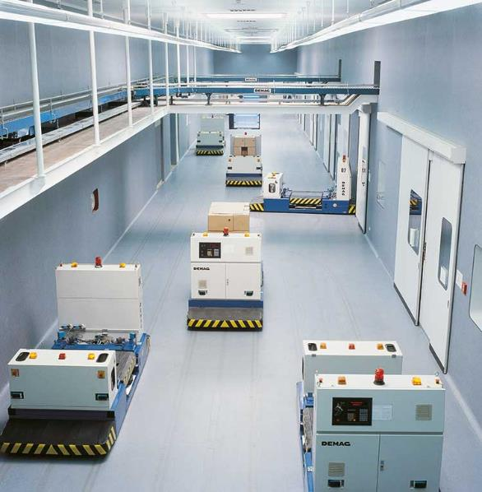
Production at Almirall

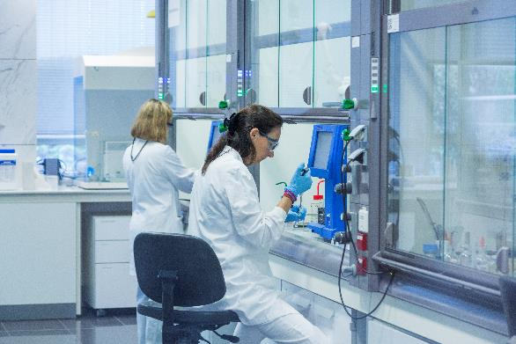
Research & development at Almirall

About Körber
We are Körber – an international technology group with about 13,000 employees at more than 100 locations worldwide and a common goal: We turn entrepreneurial thinking into customer success and shape the technological change. In the Business Areas Digital, Pharma, Supply Chain, Technologies and Tissue, we offer products, solutions and services that inspire. We act fast to customer needs, we execute ideas seamlessly, and with our innovations we create added value for our customers. In doing so, we are increasingly building on ecosystems that solve the challenges of today and tomorrow. Körber AG is the holding company of the Körber Group.

At the Körber Business Area Pharma we are delivering the difference along the pharma value chain with our unique portfolio of integrated solutions. With our software solutions we help drug manufacturers to digitize their pharmaceutical, biotech and cell & gene therapy production. The Werum PAS-X MES Suite is recognized as the world’s leading Manufacturing Execution System for pharma, biotech and cell & gene. Our Werum PAS-X Savvy Suite accelerates product commercialization with data analytics and AI solutions and uncovers hidden business value.

www.koerber-pharma.com

Contact
Dirk Ebbecke
Körber Business Area Pharma
Head of Product Marketing
Phone: +49 4131 8900-0
E-mail: dirk.ebbecke@koerber.com

