**GC Biopharma accelerates digital transformation with fast-tracked MES implementation in partnership with Körber**

**Lüneburg, Germany, 19 May 2025 – GC Biopharma, a leading South Korean biopharmaceutical company, has partnered with global tech leader Körber to implement a large-scale Manufacturing Execution System (MES) project across multiple sites. Set to go live within a year, the project marks one of Korea’s fastest MES rollouts, underscoring GC Biopharma’s focus on operational excellence and long-term growth.**

At the core of the initiative is the implementation of Körber’s PAS-X MES solution at three major manufacturing sites, including facilities producing Hunterase (a treatment for Hunter syndrome) and a range of plasma-derived therapies. The MES will serve as the digital backbone of operations, enabling real-time process visibility, batch traceability, seamless system integration, and enhanced global compliance.

“This MES project is not just about digitalization – it’s a bold step toward redefining manufacturing standards in Korea’s biopharmaceutical sector,” said Woong Shin, VP / Head of Quality Management at GC Biopharma. “Partnering with Körber reflects our shared commitment to innovation and responsibility in delivering high-quality therapies worldwide.”

The project follows a phased rollout plan, with a technical go-live scheduled in 10 months and commercial operations to begin in 14 months – a record pace for MES implementation in Korea’s complex biopharmaceutical sector. GC Biopharma expects to achieve a 25% reduction in batch cycle time, a 30% improvement in data review efficiency, and full compliance with FDA 21 CFR Part 11 and EU GMP Annex 11.

With a focus on execution and accountability, the project addresses several critical objectives:

* System integration at scale: PAS-X MES will interface with a broad landscape of systems including SAP ERP, WMS, QMS, LMS, DMS, PBS, MBS, LIMS, and L2 platforms.
* Complex interconnectivity: Custom integrations will support unique business processes across systems to maximize enterprise value.
* Prime contractor leadership: As the main contractor, Körber is responsible for overall project execution, subcontractor coordination, and quality assurance.
* Standardization and quality control: A key goal is the alignment of processes and quality standards across diverse partner contributions.
* Localized expertise: All partners bring dedicated in-country teams to ensure high-quality delivery and responsive support.

“Delivering a project of this scale within such a compressed timeline demonstrates the strength of our partnership and shared ambition,” said Andrew Lee, Managing Director Korea, Körber Business Area Pharma. “We’re not just implementing a system – we’re building a foundation for digital excellence.”

“This collaboration showcases what can be achieved when expertise, trust, and ambition come together. With our global innovation capabilities and strong local execution, we are setting a new standard for fast, high-quality MES deployments in Asia’s pharmaceutical industry. I am proud of our teams for driving this digital transformation journey together with GC Biopharma,” said Oliver Weber, CEO Software, Körber Business Area Pharma.

The deployment is backed by a robust partner network:

* euBiz Solution leads level 2 system integration using COPA-DATA’s Zenon, OT network design (via Wenet), and validation.
* Shinsegae supplies core infrastructure solutions, including Nutanix-based MES servers.
* INiinno drives MES validation efforts to ensure full regulatory alignment.

This MES project is a cornerstone of GC Biopharma’s digital strategy and a catalyst for operational excellence and accelerated market responsiveness. Together, GC Biopharma and Körber are not only setting a new benchmark for MES adoption in Korea – they are defining the future of smart, agile, and compliant pharmaceutical manufacturing.

**Picture**

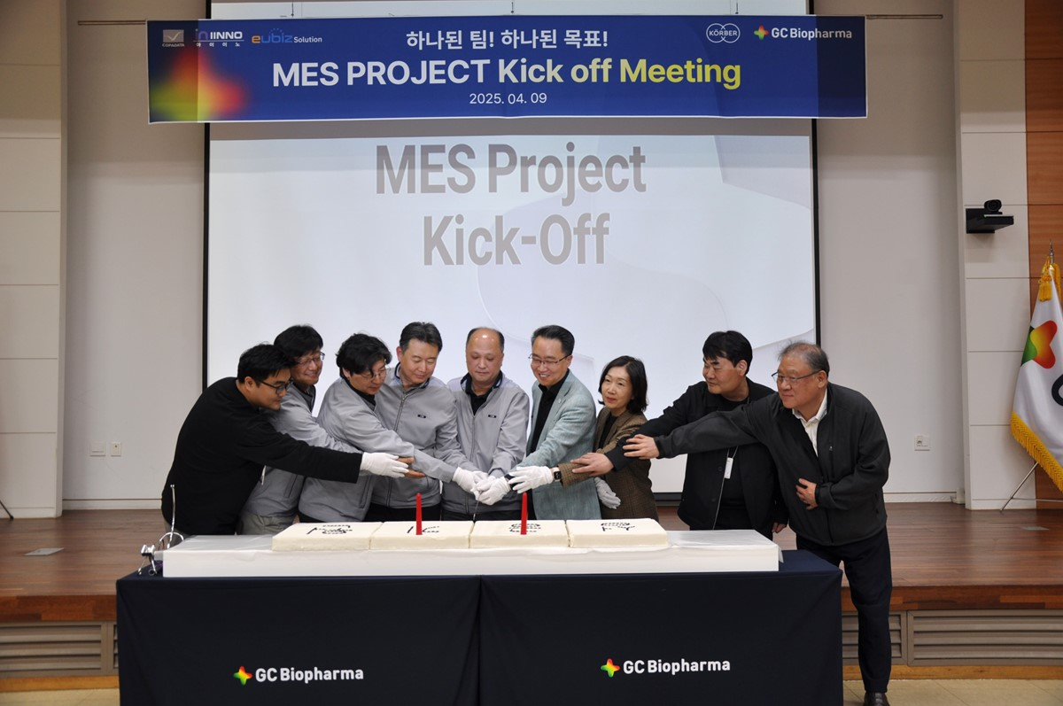

The management teams from Körber Korea and GC Biopharma symbolically cutting a cake at the MES kick-off ceremony.

**About GC Biopharma**

GC Biopharma is a leading biopharmaceutical company based in South Korea, committed to delivering innovative therapies across rare diseases, blood products, and vaccines. With a strong focus on research, quality, and global outreach, GC Biopharma plays a vital role in advancing public health both domestically and internationally.

[www.gccorp.com/eng/index](http://www.gccorp.com/eng/index)

**About Körber**

We are Körber – an international technology group with around 13,000 employees at over 100 locations worldwide and a common goal: We turn entrepreneurial thinking into customer success and shape the technological change. In the Business Areas Digital, Pharma, Supply Chain, and Technologies, we offer products, solutions and services that inspire. We act fast to customer needs, we execute ideas seamlessly, and with our innovations we create added value for our customers. In doing so, we are increasingly building on ecosystems that solve the challenges of today and tomorrow. Körber AG is the holding company of the Körber Group.

At Körber Business Area Pharma, we deliver the difference by empowering our customers with a holistic ecosystem approach. Our unique portfolio of end-to-end solutions ranges from machines – for aseptic processing, inspection, packaging and materials, and transport systems – to consulting, services, software, and digital and AI-driven solutions that serve as integrating layers to boost pharmaceutical manufacturing.

We simplify processes, reduce risks and accelerate time-to-market – ensuring smooth collaboration along the entire pharmaceutical and biotech value chain. With deep industry expertise, we support global customers unlock new potential. Our solutions support a better quality of life for both present and future generations.

[www.koerber-pharma.com](http://www.koerber-pharma.com/)

**Contact**

Dirk Ebbecke

Körber Business Area Pharma

Head of Product Marketing

T: +49 4131 8900-0

E-mail: dirk.ebbecke@koerber.com