Heel, a leading manufacturer of biological medicines, digitizes packaging lines with NextGen PAS-X MES

Lüneburg, Germany, 20 December 2023. Drug manufacturer Heel has successfully implemented Werum PAS-X MES 3.3.0, Körber's NextGen MES for pharma, biotech, and cell & gene therapy, at its main plant in Baden-Baden, Germany. The pioneer in scientific research into natural pharmaceuticals has been producing medicines, such as Neurexan® and Traumeel®, based on natural active ingredients for over 80 years.

Built on more than 30 years of expertise and leading IT technologies, PAS-X MES 3.3.0 is GMP-compliant and designed to meet the future requirements of the industry. It can be integrated into any IT infrastructure via simple and secure interfaces – whether in the customer's data center, in the cloud or as a Körber-managed “Software as a Service”.

The NextGen MES offers maximum functionality as standard, so the system has been implemented “out-of-the-box”, allowing for seamless upgrades in the future. The implementation process followed the proven ready-fit-build-run method: many of the MES implementation tasks were taken over by Körber, which reduced the customer's workload and accelerated the implementation of the system.

“The successful introduction of PAS-X MES for the digital processing and documentation of packaging orders is an important milestone in the digitalization of our production,” says Monika Gartner, Head of Digital Transformation, Biologische Heilmittel Heel GmbH. “We have a very good, open and cooperative business relationship with the Körber team, characterized by mutual trust.”

With the help of PAS-X MES 3.3.0, Heel has digitized the first four packaging lines, replacing the paper-based packaging documentation of its products. The integration was implemented almost as standard, so that more than 2,000 finished products can be processed with just a few generic MBRs. SAP ERP is fully integrated via a standard interface. The customization of numerous bills of material and production versions from SAP has paid off: Heel can now automatically perform reconciliations in Electronic Batch Recording and benefit from the parallel Batch Record Review.

Monika Gartner: “Both the project team and the packaging team contributed greatly to the successful implementation of the project. They have been involved from the very beginning and have received comprehensive information and training through our specially developed training concept.”

In the next step, Heel will introduce PAS-X KPI in the packaging area. The software application is designed to monitor the performance of packaging machines in real-time, ensuring that machine utilization and overall equipment effectiveness is maximized.

“We are looking forward to further projects on the path to digital transformation and our 'Factory of Excellence'. In the coming months and years, we are going to gradually roll out PAS-X MES in other production areas. Integration into all processes is an essential step towards full digitalization,” concludes Monika Gartner from Heel.

Picture
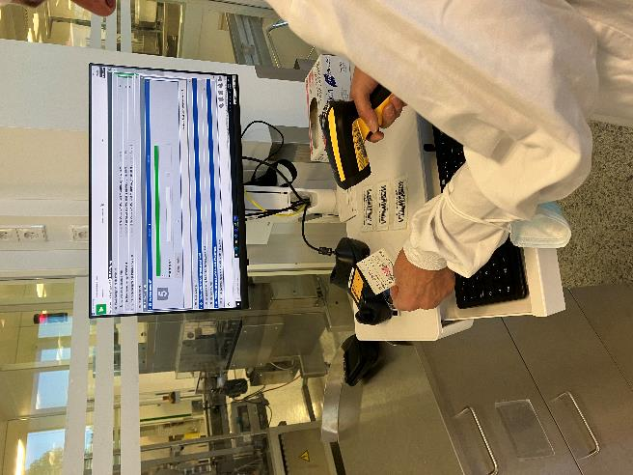
Use of Werum PAS-X MES 3.3.0 in a packaging line at Heel

About Körber
We are Körber – an international technology group with more than 12,000 employees at over 100 locations worldwide and a common goal: We turn entrepreneurial thinking into customer success and shape the technological change. In the Business Areas Digital, Pharma, Supply Chain, and Technologies, we offer products, solutions and services that inspire. We act fast to customer needs, we execute ideas seamlessly, and with our innovations we create added value for our customers. In doing so, we are increasingly building on ecosystems that solve the challenges of today and tomorrow. Körber AG is the holding company of the Körber Group.

At the Körber Business Area Pharma we are delivering the difference along the pharma value chain with our unique portfolio of integrated solutions. With our software solutions we help drug manufacturers to digitize their pharmaceutical, biotech and cell & gene therapy production. The Werum PAS-X MES Suite is recognized as the world’s leading Manufacturing Execution System for pharma, biotech and cell & gene. Our Werum PAS-X Savvy Suite accelerates product commercialization with data analytics and AI solutions and uncovers hidden business value.

www.koerber-pharma.com

Contact
Dirk Ebbecke
Körber Business Area Pharma
Head of Product Marketing
Phone: +49 4131 8900-0
E-mail: dirk.ebbecke@koerber.com

