Jan-Henrik Dieckert assumes new role as Chief Operating Officer Software at Körber Business Area Pharma

Lüneburg, Germany, 24 January 2024. Körber is appointing an executive manager from its own ranks: Jan-Henrik Dieckert has been promoted to the position of Chief Operating Officer (COO) of the Software Business Unit within Körber Business Area Pharma, effective 1 January 2024. In this role, he will oversee operational customer business globally and lead the service strategy.

“We are excited to announce the appointment of Jan-Henrik Dieckert to this role,” says Jens Woehlbier, Chief Executive Officer (CEO) Software at Körber Business Area Pharma. “Jan-Henrik brings over 15 years of experience with our company, having played a key role in establishing and expanding our sales organization in North America, EMEA, China and leading the global sales and marketing of our software products. We wish him great success in his new position.”

As COO, Jan-Henrik Dieckert will be responsible for shaping and implementing the service strategy of the Software Business Unit. He will guide pharma, biotech, and cell & gene customers through their digital transformation journey by leveraging Körber’s suite of software products within the Business Area Pharma.

Jan-Henrik Dieckert most recently was Chief Sales Officer (CSO) Software at Körber Business Area Pharma. As executive board member he was responsible for worldwide sales and marketing of the Werum PAS-X product suites and led the global sales and marketing teams of BU Software. He holds a degree in Biotechnology and has more than 15 years of experience in Manufacturing Execution Systems (MES) for pharma, biotech, and cell & gene therapy manufacturing.

Picture
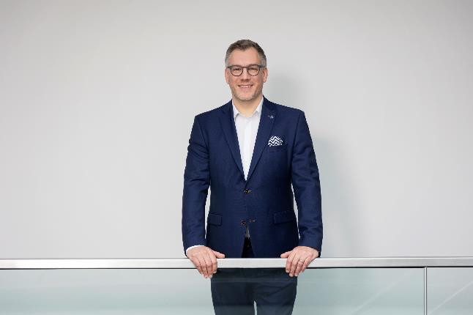
Jan-Henrik Dieckert, new Chief Operating Officer (COO) Software, Körber Business Area Pharma

About Körber
We are Körber – an international technology group with more than 12,000 employees at over 100 locations worldwide and a common goal: We turn entrepreneurial thinking into customer success and shape the technological change. In the Business Areas Digital, Pharma, Supply Chain, and Technologies, we offer products, solutions and services that inspire. We act fast to customer needs, we execute ideas seamlessly, and with our innovations we create added value for our customers. In doing so, we are increasingly building on ecosystems that solve the challenges of today and tomorrow. Körber AG is the holding company of the Körber Group.

At the Körber Business Area Pharma we are delivering the difference along the pharma value chain with our unique portfolio of integrated solutions. With our software solutions we help drug manufacturers to digitize their pharmaceutical, biotech and cell & gene therapy production. The Werum PAS-X MES Suite is recognized as the world’s leading Manufacturing Execution System for pharma, biotech and cell & gene. Our Werum PAS-X Savvy Suite accelerates product commercialization with data analytics and AI solutions and uncovers hidden business value.

www.koerber-pharma.com

Contact
Dirk Ebbecke
Körber Business Area Pharma
Head of Product Marketing
T: +49 4131 8900-0
E-mail: dirk.ebbecke@koerber.com

