With PAS-X Neo, Körber announces an additional MES offering, helping life science manufacturers take their first step toward digitalization

Lüneburg, Germany / Boston, MA, USA, 18 May 2026. At the Pharma Manufacturing World Summit, taking place in Boston from 18-20 May, Körber announces its additional MES (Manufacturing Execution System) solution PAS-X Neo which is specifically designed to enable small and mid-sized pharmaceutical companies and sites to digitalize shop floor operations quickly, effectively, and with a clear path for future growth. With this additional MES product, Körber extends its existing PAS-X portfolio with for example PAS-X MES, PAS-X Savvy or AI solutions and enables an easy entry into PAS-X and the Körber Ecosystem to life science manufacturers that want to start small and scale as their business grows.

Many pharmaceutical and biopharmaceutical manufacturers still rely on paper-based or fragmented shop floor processes. This leads to manual errors, inefficiencies, and increased compliance risk. At the same time, limited internal IT, validation, and MES capacities make digitalization projects difficult to start and hard to sustain.

Körber’s PAS-X Neo is a purpose-built MES for small and mid-sized companies and sites designed to address these challenges. It builds on a lean, standardized, cloud-native architecture with essential GMP functionality, enabling cost-efficient operations, low IT complexity, and regulatory compliance. The solution is designed for fast implementation and provides a right-sized entry point into PAS-X and the Körber Ecosystem.

“We will deliver a world-leading MES platform that makes enterprise-grade innovation accessible to small and mid-sized pharmaceutical manufacturers and sites, empowering them to operate digital, connected and regulatory-compliant from day one. By bringing together cloud-native architecture, AI-powered tooling, and deep domain expertise across MES and line-level operations, we are shaping the next era of pharmaceutical manufacturing and expanding our leadership in the fast-growing Tier-2 and Tier-3 market,” says Oliver Weber, EVP Software, Körber Business Area Pharma.

“Digitalization in pharma must not be an all-or-nothing decision,” adds Pierrick Lebigre, Vice President Product, Software, Körber Business Area Pharma. “With our new PAS-X Neo, we bring the proven quality, compliance, and reliability of our flagship product PAS-X MES into a right-sized, cloud-native solution. This gives manufacturers a simple, secure and future-proof first step into MES-based operations.”

Customers benefit from fast time to value. The goal is to implement the software within less than two months using standardized templates, minimal configuration effort, and AI support. Pharma-grade compliance is built in from day one, including ALCOA+, FDA 21 CFR Part 11, EU Annex 11, audit trails, and electronic signatures. The SaaS delivery model reduces effort and total cost of ownership. No local infrastructure is required, and pre-validated building blocks reduce the validation effort. The solution complements Körber’s flagship PAS-X MES and in future will provide benefits in terms of interoperability between MES systems across different sites, as well as a clearly defined upgrade path.

The first version of PAS-X Neo will be available in November 2026.

Picture
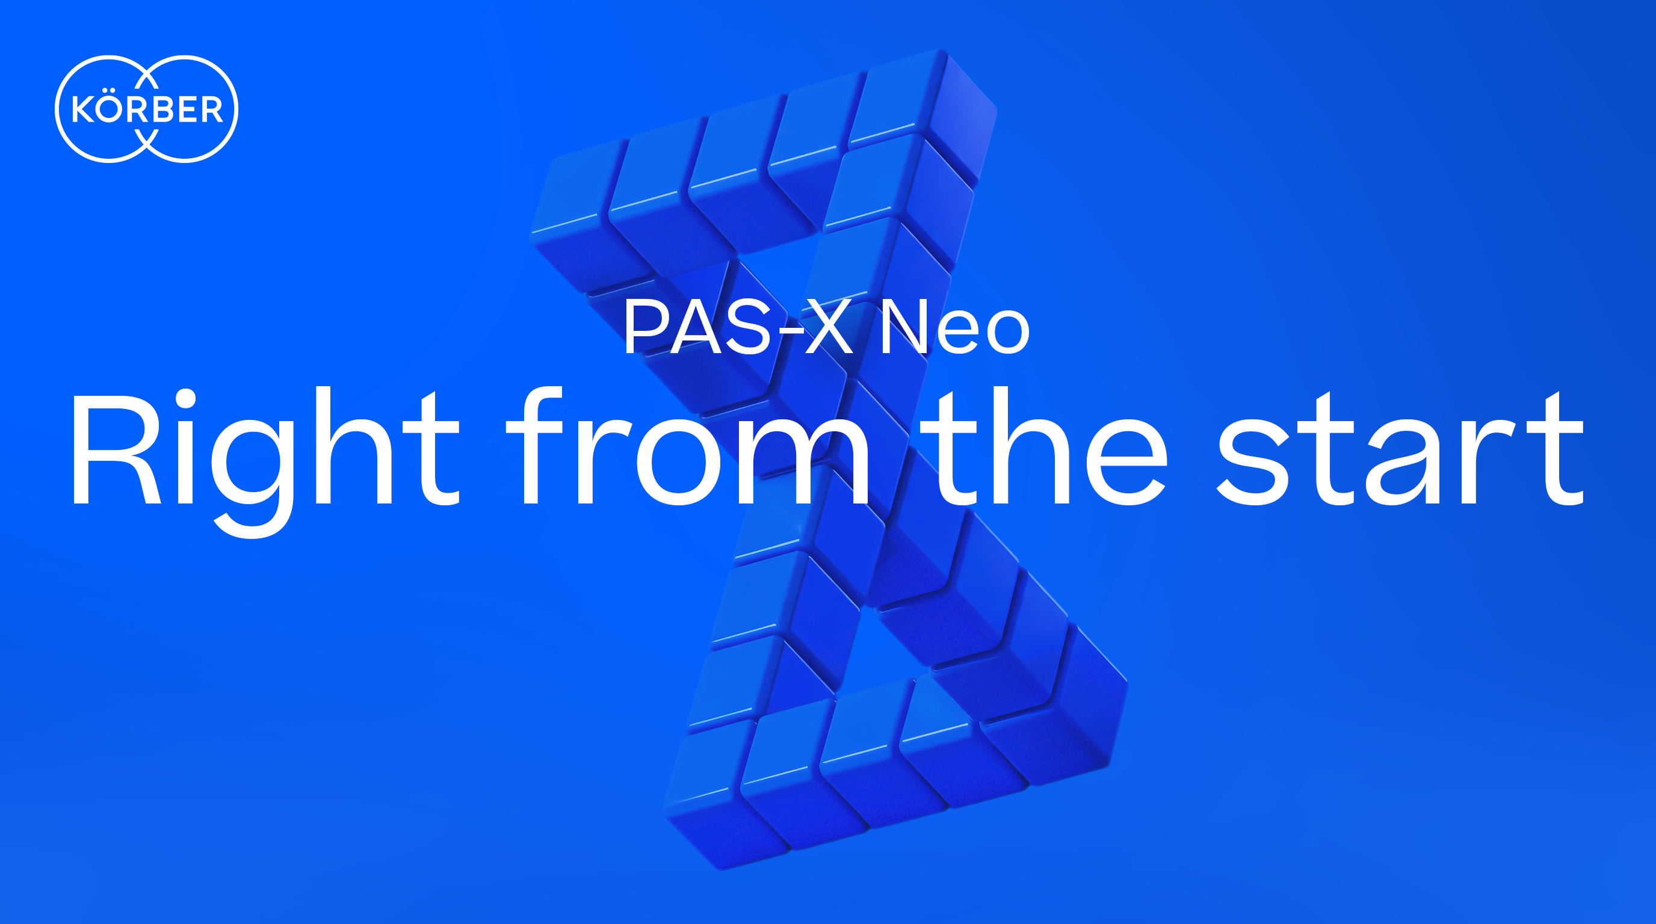

About Körber
We are Körber – an international technology group with around 13,000 employees at over 100 locations worldwide and a common goal: we turn entrepreneurial thinking into customer success and shape technological change. In our Business Areas Pharma, Supply Chain, and Technologies, we deliver products, solutions and services that inspire and create added value for customers. We build ecosystems that solve the challenges of today and tomorrow. Körber AG is the holding company of the Körber Group.

At Körber Business Area Pharma, we deliver the difference by empowering our customers with a holistic ecosystem approach. Our unique portfolio of end-to-end solutions ranges from machines – for aseptic processing, inspection, packaging and materials, and transport systems – to consulting, services, software, and digital and AI-driven solutions that serve as integrating layers to boost pharmaceutical manufacturing.

We simplify processes, reduce risks and accelerate time-to-market – ensuring smooth collaboration along the entire pharmaceutical and biotech value chain. With deep industry expertise, we support global customers unlock new potential. Our solutions support a better quality of life for both present and future generations.
www.koerber-pharma.com

Contact
Dirk Ebbecke
Körber Business Area Pharma
Head of Product Marketing Communications
T: +49 4131 8900-0
E-mail: dirk.ebbecke@koerber.com

