**Körber wins two awards at the Asia-Pacific Bioprocessing Excellence Awards for its state-of-the-art solutions for life sciences industry**

**Lüneburg, Germany / Bangkok, Thailand, 31 March 2022. Körber, provider of the world’s leading Manufacturing Execution System (MES) for the pharma, biotech and cell & gene therapy industries, was honored for its Werum PAS-X MES and PAS-X Packaging solutions in two different award categories at the Annual Biologics Manufacturing Asia conference, held virtually from 29-30 March 2022: “Best Bioprocessing Supplier Award: Automation – Software” and “Best Vaccine Solution Provider Award – Packaging”.**

The Asia-Pacific Bioprocessing Excellence Awards recognize bioprocessing technology organizations that promote biomanufacturing excellence and feature latest advancements in technology and best practices in manufacturing. The software experts of Körber Business Area Pharma received the award for their market-leading Werum PAS-X MES software, which is developed in strict accordance with legal requirements such as FDA 21 CFR Part 211 and Part 11, EU GMP and GAMP 5 guidelines, and helps digitize all production processes, increase product quality and efficiency as well as reduce time to market.

“We are humbled and privileged to receive the important recognition ‘Best Bioprocessing Supplier Award: Automation – Software’ for the fourth consecutive year,” states Rajesh Vedak, President Software India at Körber Business Area Pharma. “Most of all, I sincerely thank our customers – winning this award would not have been possible without your trust in us and our software solutions. We always strive to deliver solutions and services that best address your daily challenges in pharma manufacturing and are committed to support our ever-growing customer base in India and globally.”

“We are truly honored to be also awarded with ‘Best Vaccine Solution Provider Award – Packaging’ for COVID-19 vaccines, which has become essential during the global pandemic,” states Teerapong Cheepchol, President Software Asia at Körber Business Area Pharma. “Our customers and many companies globally are under high pressure to deliver vaccines and advanced biological therapies to prevent and treat the coronavirus outbreak. We at Körber Business Area Pharma are proud to be part of the solution in the fight against COVID-19 with our pharma portfolio. As a reliable solutions partner, we will continue to deliver innovative solutions and support our customers in the life sciences industry.”

The award ceremony was held virtually, along with the 9th Annual Biologics Manufacturing Asia and the 6th Annual Biologistics World Asia with more than 1,000 representatives from Asia’s top biopharmas, vaccine manufacturers and biologics companies.

**Photo**

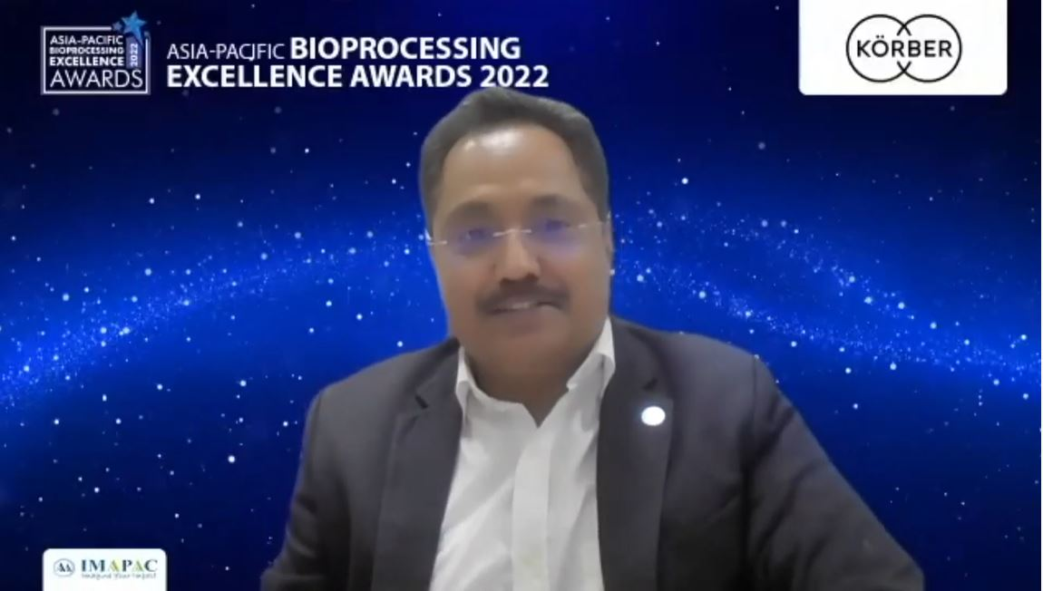

Rajesh Vedak, President Software India, Körber Business Area Pharma, receives the award at the virtual award ceremony.

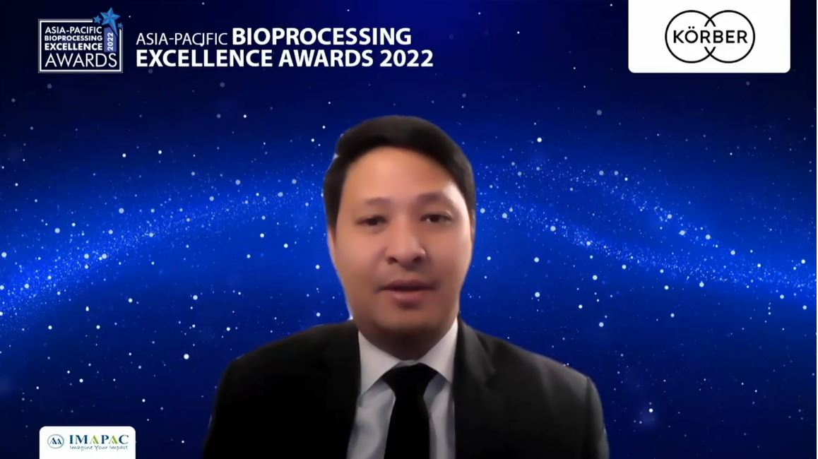

Teerapong Cheepchol, President Software Asia, Körber Business Area Pharma, receives the award for the fourth consecutive year during the virtual award ceremony.

**About Körber**

The Körber Group is an international technology group with around 10,000 employees at more than 100 locations worldwide, all bound by the same common goal: By uniting under a single brand, // Working in partnership, we are driven by an entrepreneurial spirit to turn our collective expertise into value for our customers. In the Business Areas Digital, Pharma, Supply Chain, Tissue and Tobacco, we offer products, solutions and services that inspire.

Our Business Area Pharma offers a portfolio of integrated services that provides our customers with a decisive competitive advantage along the entire value chain of pharmaceutical product development. Our software solutions support pharmaceutical enterprises with the digitization of their pharma-, biotech-, cell and gene therapy manufacturing processes. The Werum PAS-X MES Suite is recognized as the world’s leading Manufacturing Execution System for pharma, biotech and cell & gene. Our Werum PAS-X Intelligence Suite accelerates product commercialization with data analytics and AI solutions and uncovers hidden business value.

[www.koerber-pharma.com](http://www.koerber-pharma.com/)

**Contact**

Dirk Ebbecke

Körber Business Area Pharma

Head of Product Marketing Software

T: +49 4131 8900-0

E-mail: dirk.ebbecke@koerber.com