Körber joins the Alliance of Regenerative Medicine, supporting cell and gene companies with its manufacturing software solutions

Lüneburg, Germany, 29 September 2020. Körber is proud to announce its membership with the Alliance for Regenerative Medicine (ARM). ARM is the leading international advocacy organization committed to realizing the promise of regenerative medicines and advanced therapies. The Körber Business Area Pharma is dedicated to supporting regenerative medicine by working with ARM, continuously innovating its digital solutions for the cell and gene therapy industry.

“We are joining forces with the Alliance for Regenerative Medicine and the entire cell and gene therapy community to help foster the mission of saving patients’ lives,” says Rachit Jain, Head of Cell and Gene Therapy Software, Körber Business Area Pharma. “As a customer-centric digital solutions market leader, our main goal is to support cell and gene manufacturers deliver lifesaving therapies to patients – right first time every time. We want to help bring these precious therapies to market and encourage more of these groundbreaking companies to get pivotal approvals to accomplish their goals. Our vision is to be the one stop shop and help build a cell and gene consortium where we add significant value in enhancing patients and caregivers lives.”

Körber is the market leader in digital manufacturing solutions for the cell and gene industry and has been an active part of the cell and gene manufacturing industry with its manufacturing IT solution Werum PAS-X MES since the first FDA approval of a therapy took place in 2017. The software experts of Körber’s Business Area Pharma are committed to helping expedite the development of regenerative treatments that have the potential to be lifesaving.

The Alliance for Regenerative Medicine is the leading international advocacy organization committed to realizing the promise of regenerative medicines and advanced therapies. As the voice of the sector, ARM represents the interests of 360+ members across 25 countries, including small and large companies, academic research institutions, major medical centers and patient groups.

Picture
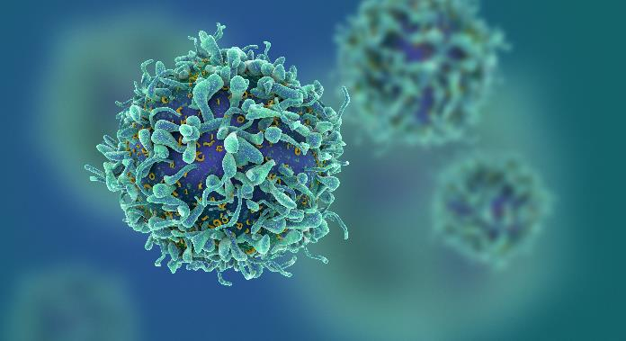
Körber supports cell and gene manufacturers worldwide

About the Körber Business Area Pharma
Körber is an international technology group with about 10,000 employees, more than 100 locations worldwide and a common goal: We turn entrepreneurial thinking into customer success and shape the technological change. In the Business Areas Digital, Pharma, Supply Chain, Tissue and Tobacco, we offer products, solutions and services that inspire.
At the Körber Business Area Pharma we are delivering the difference along the pharma value chain with our unique portfolio of integrated solutions. With our software solutions we help drug manufacturers to digitize their pharma, biotech and cell & gene factories. The software product Werum PAS-X MES is recognized as the world’s leading Manufacturing Execution System for the pharma & biotech industry. Our data analytics and AI solutions accelerate product commercialization and uncover hidden business value.
www.koerber-pharma.com

Contact
Dirk Ebbecke
Körber Business Area Pharma
Head of Global Marketing & Communications Software
Werum IT Solutions GmbH
T: +49 4131 8900-689
E-mail: dirk.ebbecke@werum.com

