Körber Business Area Pharma: New Chief Operating Officer strengthens software competence

Lüneburg, Germany, 11 December 2020. Since 1 December 2020, Dr. Christoph Fink has been appointed as Chief Operating Officer (COO) of Werum IT Solutions GmbH in the Körber Business Area Pharma at the site in Lüneburg. He will manage the operational customer business and drive the expansion of the international service portfolio and global growth.

“With Christoph Fink, we were able to win a top manager who convinced us with his many years of experience in the areas of digitization, customer centricity and leading international teams,” says Jens Woehlbier, Chief Executive Officer (CEO) Software, Körber Business Area Pharma. “He will advance the further development of our service portfolio and support our pharma and biotech customers on their way to the digitized factory. We wish him great success in his new position."

Jörn Gossé, Chief Executive Officer (CEO) in the Körber Business Area Pharma, is also pleased about the reinforcement in corporate management: “I am convinced that with his expertise and many years of experience in Asia, Christoph Fink will set the course for a continued successful future for our software offering. I wish him all the best for this!"

Christoph Fink studied physics and economical engineering and holds a doctorate in electrical engineering. He started his career at Deloitte as a Technology and Management Consultant. In the course of his professional career, he gained experience in numerous management positions at internationally operating technology and IT companies, such as Siemens and Atos Information Technology, among others in China and Singapore. Most recently, he was Head of Chapter Service and Operations Telematics at T-Systems International GmbH based in Vienna, and was responsible for deployment and service management of Deutsche Telekom's telematics infrastructure for the digitalization of the German healthcare system.

Picture
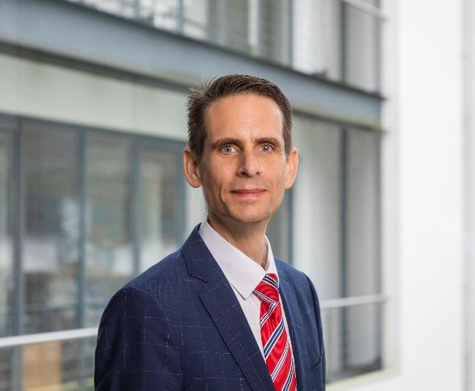
Dr. Christoph Fink, Chief Operating Officer (COO) Software, Körber Business Area Pharma

About Körber
Körber is an international technology group with about 10,000 employees, more than 100 locations worldwide and a common goal: We turn entrepreneurial thinking into customer success and shape the technological change. In the Business Areas Digital, Pharma, Supply Chain, Tissue and Tobacco, we offer products, solutions and services that inspire.
At the Körber Business Area Pharma we are delivering the difference along the pharma value chain with our unique portfolio of integrated solutions. With our software solutions we help drug manufacturers to digitize their pharma, biotech and cell & gene factories. The software product Werum PAS-X MES is recognized as the world’s leading Manufacturing Execution System for the pharma & biotech industry. Our data analytics and AI solutions accelerate product commercialization and uncover hidden business value.
www.koerber-pharma.com

Contact
Dirk Ebbecke
Körber Business Area Pharma
Head of Global Marketing & Communications Software
Werum IT Solutions GmbH
T: +49 4131 8900-689
E-mail: dirk.ebbecke@koerber-pharma.com

