Connext Asia: Körber brings pharma MES users in Asia-Pacific together virtually

Lüneburg, Germany / Bangkok, Thailand, 13 October 2021. Pharma, biotech and cell & gene companies who use Werum PAS-X MES as well as those who are interested in manufacturing IT solutions to digitize their production are invited to Connext Asia 2021 – The virtual Pharma Software Summit by Körber.

The five-day-conference from 22-26 November 2021 will take place as a virtual online event. Succeeding the previous Manufacturing Excellence Days and PAS-X User Group Meetings it is the pharma MES industry event in Asia. Körber Business Area Pharma will host five different episodes on five days, each dedicated to a specific region in the Asia Pacific: Indonesia, Thailand, South Korea, Japan, Singapore/South East Asia and India. The sessions will be conducted in local languages:

- 22 November, Episode 1: Indonesia (in Bahasa Indonesia language)
- 23 November, Episode 2: Thailand (in Thai)
- 24 November, Episode 3: South Korea (in Korean)
- 25 November, Episode 4: Japan (in Japanese)
- 26 November, Episode 5: Singapore/South East Asia & India (in English)

“We look forward to meeting online with all pharma and biotech industry experts from Asia Pacific,” says Teerapong Cheepchol, President Software Asia, Körber Business Area Pharma. “Our best-in-class program is localized and tailor-made for each region in the Asia Pacific with the aim to better support our customers. Join us and find out more about our software solutions and how they help digitize the pharma, biotech and cell & gene therapy production.”

“Connext Asia gives us the opportunity to connect with our clients and Werum PAS-X MES users globally in these extraordinary times of global pandemic. We can exchange and share use cases and experiences, especially in the area of Pharma 4.0 in the qualified environment of pharmaceutical manufacturing worldwide,” adds Rajesh Vedak, President & Managing Director Software India at Körber Business Area Pharma.

The virtual event is held under the theme “Elevate your business. Together.” and offers a comprehensive program of best-practice case studies, product demonstrations, expert panel discussions and updates from regulatory authorities:

- Products + Solutions
Stay up to date on the latest PAS-X manufacturing IT solutions to save time & effort and avoid risk in pharmaceutical production
- Best Practices + Insights
Learn from PAS-X customer cases by Government Pharmaceutical Organization (GPO) and Lupin and PAS-X user panel discussions with Biocon, Cipla, Inventia Healthcare, the Foundation for Biomedical Research and Innovation at Kobe (FBRI) and Takeda
- Thoughts + Opinions
Join our industry thought leader discussion with Kimia Farma to learn about their digital transformation initiatives and the “Road to Pharma 4.0.”
- Regulatory + Quality
Join us and get the latest updates on regulations in the pharma industry from regulatory authorities such as the National Agency of Drug and Food Control of Indonesia (Badan POM)

Further information and registration under connext.koerber-pharma.com/connext-asia. Participating in the conference is free for Werum PAS-X MES users and interested representatives of pharma and biotech companies.

Picture
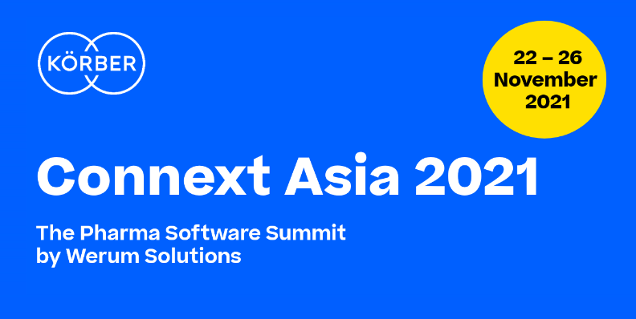

About Körber
Körber is an international technology group with about 10,000 employees, more than 100 locations worldwide and a common goal: We turn entrepreneurial thinking into customer success and shape the technological change. In the Business Areas Digital, Pharma, Supply Chain, Tissue and Tobacco, we offer products, solutions and services that inspire.
At the Körber Business Area Pharma we are delivering the difference along the pharma value chain with our unique portfolio of integrated solutions. With our software solutions we help drug manufacturers to digitize their pharmaceutical, biotech and cell & gene factories. The Werum PAS-X MES Suite is recognized as the world’s leading Manufacturing Execution System for pharma, biotech and cell & gene. Our Werum PAS-X Intelligence Suite accelerates product commercialization with data analytics and AI solutions and uncovers hidden business value.
www.koerber-pharma.com

Contact
Dirk Ebbecke
Körber Business Area Pharma
Head of Global Marketing & Communications Software
T: +49 4131 8900-0
E-mail: dirk.ebbecke@koerber.com

