Connext: first virtual pharma software summit for Werum PAS-X users and the pharma & biotech industry

Lüneburg, Germany, 12 February 2021. Pharma, biotech and cell & gene companies who use Werum PAS-X MES as well as those who are interested in the use of manufacturing IT and manufacturing intelligence to digitize their production are invited to Connext 2021 – the new virtual Pharma Software Summit by Werum Solutions.

This four-day-conference from 2-5 March 2021 will take place for the first time and as a virtual online event. Accommodations have been made for different time zones in Asia, Europe and the US. Connext is succeeding the yearly PAS-X User Group Meeting (UGM) and the PFU (PAS-X for Us) Meeting.

“We expect pharma and biotech experts from all over the world,” says Jens Woehlbier, Chief Executive Officer (CEO) Software, Körber Business Area Pharma. “Together, they form the world's largest pharma software community! Join us, connect yourself and learn how our Körber software solutions help digitize your pharma, biotech and cell & gene therapy production.”

Under the motto “Elevating your business. Together.”, Connext offers a comprehensive program of best-practice user presentations, workshops, product demonstrations, panel discussions and online networking opportunities to get attendees connected:

- Products + Solutions
Stay up to date on the latest PAS-X manufacturing IT solutions to save time & effort and avoid risk in pharmaceutical production
- Best Practices + Insights
Learn from PAS-X customer cases by Bayer, Boehringer Ingelheim, Regeneron and SteriPack and PAS-X user panel discussions with Amazon Web Services, Johnson & Johnson und Lyell
- Workshops + Insights
Select from different manufacturing topics, discuss the challenges in daily work and strategize the solutions
- Thoughts + Opinions
Join industry thought leader discussions with AstraZeneca, Bayer, Novartis, Takeda and Vetter Pharma
- Experts + Exchange
Network with Körber’s pharma software experts and peers in virtual rooms

Further information and registration under connext.koerber-pharma.com. Participating in the conference is free for PAS-X users and interested representatives of pharma and biotech companies.

Picture
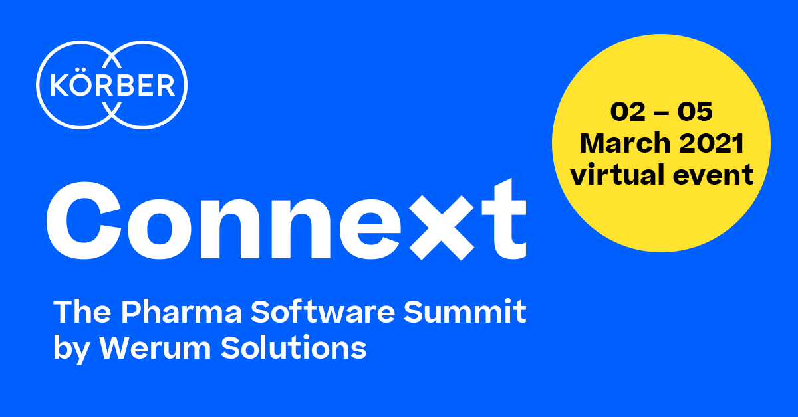

About Körber
Körber is an international technology group with about 10,000 employees, more than 100 locations worldwide and a common goal: We turn entrepreneurial thinking into customer success and shape the technological change. In the Business Areas Digital, Pharma, Supply Chain, Tissue and Tobacco, we offer products, solutions and services that inspire.
At the Körber Business Area Pharma we are delivering the difference along the pharma value chain with our unique portfolio of integrated solutions. With our software solutions we help drug manufacturers to digitize their pharma, biotech and cell & gene factories. The software product Werum PAS-X MES is recognized as the world’s leading Manufacturing Execution System for the pharma & biotech industry. Our data analytics and AI solutions accelerate product commercialization and uncover hidden business value.
www.koerber-pharma.com

Contact
Dirk Ebbecke
Körber Pharma Software
Head of Global Marketing & Communications
Werum IT Solutions GmbH
T: +49 4131 8900-0
E-mail: dirk.ebbecke@koerber-pharma.com

