Connext: Körber’s first virtual pharma software summit connects the global pharma MES community

Lüneburg, Germany, 10 March 2021. With almost 900 registrants from 160 different pharmaceutical and biotech companies from 45 countries around the globe, Connext celebrated a convincing start as a virtual software conference for the pharmaceutical industry. Right from the beginning, the format established itself as the largest and most international network event for software experts from the pharmaceutical industry.

Connext brings together pharmaceutical, biotech and cell & gene therapy companies who use Werum PAS-X MES as well as those who are interested in the use of manufacturing IT and manufacturing intelligence to digitize their production. The four-day online event succeeds the annual PAS-X User Group Meeting (UGM) and the parallel PFU meeting (PAS-X for Us) and is organized by the software experts from the Körber Business Area Pharma. For the first time, this PAS-X community meeting took place as a virtual online event.

“Under the theme 'Elevating your business. Together.‘ we put together a comprehensive program of best-practice user presentations, workshops, product demonstrations, panel discussions and various online networking opportunities,” says Jens Woehlbier, Chief Executive Officer (CEO) Software, Körber Business Area Pharma. “We were able to interactively show our numerous customers and interested parties from all over the world how they can use our PAS-X software products and services to reduce time, effort and risk in their pharmaceutical production.”

First virtual software summit for the pharmaceutical industry with record attendance
The highlights of the virtual event included panel discussions on the topics of “COVID-19 and the importance of MES” and “MES in the cloud” with industry thought leaders such as Amazon Web Services, AstraZeneca, Bayer, Johnson & Johnson, Lyell Immunopharma, Novartis and Takeda. Leading pharma and biotech companies such as Bayer, Boehringer Ingelheim, Regeneron and SteriPack presented their best-practice PAS-X MES implementation projects and explained how their production benefits from the Körber MES.

In almost 20 virtual workshops, the participants could work in small virtual groups on various specific topics from pharmaceutical production and discuss challenges in their daily work together. Important topics were the use of artificial intelligence, electronic GMP archives, digitization in cell and gene therapy, digital twins in process characterization, data collection and analysis as well as shop floor integration.

Jörn Gossé, CEO of Körber Business Area Pharma, is also satisfied: “The great interest in this pharmaceutical event, which is reflected in the very high number of registrations from drug manufacturers all over the world, exceeded our expectations! Thanks to the interactive virtual format of Connext, we were able to live up to our own claim to deliver a difference for the participants in their daily work.”

Interested parties can find a highlight video from Connext here.

Picture
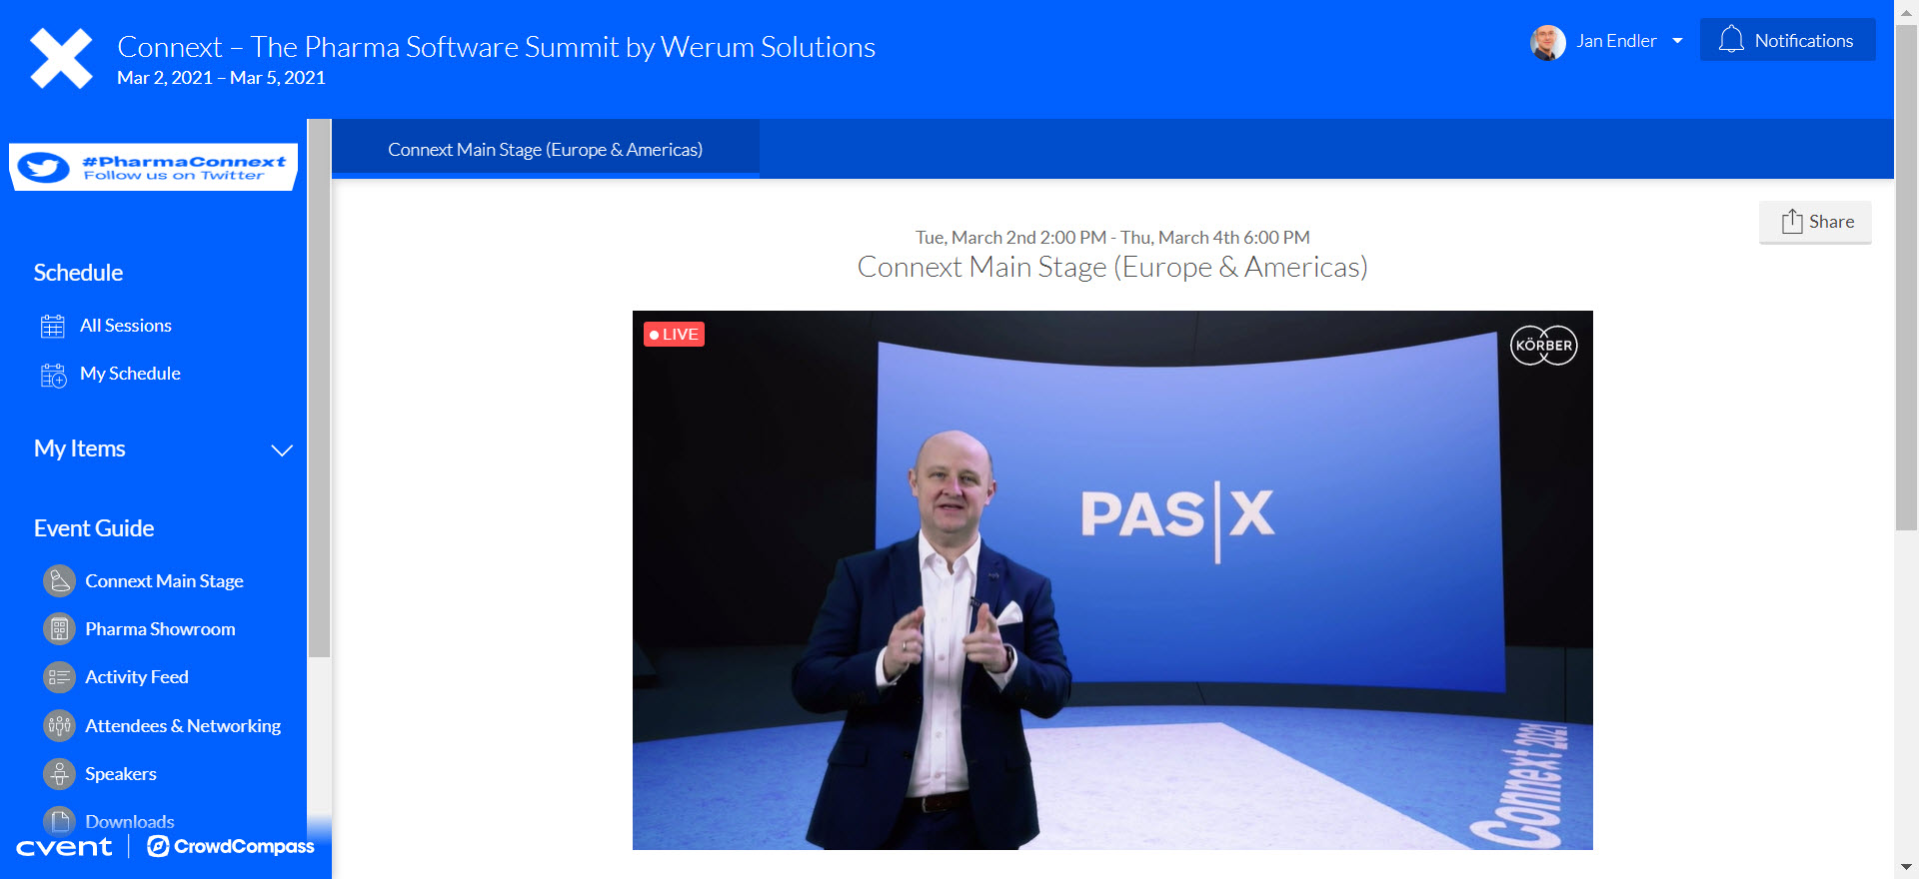
Jens Woehlbier, Chief Executive Officer (CEO) Software, Körber Business Area Pharma, opening Connext – The Pharma Software Summit by Werum Solutions

About Körber
Körber is an international technology group with about 10,000 employees, more than 100 locations worldwide and a common goal: We turn entrepreneurial thinking into customer success and shape the technological change. In the Business Areas Digital, Pharma, Supply Chain, Tissue and Tobacco, we offer products, solutions and services that inspire.
At the Körber Business Area Pharma we are delivering the difference along the pharma value chain with our unique portfolio of integrated solutions. With our software solutions we help drug manufacturers to digitize their pharma, biotech and cell & gene factories. The software product Werum PAS-X MES is recognized as the world’s leading Manufacturing Execution System for the pharma & biotech industry. Our data analytics and AI solutions accelerate product commercialization and uncover hidden business value.
www.koerber-pharma.com

Contact
Dirk Ebbecke
Körber Pharma Software
Head of Global Marketing & Communications
Werum IT Solutions GmbH
T: +49 4131 8900-0
E-mail: dirk.ebbecke@koerber-pharma.com

