The largest Thai pharma manufacturer GPO migrates to latest PAS-X MES from Körber to maintain efficient manufacturing and highest quality

Lüneburg, Germany / Bangkok, Thailand, 12 May 2022.The Government Pharmaceutical Organization (GPO) has successfully migrated its manufacturing execution system Werum PAS-X MES from version 2 to version 3 at their main production site in Rangsit, Thailand. Being a Thai state-owned enterprise, GPO is the largest pharmaceutical producer and distributor of essential medicines for the Thai market.

“Werum PAS-X MES helps us to benefit from quality-by-design principles and international best practices to manufacture affordable medicines for the people of Thailand,” says Dr. Mukdavan Prakobvaitayakit, Deputy Managing Director at Government Pharmaceutical Organization. “With the latest PAS-X MES platform, the production is up to date and fully integrated to surrounding IT systems like the Building Automation System, SAP, and LIMS, ensuring efficient manufacturing, compliant data transfer and the highest quality standards.”

“Heartiest congratulations to the GPO team on this remarkable milestone,” states Teerapong Cheepchol, President Software, Asia at Körber Business Area Pharma. “With the deployment of the latest PAS-X MES, GPO will be able to easily tackle daily challenges of pharma manufacturing, to ensure operational excellence and regulatory compliance, and to deliver life-saving medicinal products faster to the market.”

GPO was the first pharmaceutical manufacturer in Thailand that deployed Werum PAS-X MES in 2015. GPO’s objective was to change and adapt by digitizing its processes and using state-of-the-art IT systems. PAS-X MES is used as a full-scope MES across the whole facility, from receiving raw materials to batch production, packaging and shipment of the finished products to the GPO nationwide supply chains. PAS-X MES helps GPO to reduce deviations and increase productivity, e.g. in the dispensing process and in the batch record review and approval process.

Picture
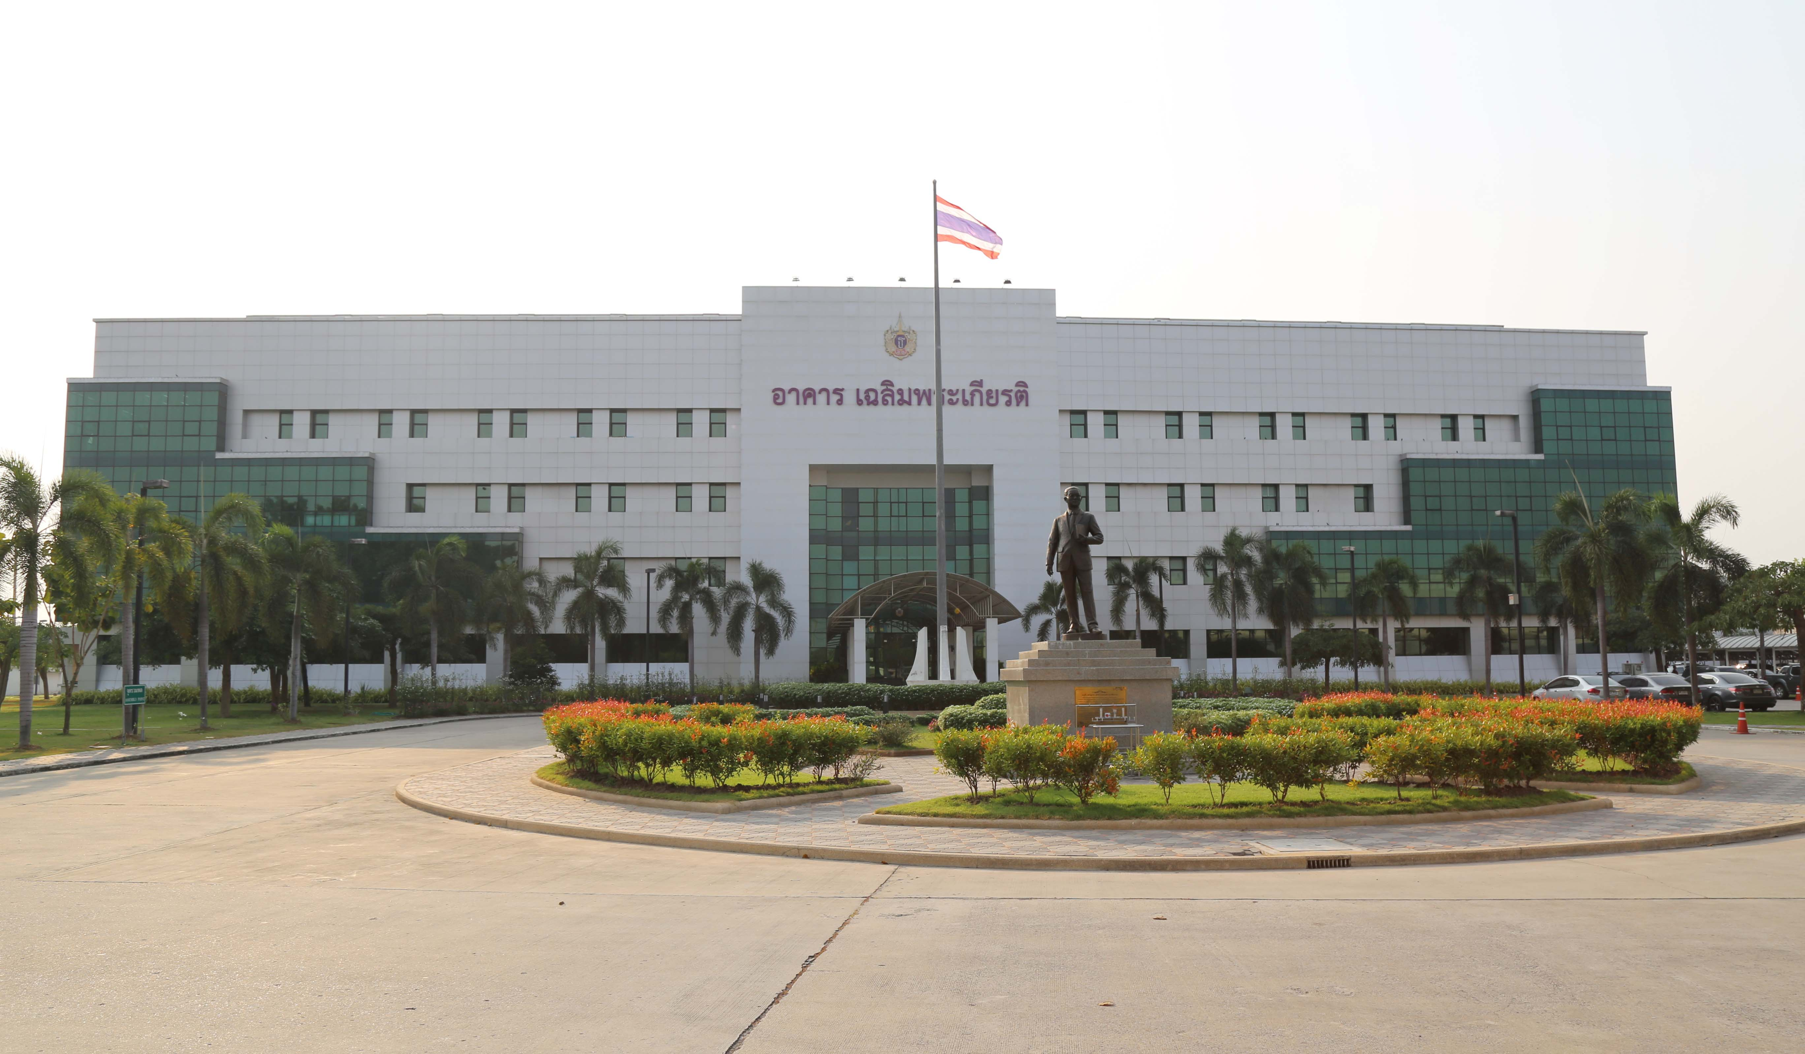
GPO Rangsit pharmaceutical plant, Thailand

About Körber
Körber is an international technology group with about 10,000 employees, more than 100 locations worldwide and a common goal: We turn entrepreneurial thinking into customer success and shape the technological change. In the Business Areas Digital, Pharma, Supply Chain, Tissue and Tobacco, we offer products, solutions and services that inspire.
At the Körber Business Area Pharma we are delivering the difference along the pharma value chain with our unique portfolio of integrated solutions. With our software solutions we help drug manufacturers to digitize their pharmaceutical, biotech and cell & gene factories. The Werum PAS-X MES Suite is recognized as the world’s leading Manufacturing Execution System for pharma, biotech and cell & gene. Our Werum PAS-X Intelligence Suite accelerates product commercialization with data analytics and AI solutions and uncovers hidden business value.
www.koerber-pharma.com

Contact
Dirk Ebbecke
Körber Business Area Pharma
Head of Product Marketing Software
T: +49 4131 8900-0
E-mail: dirk.ebbecke@koerber.com

