CDMO IDT Biologika digitizes its main facility successfully with Werum PAS-X MES

Lüneburg, Germany, 14 March 2022. The contract development and manufacturing organization (CDMO) IDT Biologika is embarking Industry 4.0 and the fully networked automated pharmaceutical production and has put Körber’s Werum PAS-X MES into operation at its main facility in Dessau, Germany, as an important milestone.

IDT Biologika is an innovative biotech company with a 100-year track record. Based on modern technologies and a high level of expertise, the CDMO supports customers in the development and manufacture of innovative virus vaccines, gene and immunotherapy products as well as biologicals.

The central requirements of the digitization project were the replacement of paper-based production documentation and logbooks with electronic batch recording. The data exchange between ERP (Enterprise Resource Planning) and MES (Manufacturing Execution System) should be automated. Most of the requirements were met through the standard implementation of PAS-X MES. Customizations were reduced to a minimum by adapting the IDT processes to the software.

“Werum PAS-X MES plays an important role in our digitization strategy," says Dr. Martin Wesseling, Director Technical Operations Head MES / EBR at IDT Biologika. "Due to the increasing digitization and automation of our processes, we can significantly reduce the batch throughput and record times, thus achieving a good right-first-time factor and high delivery reliability. We successfully avoid manual effort and errors, for example in batch preparation, documentation and archiving.”

The packaging department, where many processes have already been standardized, is a pioneer in the introduction of the digital manufacturing execution system at IDT. Customers also appreciate the innovation, because many of them work with the PAS-X MES system themselves and know that such a system delivers reliable quality: “It is definitely a customer magnet. In my eyes, the MES is the biggest digitization project at IDT and the most important project for us in packaging, which we are currently successfully completing,” says Frank Föhrigen, Head of Packaging, IDT Biologika.

The biggest advantage of working with such a system is that human error is virtually eliminated. Frank Föhrigen adds: "We deliver highest quality and give customers confidence in our processes. They expect us to have systems that prevent us from making mistakes. And now we have chosen one with Körber, which is the top of the line. It's the best we can have."

PAS-X MES is currently used in the packaging area. In a next step, the MES is to be deployed in the production area Drug Substances and Drug Product including filling processes and visual inspection. In addition, an automated exchange of information between PAS-X MES and the production systems on level 2 will be implemented.

Picture
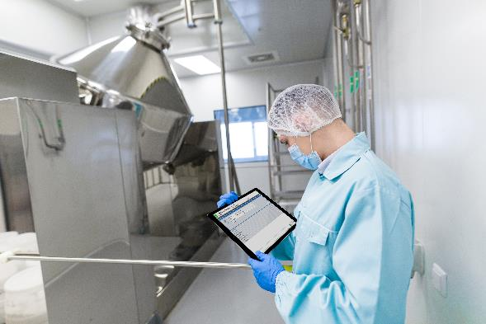
IDT Biologika has put Werum PAS-X MES into operation at its main facility in Dessau, Germany

About Körber
Körber is an international technology group with about 10,000 employees, more than 100 locations worldwide and a common goal: We turn entrepreneurial thinking into customer success and shape the technological change. In the Business Areas Digital, Pharma, Supply Chain, Tissue and Tobacco, we offer products, solutions and services that inspire.
At the Körber Business Area Pharma we are delivering the difference along the pharma value chain with our unique portfolio of integrated solutions. With our software solutions we help drug manufacturers to digitize their pharmaceutical, biotech and cell & gene factories. The Werum PAS-X MES Suite is recognized as the world’s leading Manufacturing Execution System for pharma, biotech and cell & gene. Our Werum PAS-X Intelligence Suite accelerates product commercialization with data analytics and AI solutions and uncovers hidden business value.
www.koerber-pharma.com

Contact
Dirk Ebbecke
Körber Business Area Pharma
Head of Product Marketing
T: +49 4131 8900-0
E-mail: dirk.ebbecke@koerber.com

About IDT Biologika
IDT Biologika is an innovative biotech company with a successful history dating back 100 years. On the basis of modern technologies and high levels of expertise, IDT supports customers in the development and manufacture of innovative virus vaccines, gene and immune therapy products as well as biologics employed worldwide as protection against diseases. IDT Biologika employs approximately 1,650 people. German sites are the BioPharmaPark in Dessau-Roßlau and Magdeburg. In the US, the IDT Corporation
has a manufacturing site for clinical test samples in Rockville, Maryland.
www.idt-biologika.com

Contact
Corinna Meisel
Corporate Communications Specialist
T +49 173 9249671
E-mail: corinna.meisel@idt-biologika.de

