Körber signs strategic agreement with Chinese domestic cell & gene therapy leader to set up smart factory

Lüneburg, Germany / Beijing, China, 29 June 2021. Körber and Immunotech Biopharm will implement Werum PAS-X MES in a greenfield cell & gene site in Beijing. This step is an important milestone to start Immunotech’s digital journey towards intelligent manufacturing.

As the China domestic leader in cell & gene therapy, Immunotech regards digitization and intelligent manufacturing as one of the company’s core strategies. By introducing Körber’s Manufacturing Execution System (MES) Werum PAS-X in the greenfield site in Beijing, Immunotech will build a new smart factory that takes into account safety and efficiency, while enabling interconnection and data transfer during the entire production process. In this way, the company can accelerate the strategic process of digitization and intelligence, and provide more high-quality products and services to the market.

“We are very pleased to reach a comprehensive cooperation with Körber,” says Dr. Wang Yu, Chief Executive Officer (CEO) of Immunotech Biopharm Ltd. “As the market leader, Werum PAS-X MES has unique advantages, which offers us innovative concepts and industry best practices. PAS-X combines software, content and services, and ensures fast deployment. I am looking forward to our joint cooperation, laying a solid foundation for Immunotech to accelerate product commercialization as well as to provide strong technical support to achieve our ultimate goal of curing patients.”

Jerry Zheng, General Manager China Hub of Körber Business Area Pharma, adds: “Against the backdrop of Industry 4.0, the strategic plan ‘Made in China 2025’ and the integration of digitization and intelligence in various industries across China, leveraging technology to assist the pharmaceutical industry is the trend of the future. Our PAS-X software solution has always been focusing on the factory and supply chain, while taking into account the specific requirements of the regulatory agencies and the industry itself. MES is an important entry point and breakthrough to drive intelligent manufacturing, and it is an important vehicle for the digital transformation of pharmaceutical companies.”

Pictures
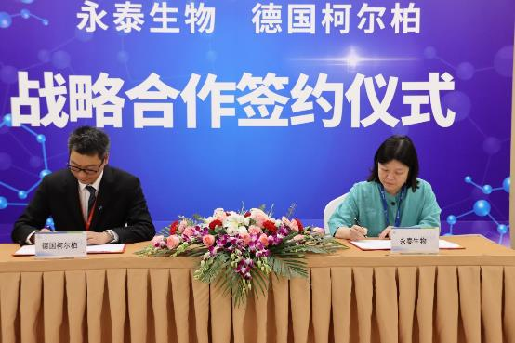
The signing ceremony (from left): Jerry Zheng, General Manager China Hub, Körber Business Area Pharma, and Dr. Wang Yu, CEO, Immunotech Biopharm

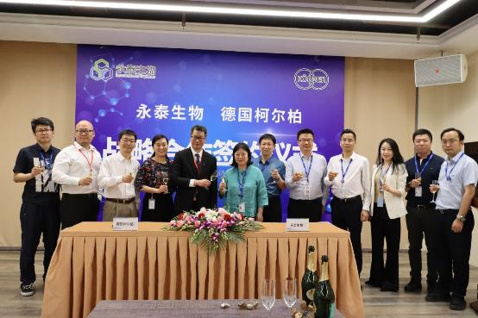
Group photo

About Immunotech Biopharm
Immunotech Biopharm Ltd. is an innovative technology enterprise specializing in the research and development of immunotherapeutic drugs. It has been recognized as a China national high-tech enterprise and owns internationally advanced technologies and rich research and development experience. Since its establishment in 2006, Immunotech Biopharm has always adhered to the “Give life a second chance” business philosophy, focusing on scientific research and technological innovation. The company is committed to the application of immunology, cell biology and genetics. It aims to develop immunocellular therapy products for major diseases such as malignant tumors, focusing on the construction of a systematic, GMP-compliant immune cell product development platform.

About Körber
Körber is an international technology group with about 10,000 employees, more than 100 locations worldwide and a common goal: We turn entrepreneurial thinking into customer success and shape the technological change. In the Business Areas Digital, Pharma, Supply Chain, Tissue and Tobacco, we offer products, solutions and services that inspire.
At the Körber Business Area Pharma we are delivering the difference along the pharma value chain with our unique portfolio of integrated solutions. With our software solutions we help drug manufacturers to digitize their pharma, biotech and cell & gene factories. The software product Werum PAS-X MES is recognized as the world’s leading Manufacturing Execution System for the pharma & biotech industry. Our data analytics and AI solutions accelerate product commercialization and uncover hidden business value.
www.koerber-pharma.com

Contact
Dirk Ebbecke
Körber Business Area Pharma
Head of Global Marketing & Communications Software
Werum IT Solutions GmbH
T: +49 4131 8900-0
E-mail: dirk.ebbecke@koerber-pharma.com

