Körber and inmation announce partnership for data-driven shop floor integration in the pharma factory of the future

Lüneburg / Köln, Germany, 9 September 2021. Körber offers its customers a best-practice solution by adding a state-of-the-art historian function to the Werum PAS-X MES Suite, which enables archiving of structured data. With their partnership, Körber and inmation are striving to achieve a high degree of integration on the shop floor in brownfield pharmaceutical production.

Körber, the world's leading supplier of Manufacturing Execution Systems (MES) for the pharmaceutical, biotech and cell & gene therapy industries, and inmation, a technology leader in global real-time information management, announce their partnership.

“With this agreement, we continue to pursue our best-of-breed partnership strategy and will offer our clients all components for Pharma 4.0 in a one-stop-shop,” says Jens Woehlbier, Chief Executive Officer (CEO) Software of Körber Business Area Pharma. “The solution enables a high level of integration in pharmaceutical production in a fast and cost-effective way. This provides customers with an integrated MES-historian solution from a single source, helping them move towards a data-driven future.”

“Our software solution enterprise:inmation has seen spectacular growth in the regulated life science industry recently,” explains Timo Klingenmeier, CEO of inmation Software. “One of the main drivers for our customers is the platform’s ability to integrate all production systems and create a fully contextualized ‘digital twin’ of pharmaceutical production data. The MES plays a key role in the system orchestration, and we are very proud to enter into a close partnership with Körber, the leader in the field. We will further drive the integration of both platforms and align closely to leverage both companies’ strength for the next-generation system architecture in life science,” adds Klingenmeier.

Picture
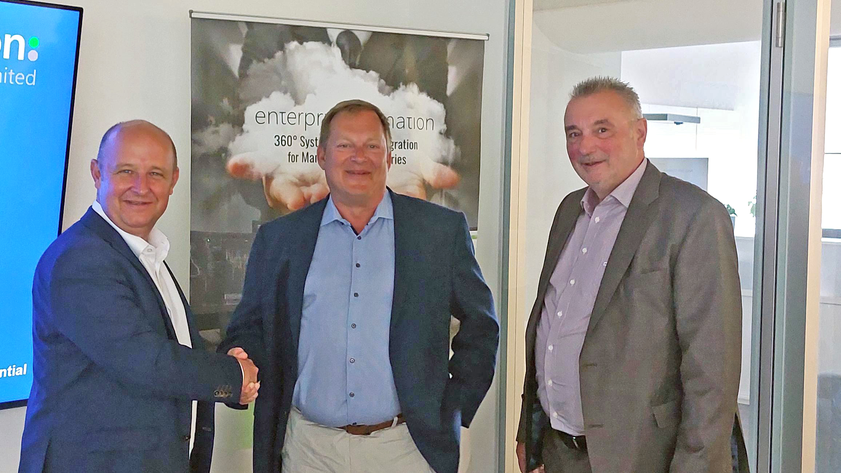
After signing of the contract: Jens Woehlbier, CEO Software, Körber Business Area Pharma, Timo Klingenmeier, CEO, inmation Software, and Reinhard Adam, Supervisory Board, inmation Software (from left to right).

About inmation Software
Headquartered in Cologne, Germany, inmation Software GmbH is one of the world's leading technology companies in the field of global and industrial real-time information management. Solutions such as enterprise:inmation are geared towards creating the real-time infrastructure for a holistic monitoring system of all data collected, as well as keeping Total Cost of Ownership (TCO) low whilst levels of networking become increasingly powerful. The scalable software adapts to the needs of customers and is able to integrate manufacturer-independent machines and components – from a micro installation for a single host to company-wide solutions with hundreds of systems on different continents. The continually growing, global client base is made up of leading companies operating in different industry sectors. Furthermore, inmation Software, in partnership with regional and international companies, is the contact point for manufacturing companies looking to effectively and sustainably realize 360° integration and full enterprise control.
www.inmation.com

Contact
Daniel Secker
Media Management
inmation Software GmbH
T: +49 221 168 144 16
E-mail: daniel.secker@inmation.com

About Körber
Körber is an international technology group with about 10,000 employees, more than 100 locations worldwide and a common goal: We turn entrepreneurial thinking into customer success and shape the technological change. In the Business Areas Digital, Pharma, Supply Chain, Tissue and Tobacco, we offer products, solutions and services that inspire.
At the Körber Business Area Pharma we are delivering the difference along the pharma value chain with our unique portfolio of integrated solutions. With our software solutions we help drug manufacturers to digitize their pharma, biotech and cell & gene factories. The software product Werum PAS-X MES is recognized as the world’s leading Manufacturing Execution System for the pharma & biotech industry. Our data analytics and AI solutions accelerate product commercialization and uncover hidden business value.
www.koerber-pharma.com

Contact
Dirk Ebbecke
Körber Business Area Pharma
Head of Global Marketing & Communications Software
T: +49 4131 8900-0
E-mail: dirk.ebbecke@koerber-pharma.com

