Körber expands local software offering for the life sciences industry in Italy

Lüneburg, Germany, 24 November 2022. Körber increases its activities in Italy with a dedicated local team and MES & Intelligence solutions for Italian pharma companies of all sizes. The international technology group provides the Werum PAS-X MES Suite which is recognized as the world’s leading Manufacturing Execution System (MES) for the life sciences industry.

Italy ranks as one of the key pharmaceutical production markets in Europe with a turnover of more than 34 billion euros. Next to Germany and France, this production value is amongst the highest within the European Union. Italy has the biggest CDMO (Contract Development Manufacturing Organizations) industry in Europe and its biopharma segment has been growing at a staggering pace for a decade.

Already today, Körber has a strong local installed base of Werum PAS-X MES with many multinational customers. In order to be able to support Italian customers even better in the future, Körber is strengthening its local team.

“Our customers benefit from the establishment of a local, dedicated Körber team consisting of MES Consultants, Solution Architects, Project Managers and Sales & Business Consultants,” says Mirko Magrini, Senior Manager Sales & Business Consulting, Körber Business Area Pharma. “Because with our local team we are present at the locations of our customers and speak their language. Our team will continue to grow to meet the needs of our Italian customers for scalable support and a full local service offering. Our goal is to establish Körber as the leading MES provider for the pharma, biotech and cell & gene therapy industries in Italy.”

Körber has a strong local presence and extensive market knowledge in Italy and is already active in Italy with the Tissue and Technologies Business Areas.

Picture
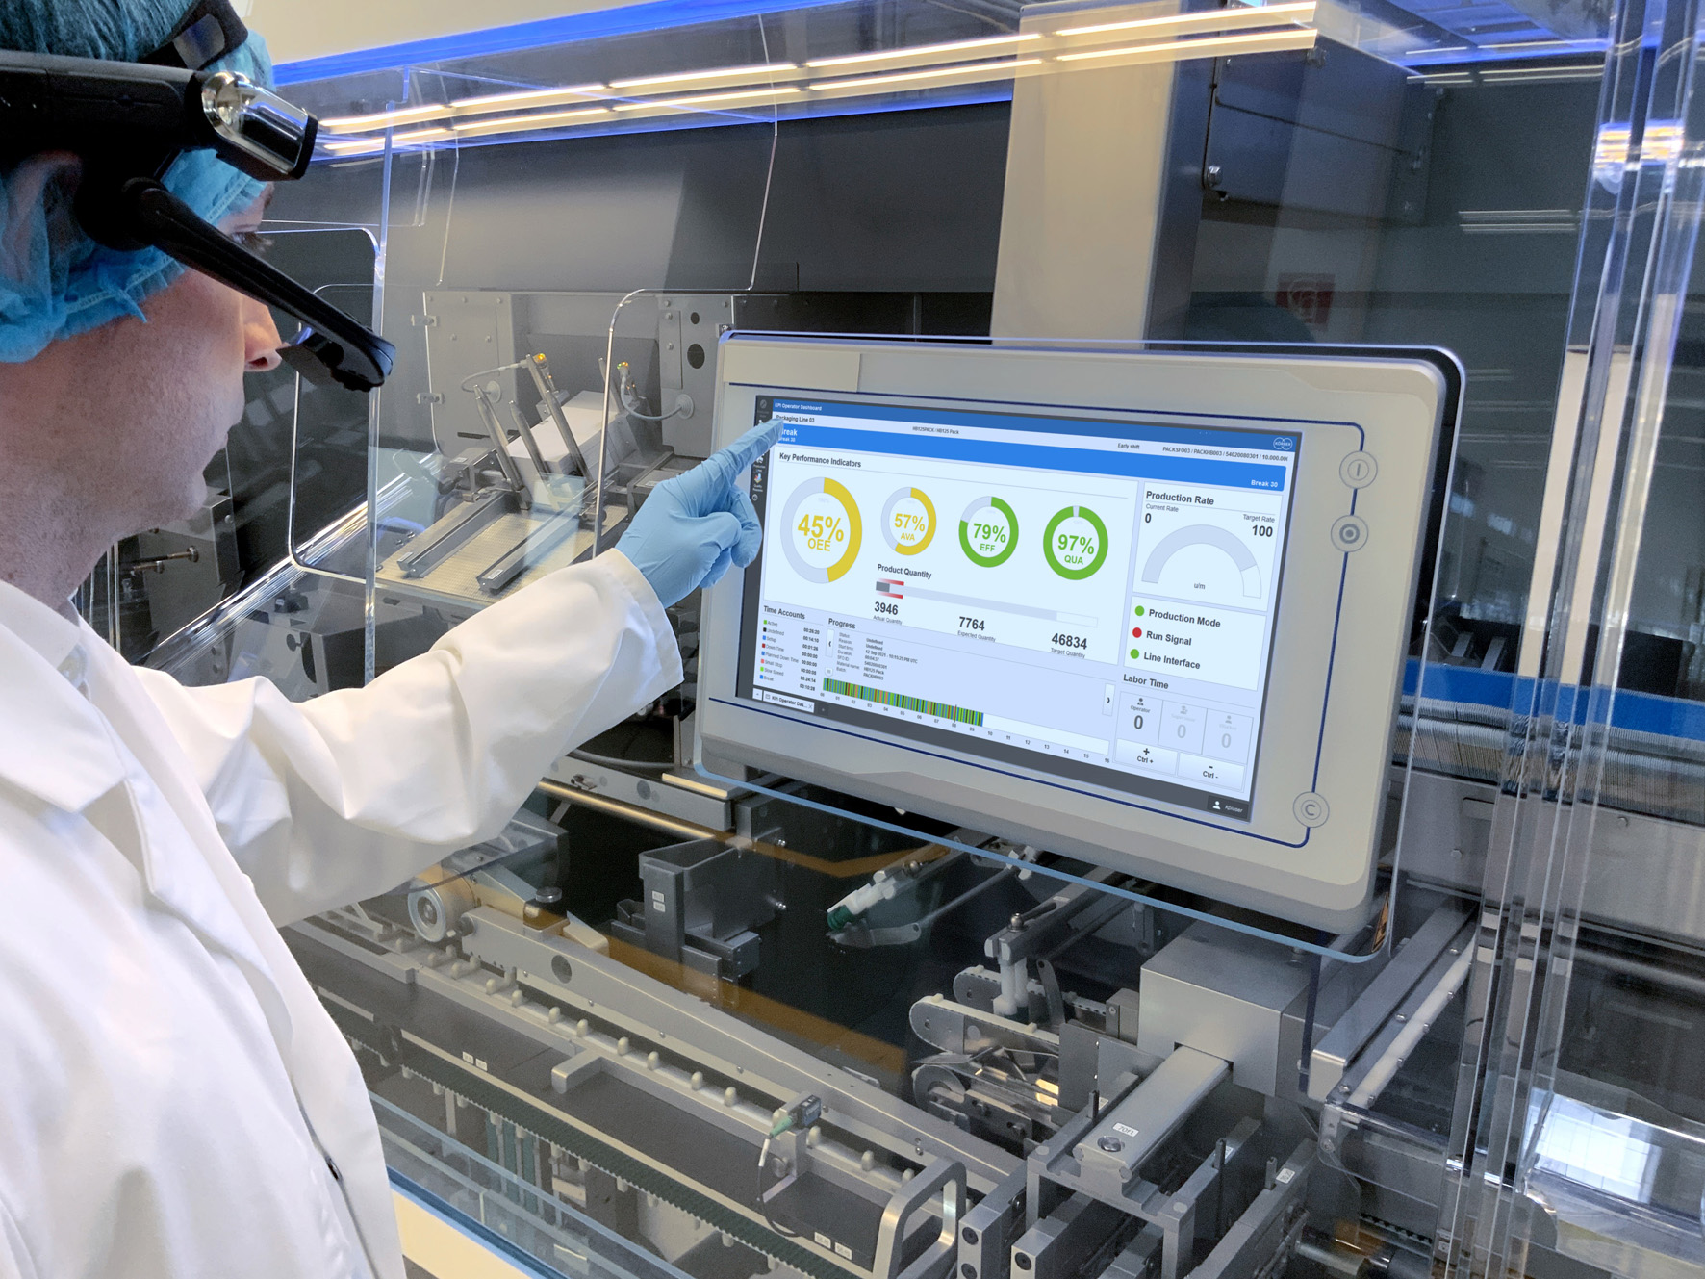

About Körber
Körber is an international technology group with about 12,000 employees, more than 100 locations worldwide and a common goal: We turn entrepreneurial thinking into customer success and shape the technological change. In the Business Areas Digital, Pharma, Supply Chain, Tissue and Technologies, we offer products, solutions and services that inspire.
At the Körber Business Area Pharma we are delivering the difference along the pharma value chain with our unique portfolio of integrated solutions. With our software solutions we help drug manufacturers to digitize their pharmaceutical, biotech and cell & gene therapy production. The Werum PAS-X MES Suite is recognized as the world’s leading Manufacturing Execution System for pharma, biotech and cell & gene. Our Werum PAS-X Intelligence Suite accelerates product commercialization with data analytics and AI solutions and uncovers hidden business value.
www.koerber-pharma.com

Contact
Dirk Ebbecke
Körber Business Area Pharma
Head of Product Marketing
T: +49 4131 8900-0
E-mail: dirk.ebbecke@koerber.com

