Extended biometric authentication for Werum PAS-X MES: Körber builds on solution from Integral Biometrics

Lüneburg, Germany, 6 October 2020. Users of Werum PAS-X MES can now benefit from an extended range of biometric authentication methods such as iris scan, fingerprint and facial recognition. To this end, the software experts of Körber’s Business Area Pharma have entered into a global collaboration with Integral Biometrics.

Integral's proven track record of designing and deploying biometric authentication solutions perfectly complements Werum K.ME-IN, the smart biometric authentication solution for pharma and biotech, allowing Werum PAS-X MES users to log in fast and securely. The US-based provider integrates the authentication products EyeLock for iris matching, DigitalPersona for fingerprint, and Windows Hello-compatible sensors for fingerprint and facial recognition, delivering increased productivity, security, ease and speed of use.

"Our collaboration with Integral Biometrics represents a milestone in offering the regulated life sciences industry the most secure and seamless way of authenticating to Werum PAS-X MES and other systems, devices and machines,” says Obay Alchorbaji, Product Manager Software, Körber Business Area Pharma. “Meeting all compliance and data integrity requirements, we can thus help our customers cut authentication times by up to 75 percent!”

“It is an eye-opener to realize that our biometric technologies offer an inherently human way to work with computers,” adds Marc Diament, Chief Executive Officer, Integral Biometrics. “Our solutions quickly and safely recognize users and take action on their behalf to make it easier and faster for them to get work done. In addition to significant user benefits, our customers gain large productivity increases. We are thrilled to work together with Körber.”

Integral offers ID At-a-GlanceTM and ID At-a-TouchTM biometric authentication with rapid and easy multi-factor biometric authentication with your finger and/or eye. This provides a level of efficiency, compliance, and security which cannot be achieved with typed logins and passwords. Cost-effective shared iris sensors at each workstation offer two-second authentication with industry-leading liveness detection, privacy protection and unique matching, as no two pairs of irises are alike. Fingerprint sensors provide sub-second logins for non-gloved workers or can be used in conjunction with iris matching to offer un-paralleled identity assurance and operator accountability.

Picture
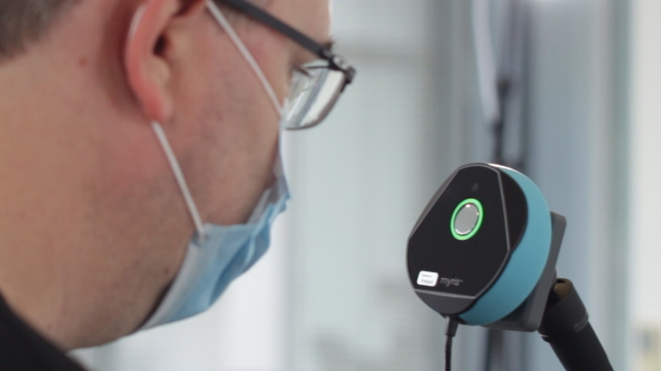
Werum PAS-X MES operators can now use iris scan with Integral Biometrics

About Integral Biometrics
Headquartered in Freehold, New Jersey, USA, Integral Biometrics (formerly Integral Technology Solutions, Inc.) is a provider of innovative integrated iris and fingerprint biometric solutions for global, world-class life science manufacturers. Integral's GxP compliant products enable real-time authentication supporting logins, eSignatures, password management, and other innovative automations. Our robust and flexible integration architecture which has been in continuous use for over 15 years provides increased productivity, ease and speed of use, and cost savings while protecting user privacy and system security.
www.integralbiometrics.com

About Körber
Körber is an international technology group with about 10,000 employees, more than 100 locations worldwide and a common goal: We turn entrepreneurial thinking into customer success and shape the technological change. In the Business Areas Digital, Pharma, Supply Chain, Tissue and Tobacco, we offer products, solutions and services that inspire.
At the Körber Business Area Pharma we are delivering the difference along the pharma value chain with our unique portfolio of integrated solutions. With our software solutions we help drug manufacturers to digitize their pharma, biotech and cell & gene factories. The software product Werum PAS-X MES is recognized as the world’s leading Manufacturing Execution System for the pharma & biotech industry. Our data analytics and AI solutions accelerate product commercialization and uncover hidden business value.
www.koerber-pharma.com

Contact
Dirk Ebbecke
Körber Business Area Pharma
Head of Global Marketing & Communications Software
Werum IT Solutions GmbH
T: +49 4131 8900-689
E-mail: dirk.ebbecke@werum.com

