Körber certifies Shanghai Leateck Technology as new Werum PAS-X Endorsed Service Partner in China

Lüneburg, Germany / Shanghai, China, 13 January 2021 – Körber further expands its Werum PAS-X MES service partner network. The world’s leading supplier of manufacturing execution systems (MES) for pharma, biotech and cell & gene therapy signed a strategic partnership agreement with Shanghai Leateck Technology. Leateck is a leading provider of consulting services and manufacturing solutions to help pharmaceutical companies in China meet compliance requirements, improve productivity and competitiveness.

As a strategic partner, Leateck will work with Körber in the People’s Republic of China to provide customers with high quality professional services and support regarding Werum PAS-X MES, from customer partnership exploration, on-site-implementation, operation and software maintenance.

As a certified PAS-X Endorsed Service Partner, Leateck will support Körber in implementing solutions for customers. Leateck will also provide services in project management, MBR design, system configuration, installation, validation and training. Customers in the Chinese life sciences market will benefit from high-quality Werum PAS-X MES implementation services.

“We value Leateck’s extensive local experience in realizing high-end solutions and services. This new strategic partnership of two strong solution providers in the life sciences industry is a further important step for us to expand our delivery capabilities in China,” says Jan-Henrik Dieckert, Executive Vice President Global Sales & Marketing Software, Körber Business Area Pharma.

Mr. Bin Lei, founder and chairman of Leateck, adds: “We are very excited about the partnership between Körber and Leateck. Together we will build a strategic and trustful partnership to empower customers with high-quality software and services to become China’s leading MES solution provider for the local pharmaceutical industry.”

PAS-X Endorsed Service Partners meet all requirements of Körber's PAS-X Service Partner Program. The main objective is to offer a consistent quality and competence of services to customers globally – through reliable, experienced and certified partners. The service partners need to have comprehensive Werum PAS-X MES knowledge, participate at PAS-X trainings on a regular basis, possess experience in the regulated industry and use a quality management system. The certification has to be renewed on a regular basis.

Picture
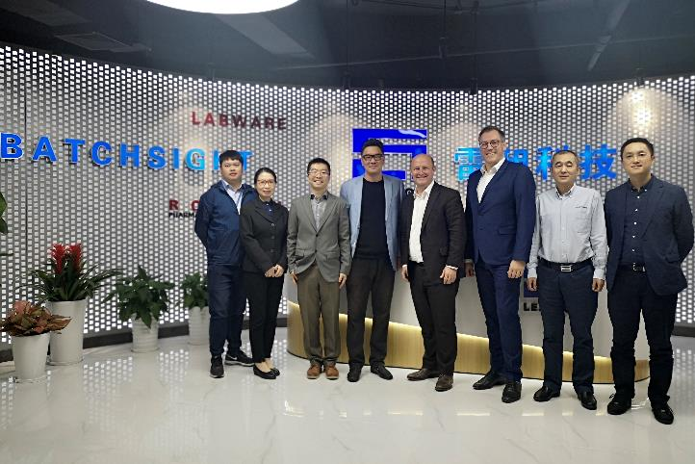
The teams of Leateck Technology and Körber Business Area Pharma (Software)

About Shanghai Leateck Technology Co., Ltd.
Shanghai Leateck Technology is a leading information service provider in the pharmaceutical industry in China, dedicated to innovatively integrate GMP consulting and comprehensive intelligent information services to help pharmaceutical companies improve cGMP management , so as to enhance their core competitiveness, and quickly enter the developed regulatory markets such as US and EU. After more than 20 years of hard work, our market share for FDA consulting business exceeds 70% in China pharmaceutical Industry, our market share for intelligent information services in China chemical drugs and vaccines industry has reached 15% and 65% respectively.

About Körber
Körber is an international technology group with about 10,000 employees, more than 100 locations worldwide and a common goal: We turn entrepreneurial thinking into customer success and shape the technological change. In the Business Areas Digital, Pharma, Supply Chain, Tissue and Tobacco, we offer products, solutions and services that inspire.
At the Körber Business Area Pharma we are delivering the difference along the pharma value chain with our unique portfolio of integrated solutions. With our software solutions we help drug manufacturers to digitize their pharma, biotech and cell & gene factories. The software product Werum PAS-X MES is recognized as the world’s leading Manufacturing Execution System for the pharma & biotech industry. Our data analytics and AI solutions accelerate product commercialization and uncover hidden business value.
www.koerber-pharma.com

Contact
Dirk Ebbecke
Körber Business Area Pharma
Head of Global Marketing & Communications Software
Werum IT Solutions GmbH
T: +49 4131 8900-689
E-mail: dirk.ebbecke@koerber-pharma.com

Sarah Shi
Marketing Specialist
Shanghai Leateck Technology Co., Ltd.
E-mail: shiminxia@leateck.org

