Pharma MES software: Körber announces the winners of its first MBR Design Challenge 2020 in India

Lüneburg, Germany / Mumbai, India, 22 December 2020. The software experts of Körber’s Business Area Pharma today announced the winners of their first MBR Design Challenge, run by the team in India. The challenge was launched in August 2020 and has received massive attention from pharma manufacturers and MES solution providers in India with more than 100 entries in total.

The aim of Körber’s MBR Design Challenge is to encourage end users to utilize Werum PAS-X MES in the most efficient way, to facilitate understanding of the system, to optimally leverage MBR development and to avoid potential design negligence on a larger scale. In addition, the Körber software experts gain further insights in the way customers use Werum PAS-X MES and the MBR design features, providing valuable feedback on how to improve user experience in the future.

All participants were expected to solve different tasks like creating a detailed MBR, finding errors in an MBR, improving a sub-optimally designed MBR and taking a quiz around MBR design and business processes. The challenge itself and the award ceremony were conducted virtually, due to the global pandemic.

After a scrutinized and thorough review process by our esteemed juries, the following participants scored highest and were presented the „MBR Design Challenge 2020 Award“ trophies for their outstanding results:
- 1st place: Mr. Prasanth Krishnam, Dr. Reddy’s Laboratories
- 2nd place: Mr. Hareesh Puligilla, Dr. Reddy’s Laboratories
- 3rd place: Mr. Chiranjiv Panchal, Ajanta Pharma

Consolation prize winners (existing MES users):
- Mr. Vinod Jagdale, Ajanta Pharma
- Mr. Vinodkumar Pawade, Cipla

Consolation prize winners (former MES users):
- Mr. Swarup Bopardikar, Biocon Biologics
- Mr. Rupesh Zungare, Sun Pharma (Vadodara)

“A big thank you to Körber and the India team for organizing the MBR Design Challenge 2020,” says Mr. Prasanth Krishnam, MES MBR Designer at Dr. Reddy’s Laboratories. “I am very happy to be one of the finalists. The MBR Design Challenge helped me to learn new concepts to control multiple conditions. I would like to participate next year to learn new features and will certainly recommend the MBR Design Challenge to my colleagues.”

„I would like to congratulate all of our winners and also thank all participants for taking the time to take part – even with a full-time job – and putting great effort into this challenge. We are very thrilled by the results and will continue running the MBR Design Challenge in the next years for pharma manufacturers and Werum PAS-X MES users in India,“ states Rajesh Vedak, Managing Director at Körber Medipak Systems India Pvt. Ltd.

Picture
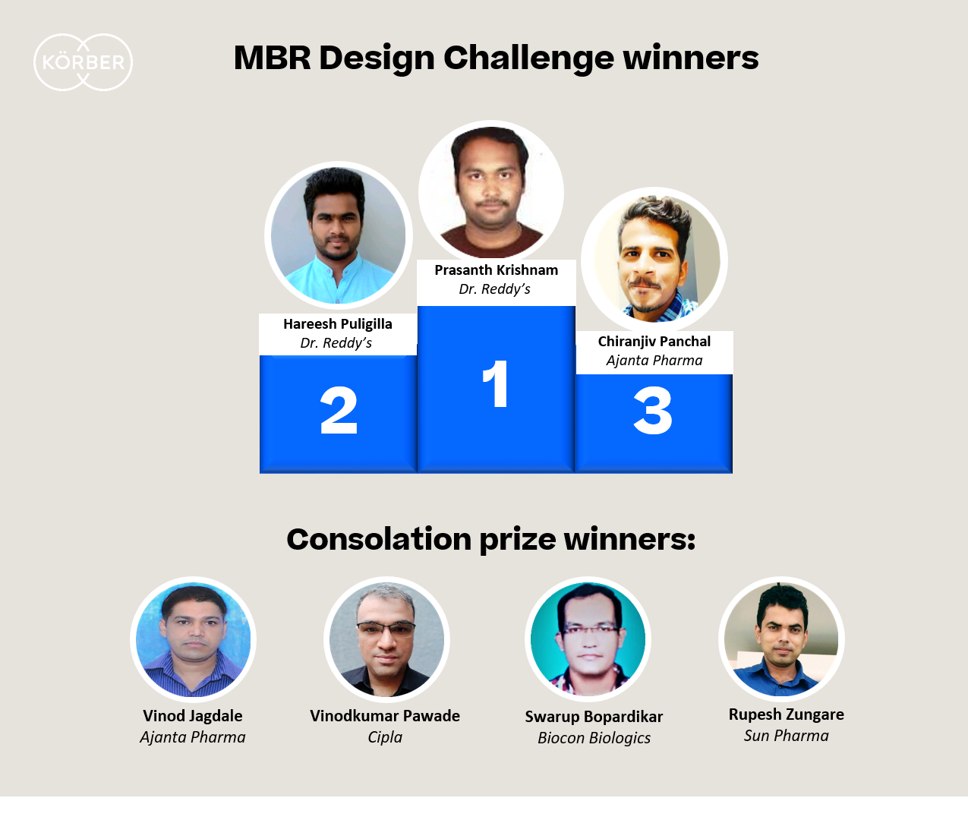
The winners of the MBR Design Challenge 2020

About Körber
Körber is an international technology group with about 10,000 employees, more than 100 locations worldwide and a common goal: We turn entrepreneurial thinking into customer success and shape the technological change. In the Business Areas Digital, Pharma, Supply Chain, Tissue and Tobacco, we offer products, solutions and services that inspire.
At the Körber Business Area Pharma we are delivering the difference along the pharma value chain with our unique portfolio of integrated solutions. With our software solutions we help drug manufacturers to digitize their pharma, biotech and cell & gene factories. The software product Werum PAS-X MES is recognized as the world’s leading Manufacturing Execution System for the pharma & biotech industry. Our data analytics and AI solutions accelerate product commercialization and uncover hidden business value.
www.koerber-pharma.com

Contact
Dirk Ebbecke
Körber Business Area Pharma
Head of Global Marketing & Communications Software
Werum IT Solutions GmbH
T: +49 4131 8900-689
E-mail: dirk.ebbecke@koerber-pharma.com

