Werum PAS-X Savvy ensures data integrity even in the development phase of pharmaceuticals

Lüneburg, Germany, 7 April 2021. Werum PAS-X Savvy, the leading real-time bioprocess data analytics software previously known as inCyght, provides a user-friendly way to ensure data integrity in the pharmaceutical and biopharmaceutical development as well as for CMC activities. A new functionality of the Körber software allows to automatically compare reports thus achieving a uniform data base and data analysis.

As part of the pharmaceutical and biopharmaceutical development and chemistry, manufacturing and controls (CMC) activities, reports need to be regularly generated and distributed. If any change or additional evaluations must be made after a report has been created, the data scientists need to make sure that the original data base is used for the revision of the report. Additionally, they need to provide evidence for equality between data analysis results, even if they have been generated at different points of time and by different users.

“With Werum PAS-X Savvy, it is possible to keep track of changes between report versions in an automated and user-friendly way,” says Dr. Daniel Borchert, Product Manager Software, Körber Business Area Pharma. “Our data science platform analyzes the results of different reports and their underlying elements, such as plots, variables, calculations and identifies the type and position of differences.“

The entire data hierarchy will be verified, including import, derived data, templates for calculations, plots and tables as well as the reports themselves. In case any discrepancy is detected, PAS-X Savvy will show on which hierarchical level the change has occurred and when and by whom it has been made.

“Our customers in the pharmaceutical and biopharmaceutical development industry benefit from the certainty of knowing that the same data and scientific methods are used in their reports. With the new PAS-X Savvy functionality ‘Trace’, data scientists can ensure data integrity, even in a non-GMP environment, and thus help accelerate the time-to-market of new products,” says Dr. Daniel Borchert, Product Manager.

Photo
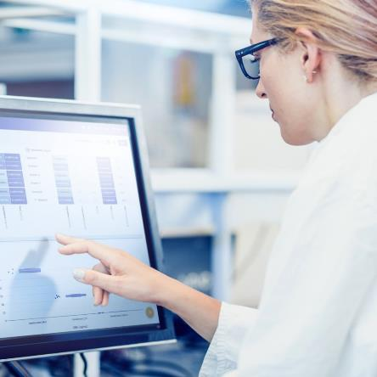
Werum PAS-X Savvy ensures data integrity in the pharmaceutical development as well as for the CMC activities

About Körber
Körber is an international technology group with about 10,000 employees, more than 100 locations worldwide and a common goal: We turn entrepreneurial thinking into customer success and shape the technological change. In the Business Areas Digital, Pharma, Supply Chain, Tissue and Tobacco, we offer products, solutions and services that inspire.
At the Körber Business Area Pharma we are delivering the difference along the pharma value chain with our unique portfolio of integrated solutions. With our software solutions we help drug manufacturers to digitize their pharma, biotech and cell & gene factories. The software product Werum PAS-X MES is recognized as the world’s leading Manufacturing Execution System for the pharma & biotech industry. Our data analytics and AI solutions accelerate product commercialization and uncover hidden business value.
www.koerber-pharma.com

Contact
Dirk Ebbecke
Körber Pharma Software
Head of Global Marketing & Communications
Werum IT Solutions GmbH
T: +49 4131 8900-0
E-mail: dirk.ebbecke@koerber-pharma.com

