Walvax Biotechnology: China’s leading vaccine manufacturer adopts Werum PAS-X MES from Körber

Lüneburg, Germany / Yunnan, China, 2 September 2020. Körber and Walvax Biotechnology have reached an agreement to implement Werum PAS-X MES, the world’s leading manufacturing execution system (MES) for pharma, biotech and cell & gene therapy manufacturing, in their Yuxi plant for vaccine production. With the introduction of PAS-X MES, Walvax takes a key step in initiating their digital journey.

As major part of their future digital factory, Werum PAS-X will control the filling and packaging processes and guide the operators through the shop floor. It will ensure correct operation and recording, while improving the production efficiency, compliance and data integrity. Walvax will also benefit from production control strategies recognized by international standards and leading industrial trends.

“I am very pleased that we cooperate with Körber,” says Mr. Huang Zhen, President of Walvax Biotechnology Co., Ltd. Yuxi. “Werum PAS-X MES is well-known in the industry and we are looking forward to the implementation of this MES. With PAS-X, Walvax will be able to gain advantages in terms of compliance, process standardization and acceleration of batch release.”

“We are honored to provide our PAS-X MES to Walvax, contributing to their world’s first-class vaccine shop floor,” says Jerry Zheng, General Manager Shanghai in the Körber Business Area Pharma. “Walvax is one of the biggest manufacturers of vaccines in China. We are sure that PAS-X will greatly improve Walvax’ shop floor operations and quality systems.”

Werum PAS-X will provide a one-stop record tracking and review platform for the entire process, which will significantly improve the speed of batch release and offer the basis of track & trace for future products. PAS-X will also manage on-site machines, instruments, containers and rooms in electronic equipment logbooks, making sure they are clean and calibrated. In the future, PAS-X will integrate the ERP system.

Picture
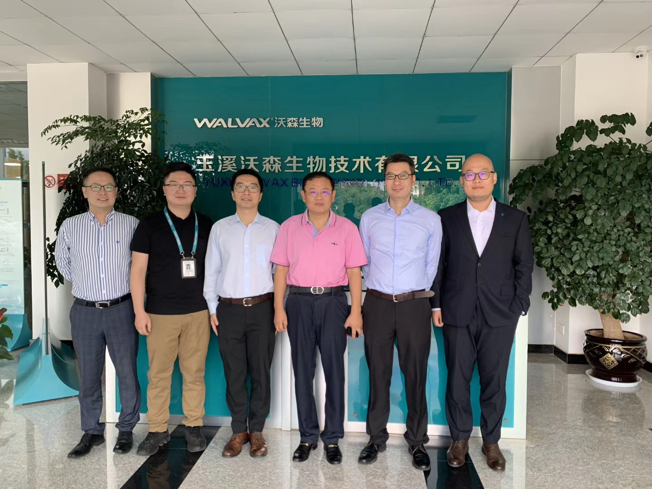

After signing the contract (from left):
Wayland Li (Manager Sales and Consulting, Körber Business Area Pharma)
Huang Junxin (Manager, Intelligent Manufacturing and Project Management, Walvax Biotechnology Co, Ltd. Yuxi)
Max Wang (Director, Greater China Operations, Körber Business Area Pharma)
Huang Zhen (President, Walvax Biotechnology Co, Ltd. Yuxi)
Jerry Zheng (General Manager Shanghai, Körber Business Area Pharma)
Baire Wang (Manager Sales and Consulting, Körber Business Area Pharma)

About Walvax Biotechnology
Walvax Biotechnology Co., Ltd. was founded in 2001 and represents a modern biological pharmaceutical company engaged in R&D, production and sales of bio-medical products. It is a China national validated high-tech enterprise and enterprise technical center. Walvax is committed to provide safe bio-medicines such as vaccines with excellent quality and advanced technology for domestic and foreign markets. The company owns a variety of high-quality vaccines, including China’s first independently developed pneumococcal 13-valent conjugate vaccine, which is also the world’s second product for the prevention of pneumonia in infants and young children.

About the Körber Business Area Pharma
At the Körber Business Area Pharma we are delivering the difference along the pharma value chain with our unique portfolio of integrated solutions. Spanning in-depth expertise in consulting, inspection, handling, packaging machines and materials, track & trace and software, we always have the right solutions to unlock the potential of our customer’s productivity. With our software solution Werum PAS-X MES we offer the world’s leading Manufacturing Execution System to digitize pharma, biotech and cell & gene factories. Our data analytics and AI solutions accelerate product commercialization and uncover hidden business value. With our profound understanding of pharma processes and regulation challenges, Körber is the right partner for leveraging all potentials of global pharma and biotech productions. Körber is an international technology group with around 10,000 employees and more than 100 locations worldwide.
www.koerber-pharma.com

Contact
Dirk Ebbecke
Körber Business Area Pharma
Head of Global Marketing & Communications Software
Werum IT Solutions GmbH
T: +49 4131 8900-689
E-mail: dirk.ebbecke@werum.com

