Werum IT Solutions receives the prestigious "Asia-Pacific Bioprocessing Excellence Award 2020" for its PAS-X MES
News Release

PAS-X Manufacturing Execution System awarded with the "Best Bioprocessing Supplier Award: Automation – Software" for the second consecutive year at the Annual Biologics Manufacturing Asia 2020 conference
Lüneburg, Germany / Bangkok, Thailand, 8 July 2020 – Werum IT Solutions, the leading supplier of manufacturing execution systems (MES) and manufacturing IT solutions for the pharmaceutical and biopharmaceutical industries, was honored with the "Best Bioprocessing Supplier Award: Automation – Software" for the second consecutive year at the 7th Annual Biologics Manufacturing Asia 2020 conference, which was held virtually on 7-8 July 2020.

Werum receives the award for its market-leading PAS-X MES solution, comprising the PAS-X software product, pre-configured content for pharma and biotech processes, as well as consulting, training, and support services. PAS-X supports pharma and biotech manufacturers to gain operational excellence by increasing efficiency, improving productivity and meeting regulatory requirements – factors that are all essential for a company's performance in these highly regulated industries.

"We are honored to be named Best Bioprocessing Excellence Supplier for the second consecutive year," states Teerapong Cheepchol, Managing Director, Werum IT Solutions Ltd., Thailand. "The recognition encourages us to continue providing the best digital solutions and services as a strategic partner to pharma and biotech manufacturers in Asia Pacific. I would like to thank our customers, partners and employees for their commitment and trust."

The Asia-Pacific Bioprocessing Excellence Awards honor bioprocessing leaders from over nine different regional biologics hubs across Asia Pacific. The virtual award ceremony was held in parallel with the 7th Annual Biologics Manufacturing Asia and the 4th BioLogistics World Asia, bringing together over 500 pharma industry experts online.

Picture
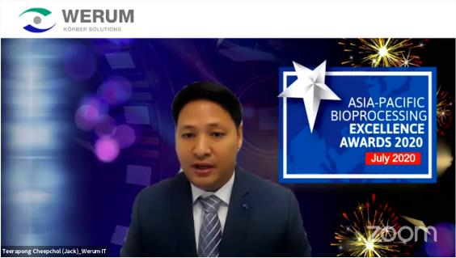
Teerapong Cheepchol, Managing Director, Werum IT Solutions Ltd., Thailand, at the virtual award ceremony

About Werum IT Solutions
Werum IT Solutions is the world’s leading supplier of manufacturing execution systems (MES) and manufacturing IT solutions for the pharmaceutical and biopharmaceutical industries. Its PAS-X software product is run by the majority of the world’s top 30 pharmaceutical and biotech companies and also by many mid-sized manufacturers. Werum’s manufacturing IT solutions help pharma manufacturers to increase efficiency, improve productivity, and meet regulatory requirements. Founded in 1969, Werum is headquartered in Lüneburg, Germany, and has many locations in Europe, America, and Asia.
www.werum.com

Werum is part of Medipak Systems, the Pharma Systems business area of Körber. The Körber Group is an international technology group with around 10,000 employees all over the world. It unites technologically leading companies with more than 100 production, service and sales locations and offers its customers solutions, products and services in the Business Areas of Körber Digital, Logistics Systems, Pharma Systems, Tissue and Tobacco. The Business Area Pharma Systems provides high quality solutions for the production, inspection and packaging of pharmaceutical products and unites seven internationally successful companies under one roof.
www.medipak-systems.com, www.koerber.com

Contact:
Dirk Ebbecke
Head of Global Marketing & Communications
Werum IT Solutions GmbH
Wulf-Werum-Str. 3
21337 Lüneburg, Germany
Tel. +49 4131 8900-689
Fax +49 4131 8900-200
dirk.ebbecke@werum.com

