Congratulations: Werum IT Solutions honored as “Top Pharma & Life Science Solution Provider 2018” in Asia-Pacific
News Release

The world’s leading Pharma MES supplier was recognized for its technology advancements and for paving the way to Pharma 4.0 / APAC CIO Outlook named Werum IT Solutions as only MES provider to win this prestigious award
Lüneburg/Germany, Bangkok/Thailand, 21 August 2018 – Werum IT Solutions was recognized as one of the “Top 10 Pharma & Life Science Solution Providers 2018” by APAC CIO Outlook. With the certificate of honor, a distinguished panel of CIOs, CEOs and VCs including the APAC CIO Outlook editorial board selected companies that are successfully tackling the challenges of the pharma and biotech industries by adopting technology advancements and paving the way to Pharma 4.0. Werum IT Solutions is the only MES supplier which has received this prestigious award this year.

“We are proud to have been recognized as the leading provider of Manufacturing Execution Systems, MES, for the pharma and life sciences industry in Asia for the last three consecutive years,” says David Margetts, Managing Director, Werum IT Solutions Ltd., Thailand. “Our PAS-X MES has become the centerpiece for pharma manufactures to shape the future Pharma 4.0 world, including advancements in Enterprise Manufacturing Intelligence, Mobility, Software as a Service and Plug & Produce integration that will truly enable Industry 4.0 and IoT within pharma facilities.”
Margetts continues: “Our clients are well beyond just thinking about the buzzwords Augmented Reality, Voice Integrated Systems, Cloud, and Big Data as they have already implemented pilots and commercial applications on top of our PAS-X solution today! To be honored as one of the Top 10 Pharma & Life Science Solution Providers in APAC is a great motivation for our entire team to continue to serve our customers even better. We are grateful for our customers’ trust and would like to thank our partners around the region for their valuable contributions in our success.”

APAC CIO Outlook is a monthly magazine published in Silicon Valley, USA, that aims to provide a platform for CxOs of solution providers and to share their expertise with the enterprise IT community of Asia-Pacific countries. You can read the full article online at https://pharma.apacciooutlook.com/vendor/werum-it-solutions-vanguards-of-pharma-40-cid-3178-mid-157.html.

Photo:
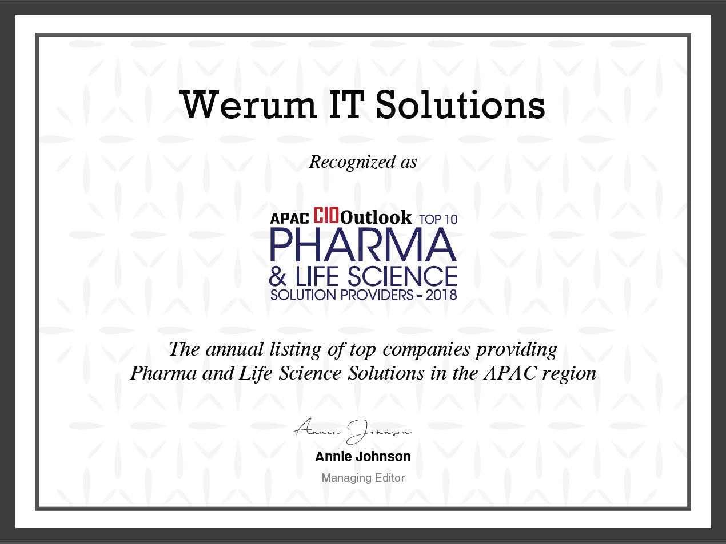
Werum IT Solutions was recognized as one of the “Top 10 Pharma & Life Science Solution Providers 2018”

About Werum IT Solutions
Werum IT Solutions is the world’s leading supplier of manufacturing execution systems (MES) and manufacturing IT solutions for the pharmaceutical and biopharmaceutical industries. Its PAS-X software product is run by the majority of the world’s top 30 pharmaceutical and biotech companies and also by many mid-sized manufacturers. Werum’s manufacturing IT solutions help pharma manufacturers to increase efficiency, improve productivity, and meet regulatory requirements. Founded in 1969, Werum is headquartered in Lüneburg, Germany, and has many locations in Europe, America, and Asia.
www.werum.com

Werum is part of Medipak Systems, the Pharma Systems business area of the international technology group Körber. The Business Area’s companies, Dividella, Fargo Automation, Mediseal, Rondo, Seidenader Maschinenbau, Systec & Services, Traxeed and Werum IT Solutions, are global leading providers of high-quality solutions for the manufacturing and packaging process of pharmaceutical products. As a Medipak Systems company, Werum provides integrated IT solutions for all phases of pharmaceutical and biopharmaceutical production – including process development, commercial production, and packaging as well as track & trace serialization. Körber unites around 12,000 professionals in industry-leading companies worldwide, achieving annual earnings of 2.6 billion Euros.
www.medipak-systems.com

Contact:
Dirk Ebbecke
Director Corporate Communications
Werum IT Solutions GmbH
Wulf-Werum-Str. 3
21337 Lüneburg, Germany
Tel. +49 4131 8900-689
Fax +49 4131 8900-200
dirk.ebbecke@werum.com

