Werum IT Solutions grows its PAS-X Endorsed Service Partner network in Japan with B-EN-G
News Release

Werum IT Solutions and Toyo Business Engineering Corporation (B-EN-G) have signed a partnership agreement / Further expansion of Werum’s services in Japan for the leading PAS-X MES for the pharma and biotech industry
Lüneburg/Germany, Tokyo/Japan, 22 February 2019 – Werum IT Solutions is pleased to announce a new strategic partnership with Toyo Business Engineering Corporation (B-EN-G), a leading and highly experienced provider of integrated enterprise and manufacturing solutions headquartered in Tokyo, Japan.
B-EN-G’s extensive track record of delivering ERP, MES and logistics systems for Japanese and international pharma manufacturers greatly complements Werum’s best-in-class manufacturing IT solutions and its flagship product PAS-X MES. The PAS-X Endorsed Service Partner agreement enables B-EN-G to act as a certified service implementation team in Japan for Werum’s premier customers. Together, the two companies are ideally placed to deliver excellent and extended support locally in Japan and to ensure the right expertise is always available throughout the country for the rapidly expanding customer base of PAS-X MES.
“We are absolutely delighted to partner with B-EN-G, one of Japan’s leading business engineering corporations and a key player for the pharma industry,” says Richard Nagorny, Managing Director and CFO of Werum IT Solutions. “The business vision and cultural fit of our two companies is very strong and with the power of Werum’s PAS-X MES product for the Pharma 4.0 Factory of the Future and with B-EN-G’s large team of experts we are greatly enhancing the value and scale of services that we provide in Japan for our clients and business partners.”
Masanori Osawa, President and CEO of B-EN-G, adds: “We are proud to have been providing IT solutions mainly for manufacturing industries over the last 30 years in Japan. The pharmaceutical industry has always been considered of strategic importance for our company so this partnership is very exciting for us. We selected Werum and its PAS-X MES in order to best meet our customers’ needs, including proven improvements of production efficiency and compliance with GMP regulation of pharmaceutical medicines. As a certified PAS-X Service Partner with long accumulated experiences and expertise in the industry, we assure that PAS-X, the leading MES solution for the pharma and biotech industry, will help advance and digitize our customers’ business quickly.”
PAS-X Endorsed Service Partners meet all requirements of Werum's PAS-X Service Partner Program. The main objective is to offer the same quality and competence of services to Werum customers all over the world – through reliable, experienced and certified partners. The Service Partners need to have comprehensive PAS-X knowledge, participate at PAS-X trainings on a regular basis, possess experience in the regulated industry and use a quality management system. The certification has to be renewed on a regular basis.

Picture
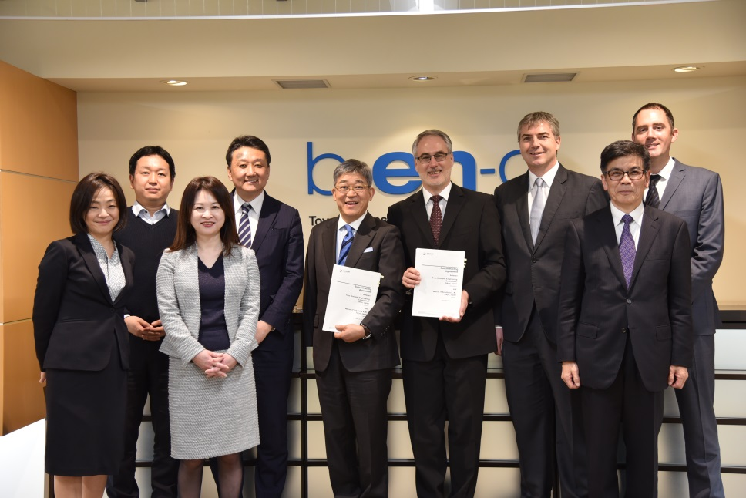
Werum and B-EN-G teams at the contract signing ceremony

About Werum IT Solutions
Werum IT Solutions is the world’s leading supplier of manufacturing execution systems (MES) and manufacturing IT solutions for the pharmaceutical and biopharmaceutical industries. Its PAS-X software product is run by the majority of the world’s top 30 pharmaceutical and biotech companies and also by many mid-sized manufacturers. Werum’s manufacturing IT solutions help pharma manufacturers to increase efficiency, improve productivity, and meet regulatory requirements. Founded in 1969, Werum is headquartered in Lüneburg, Germany, and has many locations in Europe, America, and Asia.
www.werum.com

Werum is part of Medipak Systems, the Pharma Systems business area of the international technology group Körber. The Business Area’s companies, Dividella, Fargo Automation, Mediseal, Rondo, Seidenader Maschinenbau, Systec & Services, Traxeed and Werum IT Solutions, are global leading providers of high-quality solutions for the manufacturing and packaging process of pharmaceutical products. As a Medipak Systems company, Werum provides integrated IT solutions for all phases of pharmaceutical and biopharmaceutical production – including process development, commercial production, and packaging as well as track & trace serialization. Körber unites around 12,000 professionals in industry-leading companies worldwide, achieving annual earnings of 2.6 billion Euros.
www.medipak-systems.com, www.koerber.com

Contact:
Dirk Ebbecke
Director Corporate Communications
Werum IT Solutions GmbH
Wulf-Werum-Str. 3
21337 Lüneburg, Germany
Tel. +49 4131 8900-689
Fax +49 4131 8900-200
dirk.ebbecke@werum.com

About Toyo Business Engineering Corporation (B-EN-G)
For over 30 years B-EN-G has been a driving force in the implementation of information technology for Japanese manufacturing companies to gain the benefits of the latest software and solutions. As the pharmaceutical and biotech industry is a core part of B-EN-G’s business the company has developed a full expertise and large technical team to support the specific requirements of the industry. B-EN-G is experienced in the entire lifecycle of pharma GxP IT systems and highly knowledged on all key processes and solution areas.

Contact:
Toyo Business Engineering Corporation (B-EN-G)
Public Relations
Tel.: +81-3-3510-1615
kouhou@to-be.co.jp

