Dexa Medica: Indonesia's leading pharma company introduces Werum's PAS-X MES
News Release

PAS-X MES implementation at manufacturing site in Palembang, South Sumatra, Indonesia / Full integration of level 4 and 2 systems / Digitization of manufacturing processes helps Dexa Medica to become a data-driven organization
Lüneburg, Germany / Bangkok, Thailand, 16 June 2020 – As part of their digitization initiative, Dexa Medica started their first full-scope electronic batch recording project with Werum's PAS-X Manufacturing Execution System (MES) at their manufacturing site in Palembang, Indonesia. Dexa Medica is one of Indonesia's largest ethical pharmaceutical companies and a prominent player in the domestic pharmaceutical market.

PAS-X will be integrated with ERP, LIMS, DMS, LDAP and IPC equipment as well as with level 2 automation systems in a phase-wise approach. Dexa Medica uses many latest technologies which received GMP, ISO 9001 and other quality-related certifications. Now, with the start of the MES/EBR project, the Palembang site will be fully digitized. This will enable Dexa Medica to control their manufacturing processes in a flexible and electronic way – based on accurate real-time data – and to achieve major improvements in production quality and efficiency.

"We are very excited and look forward to starting our digital transformation journey and entering a long-term strategic partnership with Werum," states Wimala Widjaja, CIO, Dexa Group. "By implementing Werum's PAS-X MES, we aim to strengthen our ability to generate and capture data from every corner of our quality system and manufacturing processes. And, most importantly, we will lay a strong foundation for Dexa Medica to become a data-driven organization."

In addition to high transparency and increased production performance benefits, PAS-X will help Dexa Medica to meet compliance requirements and accelerate batch release and time to market due to the standardization of manufacturing processes and review by exception. The project will be managed locally by Werum Asia teams from Indonesia and Thailand.

Pictures
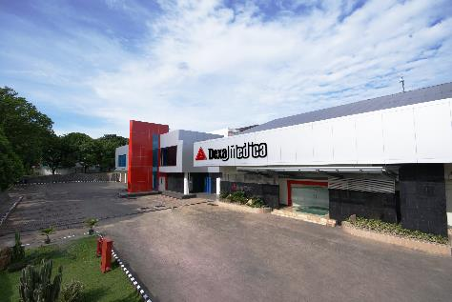
Dexa Medica's manufacturing site in Palembang, South Sumatra, Indonesia

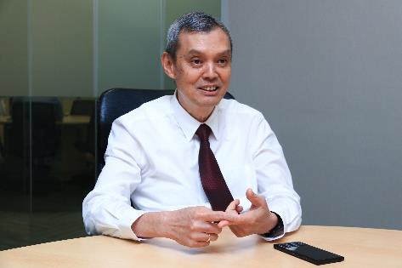
Wimala Widjaja, CIO, Dexa Group

About Werum IT Solutions
Werum IT Solutions is the world’s leading supplier of manufacturing execution systems (MES) and manufacturing IT solutions for the pharmaceutical and biopharmaceutical industries. Its PAS-X software product is run by the majority of the world’s top 30 pharmaceutical and biotech companies and also by many mid-sized manufacturers. Werum’s manufacturing IT solutions help pharma manufacturers to increase efficiency, improve productivity, and meet regulatory requirements. Founded in 1969, Werum is headquartered in Lüneburg, Germany, and has many locations in Europe, America, and Asia.
www.werum.com

Werum is part of Medipak Systems, the Pharma Systems business area of Körber. The Körber Group is an international technology group with around 10,000 employees all over the world. It unites technologically leading companies with more than 100 production, service and sales locations and offers its customers solutions, products and services in the Business Areas of Körber Digital, Logistics Systems, Pharma Systems, Tissue and Tobacco. The Business Area Pharma Systems provides high quality solutions for the production, inspection and packaging of pharmaceutical products and unites seven internationally successful companies under one roof.
www.medipak-systems.com, www.koerber.com

Contact:
Dirk Ebbecke
Head of Global Marketing & Communications
Werum IT Solutions GmbH
Wulf-Werum-Str. 3
21337 Lüneburg, Germany
Tel. +49 4131 8900-689
Fax +49 4131 8900-200
dirk.ebbecke@werum.com

