News Release

Another successful ISPE event for Werum IT Solutions
ISPE Philippines Affiliate celebrated its 10th year anniversary and its Annual Meeting was held under the topic: “Expanding the horizon of Pharmaceutical Engineering” bringing together local and international experts, regulators and practitioners.

Makati City, Philippines, June 26, 2018 – Werum IT Solutions participated in the ISPE Philippines Affiliate 2018 Annual Meeting and 10th Anniversary Celebration that was held on June 26 – 27, 2018 at the Makati Shangri-La hotel in Makati City, Philippines. The event was held under the topic: “Expanding the horizon of Pharmaceutical Engineering.” and gathered international and national regulatory authorities, industry experts from around the region and students to discuss latest trends in Pharmaceutical Quality, Regulatory, Compliance and Technology that will expand the role of pharmaceutical engineering in ensuring product quality and patient safety.

Werum IT Solutions Asia was a platinum sponsor at the event and during the exhibition hosted a table top presentation and demonstration area where they promoted their Manufacturing Execution System (MES), PAS-X, and generated a large amount of interest among the passing attendees on the key platform for future manufacturing.

ISPE Philippines celebrated its 10th anniversary which coincided with the affiliate's Annual Meeting and Exhibition on 26 - 27 June 2018. Also, the Affiliate scheduled its pre-conference activity, the Asia Pacific (APAC) Regional Meeting, on June 24 – 25 that was attended by ISPE APAC Council Directors and ISPE Board of Directors from the US.

The conference program comprised of two plenary sessions: “Compliance to GxPs – Scanning the Environment” and “Regulatory Synergy”. The first day of the conference was dedicated to plenary sessions that focused on best practice sharing in terms of GxP compliance and regulatory convergence. The second day was divided into parallel sessions composed of 4 tracks that addressed the topics of interests and specializations of the delegates.

The conference concluded with Dinner and Fellowship Night which was attended by all former ISPE Philippines presidents, ISPE Members and industry experts. The evening social event started with an award ceremony and winner announcement of the student poster competition and ended with a series of stage performances and networking.

Photos:

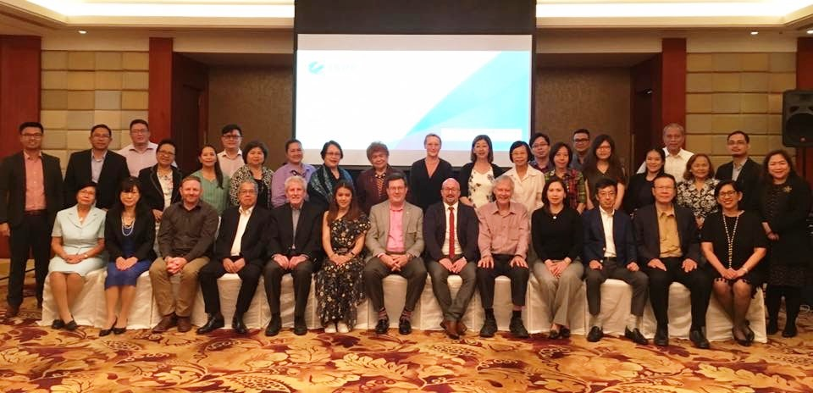

Pre-conference program: ISPE APAC Council Meeting

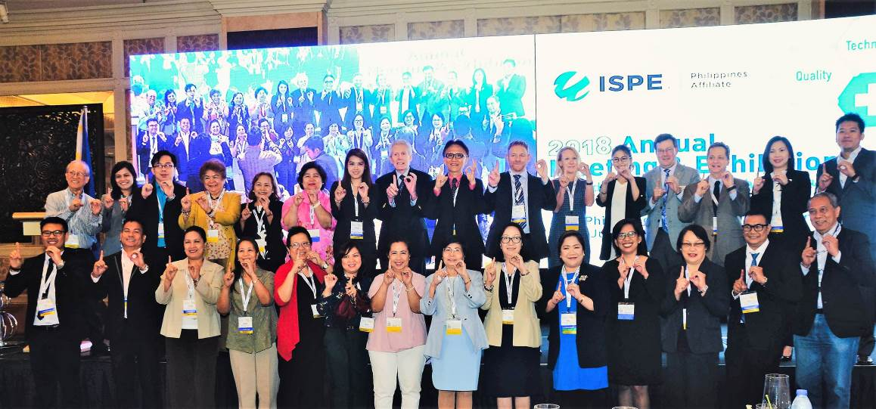

ISPE Philippines current / former presidents, Board of Directors and speakers

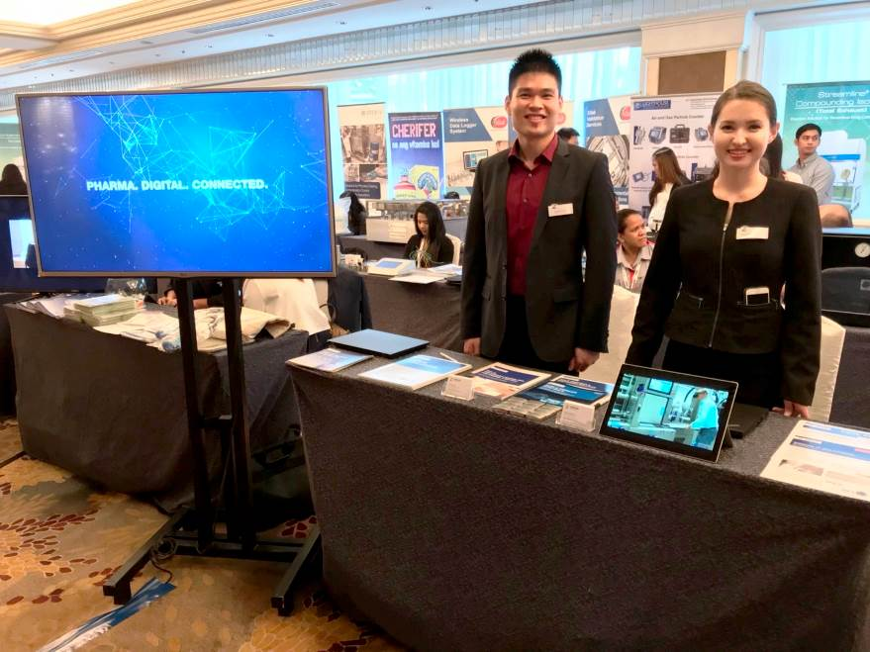
Werum’s booth at the exhibition

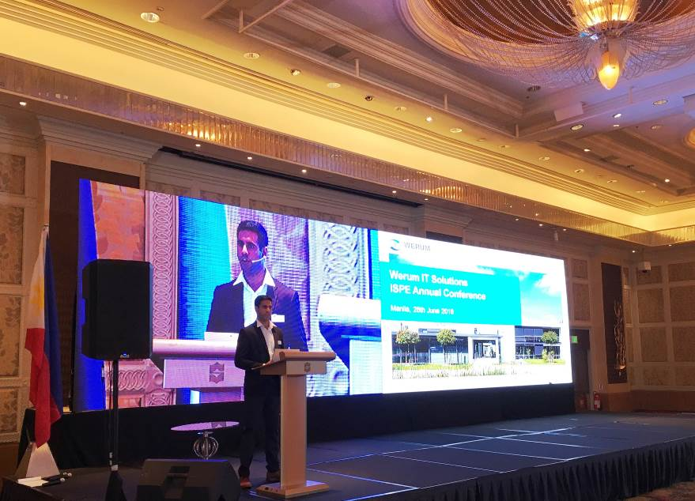

Orchun Thakral, Senior Manager of Sales & Marketing, delivering a speech on Werum’s offerings

About ISPE

The International Society for Pharmaceutical Engineering (ISPE) was founded in 1980 and is the world’s largest not-for-profit organization leading scientific, technical and regulatory advancement throughout the entire pharmaceutical lifecycle. Its 18,000+ members, located in more than 90 countries around the globe, are dedicated to the development and manufacture of safe and effective pharmaceutical and biologic medicines and medical delivery devices. Its worldwide headquarters is located in Bethesda, Maryland, while its Operations and Training Center is based in Tampa, Florida.

The ISPE Philippines Affiliate on the other hand was founded on 10 October 2008 by a group of committed Filipino pharmacists, chemists and engineers who felt the need of providing quality training and seminars that will help address the current issues faced by the industry, the regulatory authority and the academe. For almost a decade now, the Affiliate has conducted several trainings, seminars and workshops for the pharmaceutical industry, the Philippine Food and Drug Administration (FDA) as well as for young professionals and students.
www.ispe.org/, www.ispe.org/philippines-affiliate

About Werum IT Solutions Asia
Werum IT Solutions Ltd., Bangkok, Thailand is the Asia Pacific Headquarters of Werum IT Solutions GmbH, Germany and serves customers in India and other Asian countries. With our regional offices across Asia we are close to many of the world's leading pharma and biotech companies.

Werum IT Solutions GmbH is the world’s leading supplier of manufacturing execution systems (MES) and manufacturing IT solutions for the pharmaceutical and biopharmaceutical industries. Our out-of-the-box PAS-X software product is run by the majority of the world’s top 30 pharmaceutical and biotech companies but also by many mid-sized manufacturers.

Werum’s manufacturing IT solutions help pharma manufacturers to increase efficiency, improve productivity, and meet regulatory requirements. The range of projects includes global MES programs with multi-site rollouts all over the world as well as single-site solutions in India and other Asian countries.

Founded in 1969, Werum is headquartered in Lüneburg, Germany, and has many locations in Europe, Asia, and America.
www.werum-asia.com

About Körber and Medipak Systems
Werum is part of Medipak Systems, the Pharma Systems business area of the international technology group Körber. The Business Areas six companies, Dividella, Fargo Automation, Mediseal, Rondo, Seidenader Maschinenbau and Werum IT Solutions, are global leading providers of high-quality solutions for the manufacturing and packaging process of pharmaceutical products. As a Medipak Systems company, Werum provides integrated IT solutions for all phases of pharmaceutical and biopharmaceutical production – including process development, commercial production, and packaging as well as track & trace serialization. Körber unites worldwide almost 11,500 professionals in industry-leading companies, achieving annual earnings of more than 2.3 billion Euros.
www.medipak-systems.com, www.koerber.de

Contact:

Gulmira Yerdessova
Regional Marketing Executive
Werum IT Solutions Ltd.
287 Silom Rd., 1405 Liberty Square Bldg.
10500 Bangkok, Thailand
Tel. +66 2020 5736
Fax +66 2631 1114
gulmira.yerdessova@werum.com
www.werum-asia.com

