Werum’s Plug & Produce Solution awarded as one of the best solutions at the Industriepreis 2018
News Release

PAS-X MSI Plug & Produce Solution awarded as Best Of at the Industriepreis / This solution allows easy integration of equipment via message-based interface / New version MSI 1.1 with enhanced usability now available
Lüneburg, Germany, 12 September 2018 – The software solution “PAS-X MSI Plug & Produce Solution” from Werum IT Solutions was awarded as “Best Of” at the Industriepreis 2018 in the category “IT & Software Solutions for Industry”. With this award, the jury of experts honors the novelty, product maturity and future-oriented approach of the solution, as well as its economic and technological benefits.

Werum’s PAS-X MSI Plug & Produce Solution allows the easy and fast integration of machines, equipment and automation systems into the existing production environment of a pharmaceutical or biotechnological manufacturer. The machines on the shop floor and Werum’s PAS-X Manufacturing Execution System can communicate directly with each other via a new, standardized and message-based interface. This allows to reduce the integration effort for a new machine by up to 75 percent.

“We are very pleased about this award, which is both a recognition and an incentive for us,” says Christiane Dickel, responsible Product Manager at Werum IT Solutions GmbH. “Our PAS-X MSI Plug & Produce Solution is a trendsetter in networked production and an important prerequisite for advancing Industrie 4.0 solutions in the pharma and biotech industries. Together with customers and industry associations such as ISPE, we are continuously developing our solution and have just released a new version with improved usability and extended options.”

With the Industriepreis, Initiative Mittelstand and Huber Verlag für Neue Medien, publishers of IT magazines, honor particularly advanced industrial products and solutions in 14 different categories every year. An independent jury of experts consisting of professors, scientists, industry experts and journalists evaluates all submissions.

Pictures:
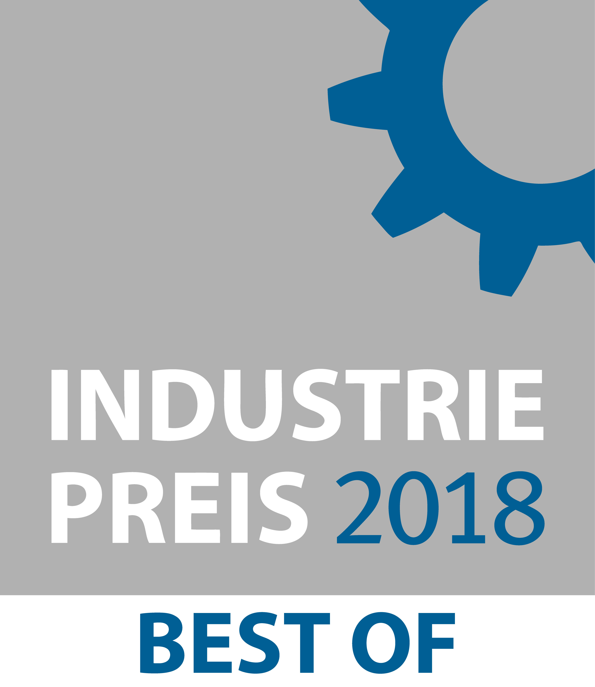
Award for Werum’s PAS-X MSI Plug & Produce Solution

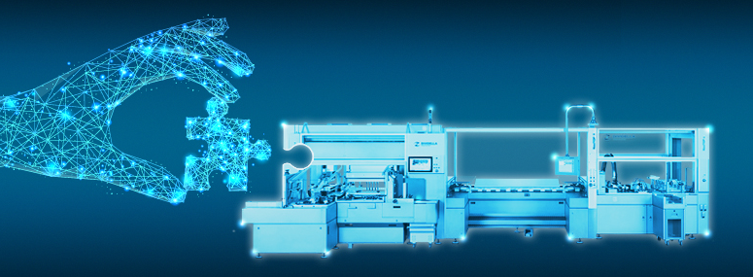
Werum’s PAS-X MSI Plug & Produce Solution

Christiane Dickel, Product Manager, Werum IT Solutions
About Werum IT Solutions
Werum IT Solutions is the world’s leading supplier of manufacturing execution systems (MES) and manufacturing IT solutions for the pharmaceutical and biopharmaceutical industries. Its PAS-X software product is run by the majority of the world’s top 30 pharmaceutical and biotech companies and also by many mid-sized manufacturers. Werum’s manufacturing IT solutions help pharma manufacturers to increase efficiency, improve productivity, and meet regulatory requirements. Founded in 1969, Werum is headquartered in Lüneburg, Germany, and has many locations in Europe, America, and Asia.
www.werum.com

Werum is part of Medipak Systems, the Pharma Systems business area of the international technology group Körber. The Business Area’s companies, Dividella, Fargo Automation, Mediseal, Rondo, Seidenader Maschinenbau, Systec & Services, Traxeed and Werum IT Solutions, are global leading providers of high-quality solutions for the manufacturing and packaging process of pharmaceutical products. As a Medipak Systems company, Werum provides integrated IT solutions for all phases of pharmaceutical and biopharmaceutical production – including process development, commercial production, and packaging as well as track & trace serialization. Körber unites around 12,000 professionals in industry-leading companies worldwide, achieving annual earnings of 2.6 billion Euros.
www.medipak-systems.com, www.koerber.de/en

Contact:
Dirk Ebbecke
Director Corporate Communications
Werum IT Solutions GmbH
Wulf-Werum-Str. 3
21337 Lüneburg, Germany
Tel. +49 4131 8900-689
Fax +49 4131 8900-200
dirk.ebbecke@werum.com

