News Release

Werum IT Solutions at Interphex Japan 2018
Werum Asia’s keynote presentation on Pharma 4.0 at the Interphex Week in Tokyo.
Tokyo, Japan, June 27, 2018 – Interphex, the leading pharmaceutical exhibition in Japan, this year hosted its 31st pharma expo and welcomed around 48,000 local and international visitors. The trade show attracts industry professionals to see the latest in manufacturing technology, all types of manufacturing, R&D and lab equipment, packaging and IT solutions. This year Interphex consisted of 4 exhibitions: INTERPHEX JAPAN (Manufacturing & Packaging), in-Pharma Japan (Ingredients), BioPharma Expo (Biopharmaceutical) and Pharma R&D Japan (Drug Discovery). A wide range of products and innovative solutions are presented at the exhibition each year. The renowned pharma expo was organized by Japan’s largest event organizer, Reed Exhibitions Japan Ltd., well-known for its high-quality and large-scale exhibitions.

The conference program was held concurrently and included more than 100 sessions and covered topics such as Drug Development, Industry 4.0, R&D Strategy by Pharma Companies, Quality Assurance and Global Trends, to name a few. David Margetts, Managing Director for Werum IT Solutions Asia, was invited and honored to deliver an opening keynote speech on “Pharma 4.0: Trends for Future Manufacturing”. Margetts’ presentation shared an overview of where Asian is in context to Digitalization, What are the steps along the Pharma 4.0 journey and explained recent case studies from Werum’s customers who are applying cutting edge technologies such as Data Analytics, Augmented Reality (AR), Biometrics and Voice-Directed technology in pharmaceutical manufacturing at their sites.

An abstract paper developed from the concepts covered in the Asia Pharma 4.0 presentation will be released shortly and made available through our websites and other regional industry information platforms.

Photos:

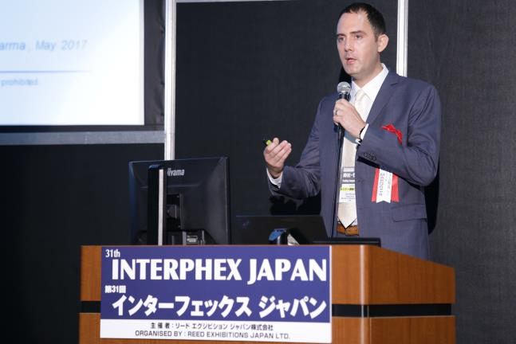
David Margetts, Managing Director, Werum IT Solutions Asia, delivering a speech at the Interphex Japan 2018

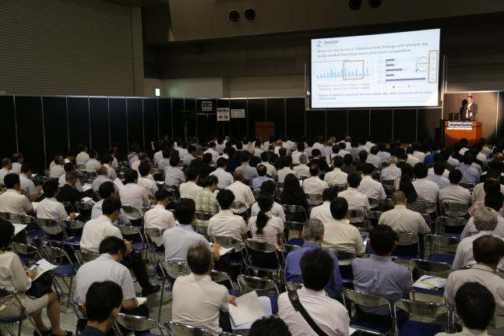
David Margetts, Managing Director, Werum IT Solutions Asia, in front of the wide audience at the conference

About Werum IT Solutions Asia
Werum IT Solutions is the internationally leading supplier of manufacturing execution systems (MES) and manufacturing IT solutions for the pharmaceutical and biopharmaceutical indus­tries. Its out-of-the-box PAS-X software product is run by the majority of the world’s top 30 pharmaceutical and biotech companies but also by many mid-sized manufacturers.
Werum’s manufacturing IT solutions help pharma manufacturers to increase efficiency, im­prove productivity, and meet regulatory require­ments. The range of projects includes global MES programs with multi-site rollouts all over the world as well as single-site solutions in India and other Asian countries.
www.werum-asia.com

About Körber and Medipak Systems
Werum is part of Medipak Systems, the Pharma Systems business area of the international technology group Körber. The Business Areas six companies, Dividella, Fargo Automation, Mediseal, Rondo, Seidenader Maschinenbau and Werum IT Solutions, are global leading providers of high-quality solutions for the manufacturing and packaging process of pharmaceutical products. As a Medipak Systems company, Werum provides integrated IT solutions for all phases of pharmaceutical and biopharmaceutical production – including process development, commercial production, and packaging as well as track & trace serialization. Körber unites worldwide almost 11,500 professionals in industry-leading companies, achieving annual earnings of more than 2.3 billion Euros.
www.medipak-systems.com, www.koerber.de

Contact:

Gulmira Yerdessova
Regional Marketing Executive
Werum IT Solutions Ltd.
287 Silom Rd., 1405 Liberty Square Bldg.
10500 Bangkok, Thailand
Tel. +66 2020 5736
Fax +66 2631 1114
gulmira.yerdessova@werum.com
www.werum-asia.com

