Jens Woehlbier assigned as new CEO of Werum IT Solutions
News Release

Lüneburg, Germany, 16 May 2019 – On 15 April 2019 Jens Woehlbier started as new Chief Executive Officer (CEO) of Werum IT Solutions. He succeeds Rüdiger Schlierenkämper who has worked for Werum in managerial positions since 2000 and will retire at the end of June 2019.

Before joining Werum, Jens Woehlbier worked for more than 20 years in various management positions at the management consultancy Accenture where he was responsible for IT transformation projects of industry customers. Most recently, he was Head of Front Office Digitization and Automotive managing the global technology portfolios of several Accenture key accounts and taking care of their digital transformation.

“As a profound IT and digitization specialist, Jens Woehlbier is a perfect match for Werum,” says Jörn Gossé, CEO at Körber Medipak Systems. “He will actively drive forward the further development of Werum's product portfolio realizing the Factory of the Future of our pharma and biotech customers.”

At the same time, Jörn Gossé thanks Rüdiger Schlierenkämper for his successful work and his commitment: “Rüdiger Schlierenkämper has had a strong influence on the internationalization of Werum and the great success of the company as the global market leader for pharma and biotech Manufacturing Execution Systems (MES).”

Picture
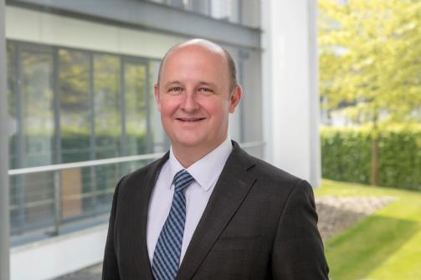
Jens Woehlbier, new Chief Executive Officer (CEO) of Werum IT Solutions

About Werum IT Solutions
Werum IT Solutions is the world’s leading supplier of manufacturing execution systems (MES) and manufacturing IT solutions for the pharmaceutical and biopharmaceutical industries. Its PAS-X software product is run by the majority of the world’s top 30 pharmaceutical and biotech companies and also by many mid-sized manufacturers. Werum’s manufacturing IT solutions help pharma manufacturers to increase efficiency, improve productivity, and meet regulatory requirements. Founded in 1969, Werum is headquartered in Lüneburg, Germany, and has many locations in Europe, America, and Asia.
www.werum.com

Werum is part of Medipak Systems, the Pharma Systems business area of the international technology group Körber. The Business Area’s companies, Dividella, Fargo Automation, Mediseal, Rondo, Seidenader Maschinenbau, Systec & Services, Traxeed and Werum IT Solutions, are global leading providers of high-quality solutions for the manufacturing and packaging process of pharmaceutical products. As a Medipak Systems company, Werum provides integrated IT solutions for all phases of pharmaceutical and biopharmaceutical production – including process development, commercial production, and packaging as well as track & trace serialization. Körber unites around 10,000 professionals in industry-leading companies worldwide, achieving annual earnings of 2.6 billion Euros.
www.medipak-systems.com, www.koerber.com

Contact:
Dirk Ebbecke
Director Corporate Communications
Werum IT Solutions GmbH
Wulf-Werum-Str. 3
21337 Lüneburg, Germany
Tel. +49 4131 8900-689
Fax +49 4131 8900-200
dirk.ebbecke@werum.com

