Werum IT Solutions launches new smart biometric authentication solution K.ME-IN for pharma and biotech in cooperation with Nymi
News Release

Full integration into Werum’s PAS-X Manufacturing Execution System / Out-of-the-box solution with Nymi Band / Secure operator authentication on the pharma and biotech shopfloor / Increased data integrity and production efficiency
Lüneburg, Germany / Toronto, Canada, 8 January 2020 – Werum IT Solutions is excited to announce the launch of K.ME-IN, a biometric authentication solution with Nymi for Werum’s PAS-X Manufacturing Execution System (MES). The new solution will allow users on the pharmaceutical or biopharmaceutical shop floor to securely and seamlessly authenticate to systems, devices and machines via a smart wristband. In the future, K.ME-IN will be extended to allow user authentication via further biometric means such as iris scan, face recognition, fingerprint or a combination of those.

The Nymi Band is a wearable device that can be worn under all types of protective clothing and is uniquely assigned to each user, based on their irreplicable biometric identity. The out-of-the-box solution is fully integrated into Werum’s PAS-X MES, the market leading MES for pharma and biotech manufacturing. What makes the Nymi Band unique is that once authenticated it remains on, transmitting the wearer’s identify until removed. It replaces the traditional method of entering user name and password, PIN codes, or badges. In addition, the Nymi Band is the most secure authentication solution available on the market today ensuring that only the logged-in user is making the entries.

“We are convinced that having Nymi as part of our K.ME-IN biometric authentication solution is going to make our pharmaceutical and biotech customers even more productive,” says Obay Alchorbaji, Product Manager, Werum IT Solutions. “With our new solution we address the very real challenge in the pharmaceutical and biopharmaceutical market of ensuring secure and fast authentication while meeting compliance and data integrity requirements. We help our customers cut authentication times by up to 75% thus significantly increasing their production efficiency.”

Andrew Foxcroft, VP at Nymi, adds: "We are delighted that Werum has chosen to directly integrate Nymi into their PAS-X system and have already seen the tremendous increase in productivity and security that this partnership brings to the production environments of their customers. It will ease the authentication procedures for pharma and biotech operators so that they can concentrate better on their task at hand.”

Picture
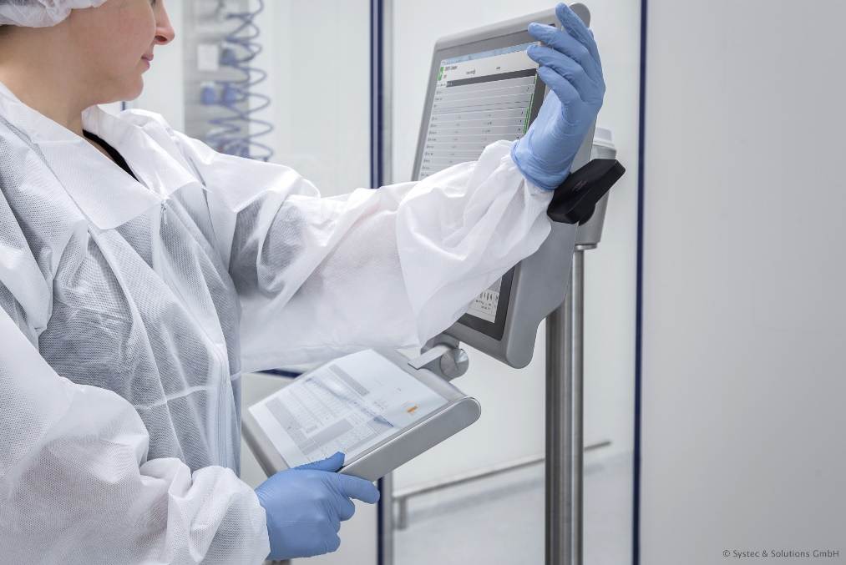
The Nymi Band allows operators to securely and seamlessly authenticate to Werum’s PAS-X MES via biometric means.

About Werum IT Solutions
Werum IT Solutions is the world’s leading supplier of manufacturing execution systems (MES) and manufacturing IT solutions for the pharmaceutical and biopharmaceutical industries. Its PAS-X software product is run by the majority of the world’s top 30 pharmaceutical and biotech companies and also by many mid-sized manufacturers. Werum’s manufacturing IT solutions help pharma manufacturers to increase efficiency, improve productivity, and meet regulatory requirements. Founded in 1969, Werum is headquartered in Lüneburg, Germany, and has many locations in Europe, America, and Asia.
www.werum.com

Werum is part of Medipak Systems, the Pharma Systems business area of Körber. The Körber Group is an international technology group with around 10,000 employees all over the world. It unites technologically leading companies with more than 100 production, service and sales locations and offers its customers solutions, products and services in the Business Areas of Körber Digital, Logistics Systems, Pharma Systems, Tissue and Tobacco. The Business Area Pharma Systems provides high quality solutions for the production, inspection and packaging of pharmaceutical products and unites seven internationally successful companies under one roof.
www.medipak-systems.com, www.koerber.com

Contact:
Dirk Ebbecke
Head of Global Marketing & Communications
Werum IT Solutions GmbH
Wulf-Werum-Str. 3
21337 Lüneburg, Germany
Tel. +49 4131 8900-689
Fax +49 4131 8900-200
dirk.ebbecke@werum.com

About Nymi
Nymi is a Toronto based authentication company with a completely new model of authentication: biometric enabled multifactor authentication solution that delivers continuous, on-body authentication. To bring this concept to market, Nymi brings dedicated authentication hardware in combination with their enterprise authentication solution, Nymi Enterprise Edition. To date, Nymi works with top 100 pharmaceutical companies to deliver data integrity and security, allowing highly regulated industries to achieve compliance and productivity.

Contact:
Phil Chang
Nymi
Tel. +1 416.977.3042
pchang@nymi.com

Shnane Liem
Vive Social
Tel. +1 778-866-0084
shnane@vivesocialpr.com

