News Release

Werum IT Solutions Asia host their first Manufacturing Excellence Summit in Asia

Bangkok, Thailand, May 24, 2018 – Werum IT Solutions hosted their first Manufacturing Excellence Summit (MES) for Asia on May 24th and 25th at the Dusit Thani Hotel in Bangkok, Thailand. The event was held under the theme of “Pharma. Digital. Connected.” and was dedicated to the latest developments in the pharma industry, cutting edge technologies and how to navigate a successful roadmap to Pharma 4.0.

The Manufacturing Excellence Summit kicked off with a private facility tour to give our attendees the opportunity to observe an outstanding example of lean manufacturing atone of Toyota’s Lean Manufacturing assembly shops. Here they observed the amazing orchestration of 300 different processes to produce a fully functioning car in 2hrs! Our attendees really appreciated the chance to see such a high performing manufacturing plant at first hand and could discuss many concepts and consider how to apply them back to their own business.

The conference program itself commenced with keynote presentations focused on our Theme: Pharma. Digital. Connected. and how an understanding in technology and IT automation is now critical to achieve excellence in manufacturing and to ensure compliance to the latest GxP requirements. The event continued with a set of executive workshops designed to inspire and guide senior management from Operations, QA and IT in the strategies and knowledge needed to be successful in the implementation of IT programs. The workshops and presentations focused on key topics such as IT Landscape & Strategy, Justifying Investment / ROI for and How to Achieve Excellence in Pharma Manufacturing and finished with several case studies on Pharma 4.0 topics including from Sun Pharma (India) and AstraZeneca (Australia).

Our first Manufacturing Excellence Summit Asia ended with a private cruise on the Chao Phraya River where our guests could network and enjoy the majestic views of renowned historical sites and connect with their peers and our speakers. This highly successful event brought together experts from the leading pharmaceutical companies from across the entire Asia region and created a great platform and opportunity to connect, share ideas, experiences and insights in the future of manufacturing.

Our esteemed speakers for the event included: Hanns E. Erle, PhD (Senior Industry Consultant and ex-EVP Operations, Merck Serono), Jennie Burton (Operations IT Lead & Senior Business Analyst, AstraZeneca PLC), K. Kulbhushan (Global Head for Operations Strategy / Excellence, Sun Pharmaceutical Industries Ltd.), Jason Young (Principal Consultant, SilverBullet Security) and Lars Hornung (Senior Director Sales & Marketing, Werum IT Solutions GmbH). The finale of the event was an expert panel discussion held as an interactive session allowing the participants to post and vote on questions electronically and ask the experts to provide their guidance and feedback on how to realize Pharma 4.0.

We would like to deeply thank all participants and speakers for travelling across Asia to attend, and we are greatly looking forward to building on the achievement of the Manufacturing Excellence Summit Asia at our next events this and in the next years, stay Connected on our web links to receive the latest news from Werum IT Solutions.

Photos:
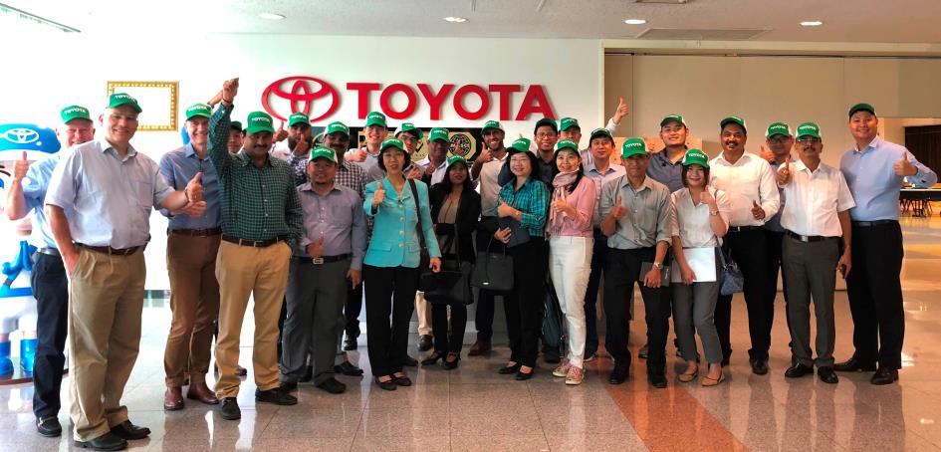
Participants of the pre-conference factory tour

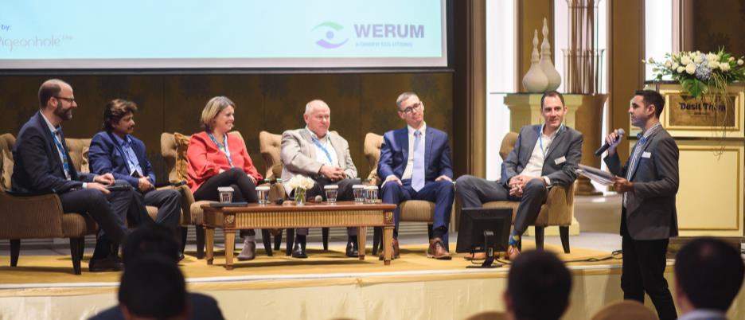
Keynote speakers and panelists

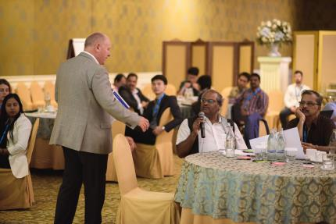
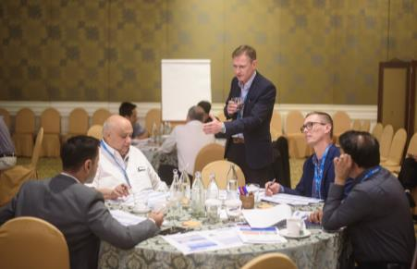
Executive workshops by Pharma industry consultants

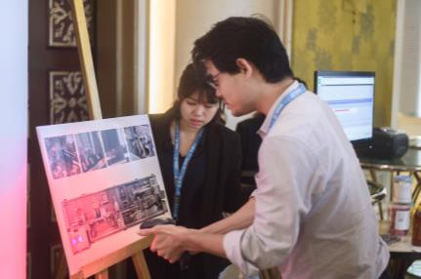
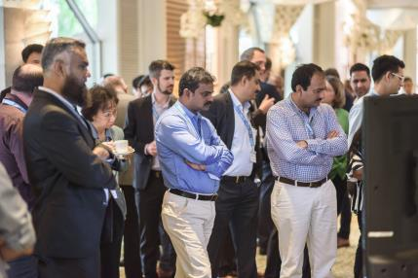

Guests getting hands-on with PAS-X

About Werum IT Solutions Thailand
Werum IT Solutions Ltd., Bangkok, Thailand is the Asia Pacific Headquarters of Werum IT Solutions GmbH, Germany and serves customers in India and other Asian countries. With our regional offices across Asia we are close to many of the world's leading pharma and biotech companies.

Werum IT Solutions GmbH is the world’s leading supplier of manufacturing execution systems (MES) and manufacturing IT solutions for the pharmaceutical and biopharmaceutical industries. Our out-of-the-box PAS-X software product is run by the majority of the world’s top 30 pharmaceutical and biotech companies but also by many mid-sized manufacturers.

Werum’s manufacturing IT solutions help pharma manufacturers to increase efficiency, improve productivity, and meet regulatory requirements. The range of projects includes global MES programs with multi-site rollouts all over the world as well as single-site solutions in India and other Asian countries.

Founded in 1969, Werum is headquartered in Lüneburg, Germany, and has many locations in Europe, Asia, and America.
www.werum-asia.com

About Körber and Medipak Systems
Werum is part of Medipak Systems, the Pharma Systems business area of the international technology group Körber. The Business Areas six companies, Dividella, Fargo Automation, Mediseal, Rondo, Seidenader Maschinenbau and Werum IT Solutions, are global leading providers of high-quality solutions for the manufacturing and packaging process of pharmaceutical products. As a Medipak Systems company, Werum provides integrated IT solutions for all phases of pharmaceutical and biopharmaceutical production – including process development, commercial production, and packaging as well as track & trace serialization. Körber unites worldwide almost 11,500 professionals in industry-leading companies, achieving annual earnings of more than 2.3 billion Euros.
www.medipak-systems.com, www.koerber.de

Contact:

Gulmira Yerdessova
Regional Marketing Executive
Werum IT Solutions Ltd.
287 Silom Rd., 1405 Liberty Square Bldg.
10500 Bangkok, Thailand
Tel. +66 2020 5736
Fax +66 2631 1114
gulmira.yerdessova@werum.com
www.werum-asia.com

