OPEN-SCS: milestone for open communication standard
in pharma packaging serialization reached
News Release

OPEN-SCS plug fest took place in Lüneburg on invitation of Werum IT Solutions / Successful testing of interfaces, interoperability, and compliance adherence / OPEN-SCS honored with Pharma 4.0 Award
Lüneburg, Germany, 17 October 2019 – OPEN-SCS and Werum IT Solutions successfully staged the “OPEN-SCS plug fest” at Werum’s headquarters in Lüneburg, Germany. The OPEN-SCS working group is partnered with the OPC Foundation to develop an open source standard covering the complete business transaction for the data exchange in pharma packaging serialization.

During the plug fest the interfaces between the ISA levels 2-3 and 3-4 and the different vendors have been tested. Besides Werum (manufacturing IT including serialization solutions) the companies ACG (end-to-end pharmaceutical solutions), ADVANCO (packaging/distribution serialization and track and trace level 3 and 4), and WIPOTEC (serialization provider of level 2 systems) took part in the interoperability tests. Complex data containing, for instance, serialization mass data, were exchanged and the compliance with the OPC UA standard checked.

“The results are very satisfactory,” says Costantino Pipero, leading the event on behalf the OPC Foundation. “We fully achieved our goals, testing the interfaces, interoperability, and compliance adherence. The specification is viable, that means no changes are needed. For OPEN SCS this is the basis to now start and speed up implementation.”

In recognition of its efforts to develop an open communication standard, the OPEN-SCS working group was honored with the Pharma 4.0 Award by the Pharma MES / Pharma TRACKTS! conference. The award will further boost OPEN-SCS to realize its vision: to reduce the total cost of ownership for packaging serialization in the pharma and biotech industry.

Pictures
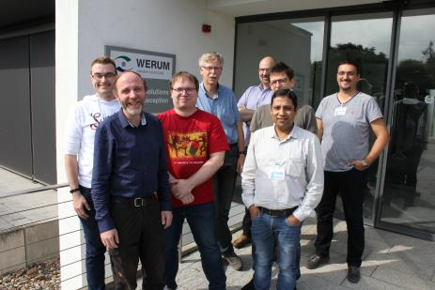
OPEN-SCS plug fest at Werum’s HQs in Lüneburg

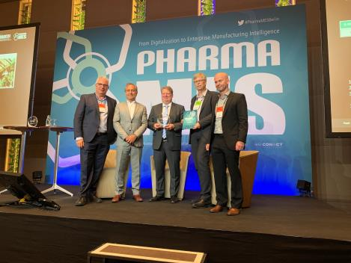
OPEN-SCS honored with Pharma 4.0 Award

About Werum IT Solutions
Werum IT Solutions is the world’s leading supplier of manufacturing execution systems (MES) and manufacturing IT solutions for the pharmaceutical and biopharmaceutical industries. Its PAS-X software product is run by the majority of the world’s top 30 pharmaceutical and biotech companies and also by many mid-sized manufacturers. Werum’s manufacturing IT solutions help pharma manufacturers to increase efficiency, improve productivity, and meet regulatory requirements. Founded in 1969, Werum is headquartered in Lüneburg, Germany, and has many locations in Europe, America, and Asia.
www.werum.com

Werum is part of Medipak Systems, the Pharma Systems business area of Körber. The Körber Group is an international technology group with around 10,000 employees all over the world. It unites technologically leading companies with more than 100 production, service and sales locations and offers its customers solutions, products and services in the Business Areas of Körber Digital, Logistics Systems, Pharma Systems, Tissue and Tobacco. The Business Area Pharma Systems provides high quality solutions for the production, inspection and packaging of pharmaceutical products and unites seven internationally successful companies under one roof.
www.medipak-systems.com, www.koerber.com

Contact:
Dirk Ebbecke
Director Corporate Communications
Werum IT Solutions GmbH
Wulf-Werum-Str. 3
21337 Lüneburg, Germany
Tel. +49 4131 8900-689
Fax +49 4131 8900-200
dirk.ebbecke@werum.com

