Werum IT Solutions:
PAS-X innovations facilitate production processes on the shop floor in pharma and biotech factories
News Release

New features for biometric authentication, detailed scheduling and mobile execution / Easier, more secure and efficient production processes in the pharma and biotech industries
Lüneburg, Germany, 20 June 2019 – In 2019, Werum IT Solutions adds many innovations to its world-leading PAS-X Manufacturing Execution System (MES) for the pharma and biotech industries which provides advanced user options and better performance. This includes, for example, biometric alternatives to the usual authentication process, an integrated solution for detailed scheduling and optimized operation on mobile terminals.

Biometric authentication
The current authentication process requires entering a username and password, pincode or ID – and is thus time-consuming. With K.Me-In [ki mi ɪn] Werum now offers an innovative biometric authentication product to simplify log-in and signing processes. In the future, various user-specific biometric parameters such as fingerprint, iris, face recognition or a combination of those will be used. Additionally, PAS-X logs off the user automatically when he or she leaves the application – an important aspect to ensure data integrity. Werum’s new biometric authentication product allows users on the shop floor to authenticate more quickly so they can concentrate on their main tasks.

Seamless integration of detailed scheduling
Moreover, Werum has further enhanced the functionality of its PAS-X MES by integrating a detailed scheduling solution based on sedApta’s Factory Scheduler. Through PAS-X, this scheduling solution can directly access all necessary data, such as master data, MBRs or order data for the shop floor. PAS-X provides the data in real time and with a higher quality than any ERP. Thus, there is no more need for an interface between the scheduling solution and the ERP.

Easier mobile operation
PAS-X is increasingly being used on mobile terminals on the shop floor. For this reason, Werum has further optimized the use of its MES software on hand-held scanners and tablets. For instance, this allows tablet users to benefit from an improved touch operation. PAS-X now has a new browser-based user interface specifically designed for the operation on hand-held terminals which supports current hardware and software platforms. In industrial environments, the improved usability allows for increased performance, stable operation and safety.

“We are continually enhancing PAS-X. On one hand, we aim to address new production processes, regulations and customer requirements in an optimal way. On the other hand, it is our goal to stimulate innovation and to quickly pave the way for the pharmaceutical industry to the digital factory of the future,” says Robert Welter, Senior Head of PAS-X Product Management, Werum IT Solutions GmbH.

Pictures
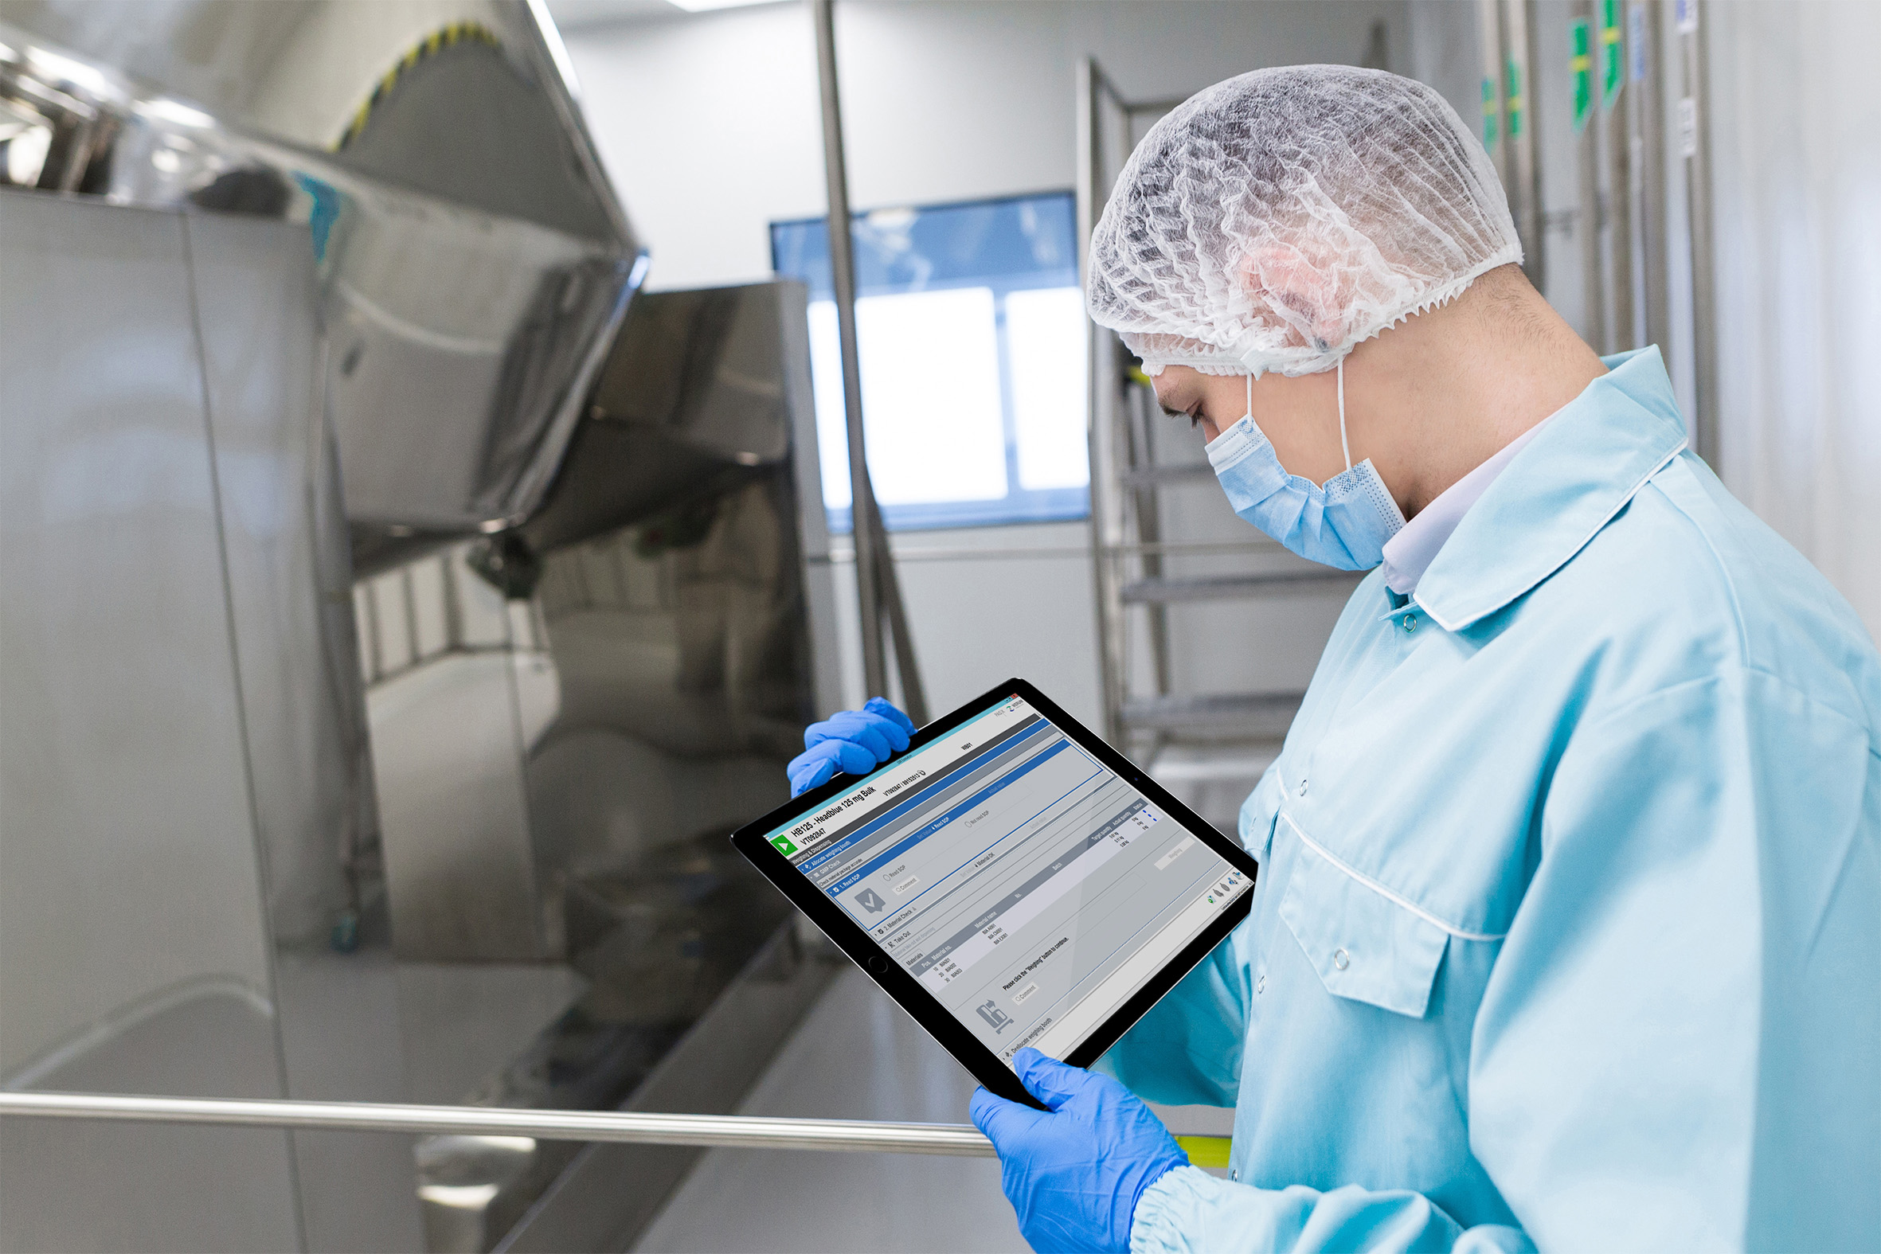
Operator with tablet
Robert Welter, Senior Head of PAS-X Product Management, Werum IT Solutions GmbH

About Werum IT Solutions
Werum IT Solutions is the world’s leading supplier of manufacturing execution systems (MES) and manufacturing IT solutions for the pharmaceutical and biopharmaceutical industries. Its PAS-X software product is run by the majority of the world’s top 30 pharmaceutical and biotech companies and also by many mid-sized manufacturers. Werum’s manufacturing IT solutions help pharma manufacturers to increase efficiency, improve productivity, and meet regulatory requirements. Founded in 1969, Werum is headquartered in Lüneburg, Germany, and has many locations in Europe, America, and Asia.
www.werum.com

Werum is part of Medipak Systems, the Pharma Systems business area of the international technology group Körber. The Business Area’s companies, Dividella, Fargo Automation, Mediseal, Rondo, Seidenader Maschinenbau, Systec & Services, Traxeed, and Werum IT Solutions, are global leading providers of high-quality solutions for the manufacturing and packaging process of pharmaceutical products. As a Medipak Systems company, Werum provides integrated IT solutions for all phases of pharmaceutical and biopharmaceutical production – including process development, commercial production, and packaging as well as track & trace serialization. Körber unites around 10,000 professionals in industry-leading companies worldwide, achieving annual earnings of 2.6 billion Euros.
www.medipak-systems.com, www.koerber.com

Contact:
Dirk Ebbecke
Director Corporate Communications
Werum IT Solutions GmbH
Wulf-Werum-Str. 3
21337 Lüneburg, Germany
Tel. +49 4131 8900-689
Fax +49 4131 8900-200
dirk.ebbecke@werum.com

